PILGRIMAGE (HAJJ) AND SACRIFICE

Sura Bakara/Ayat 196:

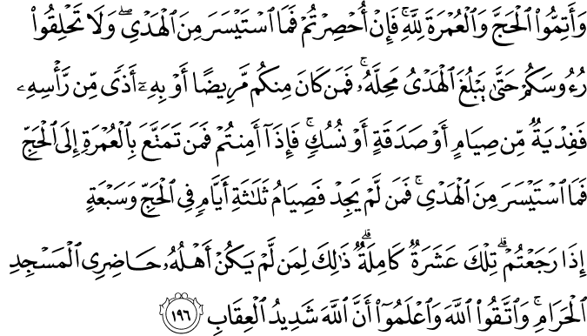

Complete the Hajj (the Major Pilgrimage) and the ‘Umrah (the Minor Pilgrimage) for God, and if you are impeded (after you have already put on the Pilgrimage attire), then send (to Makkah) a sacrificial offering you can afford. Do not shave your heads (to mark the end of the state of consecration for the Pilgrimage) until the offering has reached its destination and is sacrificed. However, if any of you is ill (so that he is obliged to leave the state of consecration) or has an ailment of the head, he must make redemption by fasting, or giving alms, or offering a sacrifice. When you are secure (when the Pilgrimage is not impeded, or the impediment is removed), then whoever takes advantage of the ‘Umrah before the Hajj must give a sacrificial offering he can afford. For whoever cannot afford the offering, a fast for three days during the Hajj, and for seven days when you return home, that is, ten days in all. This is for those whose families do not live in the environs of the Sacred Mosque. Act in due reverence for God and piety (avoiding disobedience to Him and obeying His ordinances), and know that God is severe in retribution.(1)

SuraBakara/Ayat 197:
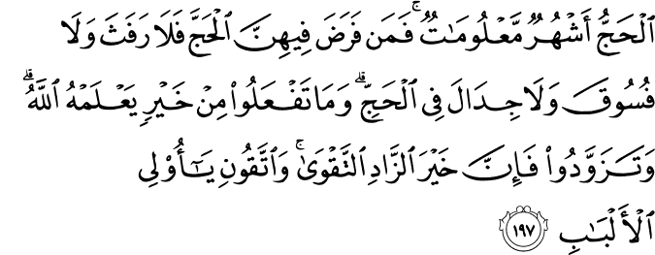

The Hajj is in the months well-known.¹⁴¹ Whoever undertakes the duty of Hajj in them, there is no sensual indulgence, nor wicked conduct, nor disputing during the Hajj. Whatever good you do (all that you are commanded and more than that, especially to help others), God knows it. Take your provisions for the Hajj (and do not be a burden upon others). In truth, the best provision is righteousness and piety, so be provided with righteousness and piety to guard against My punishment, O people of discernment!(2)

HADITH

Narrated Abu Huraira:

The Prophet was asked, "Which is the best deed?" He said, "To believe in Allah and His Apostle." He was then asked, "Which is the next (in goodness)?" He said, "To participate in Jihad in Allah's Cause." He was then asked, "Which is the next?" He said, "To perform Hajj-Mabrur.(3)

Narrated Abu Huraira:
The Prophet (p.b.u.h) said, "Whoever performs Hajj for Allah's pleasure and does not have sexual relations with his wife, and does not do evil or sins then he will return (after Hajj free from all sins) as if he were born anew." (4)

Narrated 'Aisha:
(the mother of the faithful believers) I said, "O Allah's Apostle! We consider Jihad as the best deed." The Prophet said, "The best Jihad (for women) is Hajj Mabrur. " (5)
What is Hajj? H
ajj HOLY JOURNEY TO THE HO
Hajj is the pilgrimage to Mecca, the journey made to the Ka’bah and visits to certain holy places to perform the prescribed acts of worship by Muslims at a particular time of the year. Hajj, or the pilgrimage to Mecca, is one of the five pillars of Islam. Hajj was made obligatory upon the Muslims during the ninth year of the holy migration. The obligation of Hajj is defined in this verse of the Qur’ân: “…Pilgrimage to the House is a duty owed to God by all who can afford a way to it…” (Âl ‘Imrân 3:97)

The rewards of performing Hajj once in a lifetime, for those who have the financial means and physical capability, are numerous, and these words of the Prophet are more than significant in conveying the abundance of the holy pilgrimage: “Whoever performs the Hajj and does not commit obscenity or transgression, he returns purified from sin just like the day his mother gave birth to him.”

Hajj Awakens Humans to the Joy of Servitude

By nature, every human feels the need of demonstrating their worship, their servitude to the Creator. Hajj is a form of worship that truly gives believers the opportunity to expose humbleness, to express devotedness as servants, and to demonstrate gratitude before the Creator for all the blessings He bestowed. Those who perform the Hajj leave all worldly bonds behind; they abandon wealth, possessions, position and status, and turn to the Creator in humbleness. Standing in total submission before the One of eternal power and might, the believer expresses absolute devotion and worship to God, which in turn awakens the believer to the joy and pleasures of servitude.

Hajj Is Clear Evidence That Every Human Is Equal in the Eyes of the Creator

Hajj is a form of worship that brings millions of Muslims together every year regardless of race, language, color, nation, culture, position, or status. Portraying an inspiring scene of brotherhood and equality, the millions of Muslims from all walks of life gather together for the same purpose, in worship and submission to the Creator. Dressed identically, the wealthy Muslims alongside the poor, the powerful integrated with the weak, all enduring the same difficulties, but even more important, all experiencing the discipline of equality and brotherhood. Hajj is total submission, a form of worship that makes the rich stand together, shoulder to shoulder on mount Arafat supplicating together, or circling the Ka’bah side by side with the deprived that can barely provide for their families. Hajj teaches Muslims not to boast regarding their position, status, wealth or possessions. It teaches them to gather and integrate according to the Islamic boundaries of brotherhood and to never forget the Day of Reckoning.

Hajj Increases Devotedness to Islam

The journey to this sacred place, the land where the Islamic faith emerged and later spread following the years of hardship and suffering by the Prophet Muhammad, peace and blessings be upon him, and his devoted Companions, this sacred place where the first verses of the Qur’ân were revealed, a holy land that has been a place visited by many Prophets since the Prophet Adam, strengthens the spiritual emotions of a Muslim and increases their devotion to Islam.

Hajj Is Patience and Gratification

By performing the worship of Hajj, a Muslim displays gratification to the Lord for health and accomplishments and for the wealth and possessions bestowed by God. The Muslims who perform Hajj must display patience and tolerance, endure hardships, and confront difficulties. They develop the abilities of acting together as a group, performing the same actions together in huge crowds, integration, and helping others while adapting to the specific rules and regulations.

Who should attend Hajj?

Hajj is compulsory for those who conform with the conditions below:
1. The sane and conscious.
2. They must be Muslim.
3. They must have reached puberty.
4. Those who are free (not enslaved).
5. Those who know that Hajj is obligatory.
6. They must have the means to perform the journey and provide for both themselves, for their families and whoever else they may be responsible for until their return from Hajj. 7. They must reach Hajj in due time for the rituals of worship.
8. The journey for Hajj must be safe.
9. They must be healthy humans.

What is ‘Umrah?

‘Umrah is visiting the Ka’bah, Mecca, Medina, and the other sacred places visited during the holy pilgrimage outside the Hajj season. In fact, the ‘Umrah worship is performed in the close vicinity of the Ka’bah. It is composed of entering into ihrâm, or the state of consecration for the pilgrimage worship, at any time of the year, except the Hajj season, and coming out of the state of ihrâm after performing the tawâf (circumambulation) of the Ka’bah, the sa’y (striding between the hillocks of Safa and Marwa), and shaving (or shortening) the hair. Performing ‘Umrah is a sunnah act of worship.

Sacrifice: The Mount for Crossing the Sirat Bridge
The Meaning of the Sacrifice

The sacrifice is offered at a particular time of the year (on the first, second, or third day of the ‘Iydul-Adhâ, the festival of sacrifice) with the intention of worship and obtaining reward from the Creator. Sacrificing an animal is a wâjib (necessary) form of worship which is executed with an individual’s wealth. The sacrifice is a display of our devotion, a demonstration of our gratitude for all the blessings God generously bestows upon us. The Prophet said: “The one who has the means but does not perform the sacrifice may not approach our mosque,” expressing just how important the duty of sacrificing an animal is for those who have the means to do so.

Who should sacrifice an animal?

Sacrificing an animal is obligatory for those who conform with the conditions stated below:
1. The person must be a Muslim.
2. Must have reached puberty.
3. Must be sane.
4. Must be free (not enslaved).
5. Is not travelling or a guest.
6. Must have sufficient wealth to sacrifice an animal.

When is the animal sacrificed?

The animal is usually sacrificed on the first, second, or third day of the ‘Iydul-Adhâ, the festival of sacrifice. This worship of offering a sacrifice for the sake of God can be fulfilled any time during the ‘Iyd of the sacrifice until the evening prayer on the third day of the ‘Iyd; however, it is more advisable to sacrifice the animal on the first day of the ‘Iyd.

Which animals can be sacrificed?

Only sheep, goats, cattle, buffalo, and camels can be sacrificed. The sheep and goats must have reached one year, cattle and buffalo two, and camels five years. If a six month old sheep is larger than average and looks more like an animal of a year old, it may be sacrifice, whereas goats must reach a year old before being sacrificed. A sheep or goat can only be sacrificed by one person, whereas up to seven people can sacrifice a cow, buffalo, or camel jointly. Animals that have damaged or no horns and that are slightly lame or have teeth missing can be sacrificed.

A Prayer of Hope

Every form of worship ordained by God as a duty upon all Muslims is embodied by the practices of the Prophet, who represents an ideal for all humanity to aspire to. In the Qur’ân, God Almighty addresses the Prophet with the words: “You are surely of a sublime character, and do act by a sublime pattern of conduct” (Qalam 68:4), guiding us to acknowledge His Messenger, Prophet Muhammad, as the most excellent example to follow in every aspect of our lives.

If we sincerely seek God’s good pleasure and become His servants “whom He loves, and who love Him” (Mâedah 5:54), we should follow the perfect example of His Messenger in both worship and sublime character. Love of God requires loving His most beloved servant and Messenger. As the following verse points out, loving the Prophet shows itself by following him and designing our lives according to the practice, or Sunnah, of the Prophet in all respects: “Say (to them, O Messenger): ‘If you indeed love God, then follow me, so that God will love you and forgive you your sins’” (Âl ‘Imrân 3:31). Living a life of worship and performing every act of worship in accordance with the example of the Prophet will lead us to taking him as a role model in every aspect of our lives and thus to adopting his sublime conduct and character.

Inshâllah, we will be among those members of the community of the Prophet who follow his sublime example in our daily lives and become people whom God loves, and who love Him. (6)
References

(1) 2:196/The Quran with Annotated Interpretation in Modern English by Ali Unal
(2)2:197/The Quran with Annotated Interpretation in Modern English by Ali Unal
(3) SahihBukhari, Volume 2, Book 26, Number 594
(4)SahihBukhari, Volume 2, Book 26, Number 596
(5)SahihBukhari, Volume 2, Book 26, Number 595
(6) The Young Person’s Guide to Living Islam, Asli Kaplan Tughrabooks

