Observe the Book with a Firm Resolve

Prelude
The most valuable of beings is LIFE; and the best service to life is efforts to transform this life into the everlasting life.
It is necessary to seek a way of making that scientific information and knowledge of philosophy useful, and spiritual.
Life is short and the work to be done much. How many unnecessary, useless, unimportant you would find among your knowledge. And so, it is necessary to seek a way of making that scientific information and knowledge of philosophy useful, and spiritual. You, also, should ask Almighty God for an awakening so that you may transform your thought into thought for the All-Wise and Glorious One’s sake. So that your unnecessary scientific knowledge may become valuable knowledge of God.

Love necessitates knowledge.
- The highest aim of creation is Belief in God.
- The highest degree in humanity is the Knowledge of God contained within belief in God.
- The most radiant happiness is the Love of God contained within the knowledge of God.
If one discovers his Owner, if he knows his Master, then he will seek refuge in His Mercy, and rely on His power. Then the world will turn into a place of recreation and pleasure, it will become a place of trade for the hereafter. Belief leads to happiness in this world and the next.

Three Sources

Three universal sources which make known to us our Sustainer.
- The Qur’an of Mighty Stature
- The Seal of the Prophets (Upon whom be blessings and peace)
- The supreme sign of the book of the universe

The Qur’an:
The Qur’an from the perspective of Universe: the pre-eternal translator of the mighty Book of the universe; the post-eternal interpreter of the various tongues reciting the verses of creation; the commentator of the book of the worlds of the seen and the unseen; the revealer of the treasures of the Divine Names hidden in the heavens and on the earth; the key to the truths concealed beneath the lines of events; the clear interpreter of the Divine Essence, Attributes, Names, and functions.
A book of prayer, and a book of wisdom, and a book of worship, and a book of command, and a book of thought.
The Qur’an from the perspective of God Almighty: The Qur’an is a revealed Scripture which comprises in summary of the Books of all the prophets, whose times were all different, and the works of all the purified scholars, whose paths are all different.
The Qur'an has four fundamental aims: Divine unity (tavhid); Messengership (nübüvvet); Afterlife (haşir); Integrity (ibadet ve adalet)

The Seal of the Prophets (Peace Be Upon Him):
Now, we must become acquainted with the Seal of the Prophets (PBUH), who is the second and articulate proof, and must listen to him.
Indeed, look at the collective personality of this proof: the face of the earth has become his mosque, Mecca, his mihrab, and Medina, his pulpit. Our Prophet (Peace and blessings be upon him), this clear proof, is leader to all the believers, preacher to all mankind, the chief of all the prophets, lord of all the saints, the leader of a circle for the remembrance of God comprising all the prophets and saints. He is a luminous tree whose living roots are all the prophets, and fresh fruits are all the saints; whose claims all the prophets relying on their miracles and all the saints relying on their wonder-working confirm and corroborate. For he declares and claims: There is no god but God! And all on left and right, that is, those luminous reciters of God's Names lined up in the past and the future, repeat the same words, and through their consensus in effect declare: "You speak the truth and what you say is right!" What false idea has the power to meddle in a claim which is thus affirmed and corroborated by thousands?

Supreme Sign:
The purpose for the sending of man to this world and the wisdom implicit in it, consists of knowing the Creator of all beings or believing in Him and worshipping Him.
The Primordial duty of man and the obligation incumbent upon him are to know God and believe in Him, to assent to His Being and Unity in submission and perfect certainty.
For man, who by nature desires permanent life and immortal existence, whose unlimited hopes are matched by boundless afflictions, any object or accomplishment other than faith in God, knowledge of God and the means for attaining these, which are the fundamental and key of eternal life – any such object or accomplishment must be regarded as lowly for man, or even worthless in many cases.
“A non-particularized denial, not directed to a particular locus, cannot be proven.”
For example, if I affirm the existence of a thing in the world, and you deny it, I can easily establish its existence with a single indication. But for you to justify your negation, that is to establish the non-existence of the thing – it is necessary to exhaustively through the whole world, and even to examine every aspect of past ages. Only then can you say “It does not exist, and never existed.”
Since those who negate and deny do not regard the matter as it is but judge rather in the light of their own souls, and their own intelligence, and vision, they can in no way strengthen and support each other. For the veils and causes that prevent them from seeing and knowing are various. Any one can say “I do not see it; therefore, in my opinion and belief, it does not exist.” But none can say, “It does not exist in actuality.”
In short, the result is one and single in the case of affirmation, and every instance of affirmation supports all other instances.
Negation by contrast is not one, but multiple. Multiplicity arises through each person’s saying concerning himself, “in my opinion and view” or “in my belief” and leads to multiplicity of result. Hence each separate instance cannot support all other instances.
Therefore, with respect to the truth with which we began, there is no significance in the multiplicity and apparent predominance of the unbelievers and deniers who oppose belief. The grave with open door constantly threatens the denier with annihilation and poisons his life with the bitterest of sourness. Appreciate then how great a blessing is faith, and the very essence of life.

Let’s sail away in our boundless journey with an inquisitive mind and love.

Weekly Lecture Series
This lecture series has been developed to be studied by a group of 8 to 12 participants. Each session could be around 120 minutes. Everyone is expected to read and/or summarize a small part in turn, under the guidance of a facilitator. Active participation is essential in studying this series.
The topics are primarily on Divine Unity, Messengership, and Integrity. These masterpiece articles will hopefully lead into a) contemplation, b) active discussion, and c) lifelong self-reflection.
Section | Topics | Sources | Pages | Sessions
 | Introduction – Observe the Book | 27th, 20th Words | 22 | 1
 | Divine Unity | 20th Letter | 7 | 1
 | Bismillah and the Hereafter | 1st, 7th Word | 7 | 1
 | Universal Signs |  | 9 | 1
 | Prophets Miracles | 20th Word | 10 | 1
 | Supreme Signs | From the Staff of Moses | 45 | 4
 | God is Most Great | From the Staff of Moses | 3 | 1
 | Jonah’s Supplication | 1st Gleam | 4 | 1
 | Job’s Supplication | 2nd Gleam | 8 | 1
 | Seal of the Prophets | 19th Word | 11 | 1
 | On Sincerity | 21st Gleam | 11 | 1
 | Six Pillars | 9th Topic, Staff of Moses | 7 | 1
 | Fruits of Belief | 7th Topic, Fruits of Belief | 13 | 1
 | Great Bliss | 2nd Word | 4 | 1
 | Prayers | 23rd Word | 18 | 1
 | The True Duty | 5th, 9th Words | 12 | 1
 | Wisdom of the All-Wise Qur’an | 25th, 12th, 13th Words | 12 | 2
 | Miracles in Qur’an | 25th Word | 18 | 2
 | Thirty-three Windows | 33rd Window | 44 | 4
 | Rays from God’s Unity | 1st Treatise, Epitomes of Light | 15 | 2
 | On Thanks | 28th Letter | 5 | 1
 | Thankfulness | Key Concepts in Sufism | 4 | 1
 | Four Principles | 29th Letter | 4 | 1
 | Surah of Opening | Ishârât al-I'jâz | 13 | 2
 | Alif and Dot | 30th Word | 28 | 3
 | Three Letters | 3rd, 4th, 5th Letters | 8 | 1
 | Refuge with God | 13th Gleam | 26 | 3
 | Highway of Sunna | 4th Gleam | 10 | 1
 | Stairways of Sunna | 11th Gleam | 15 | 2
 | Seeds of Reality | The Letters | 13 | 3
 | Companions | 27th Word | 12 | 1
 | Resurrection and the Hereafter | 10th Word | 52 | 4
 | Divine Determining | 26th Word | 15 | 2
 | The Miraculousness of the Qur’an | 25th Word | 115 | 7
 |  | Total | 600 | 62

Discussions
- When, where and for how long to meet to study these topics? Once a week for 120 minutes? Just before or after the prayer? Simple home-made treats and tea?
- What are the resources? Video projector? White board with markers? Print outs? Where to take notes? On print-outs? Notepads? Tablets?
- What are the main take-away points? Knowing thyself? Belief and knowledge? Contemplation and Remembrance?
- What is the definition of the Qur’an?
- What to do before and after the gathering? Any one-page self-reflection writings? One to three slides? After each gathering? Any new supplication/prayer?
- Any personal experience/reflection?

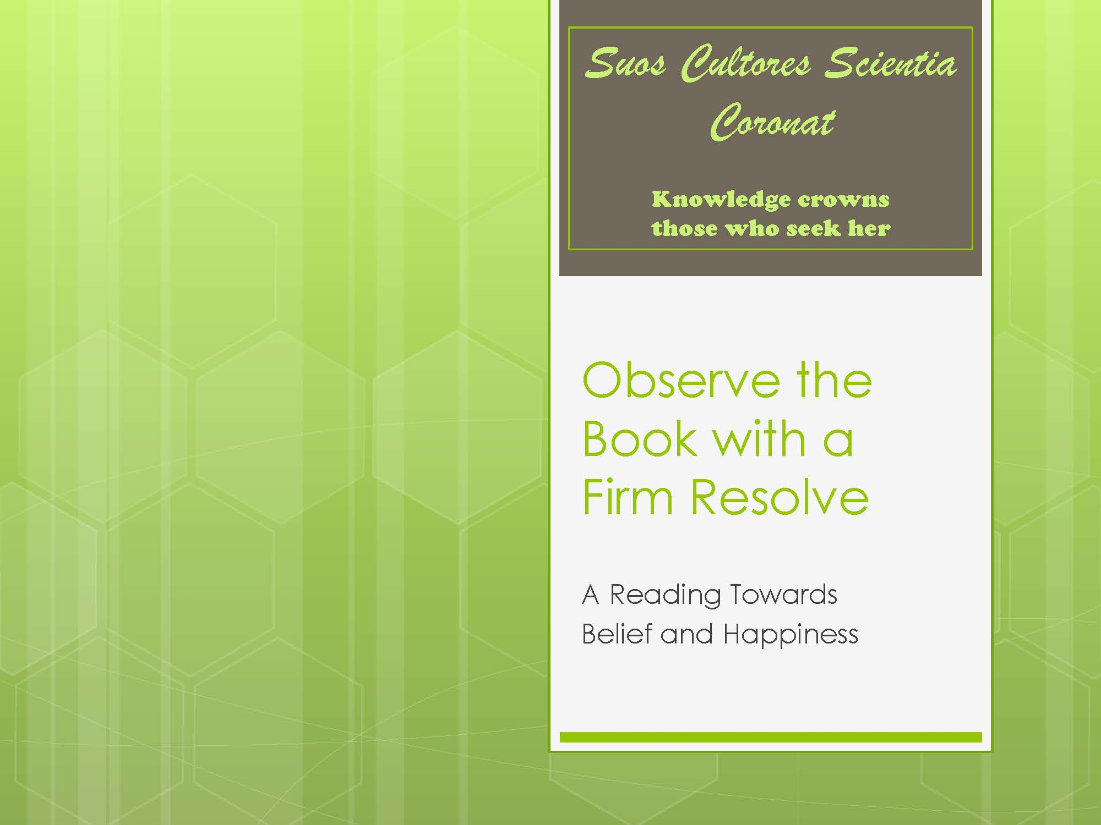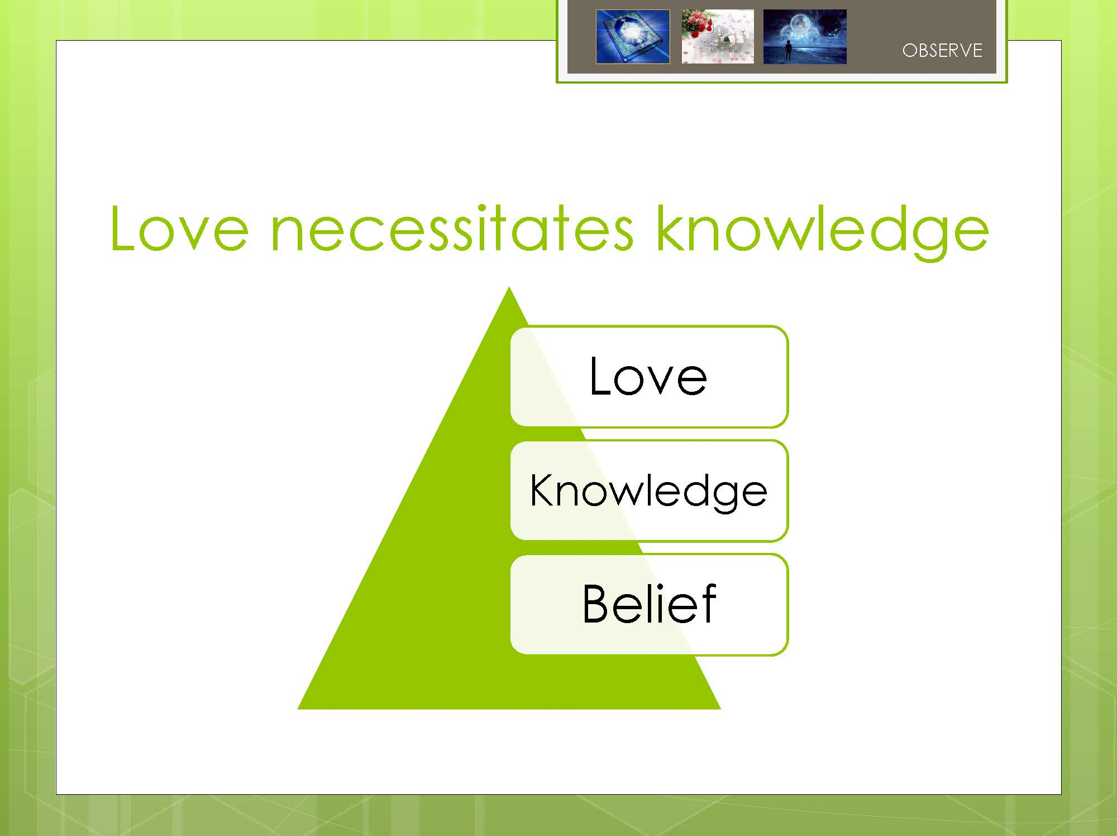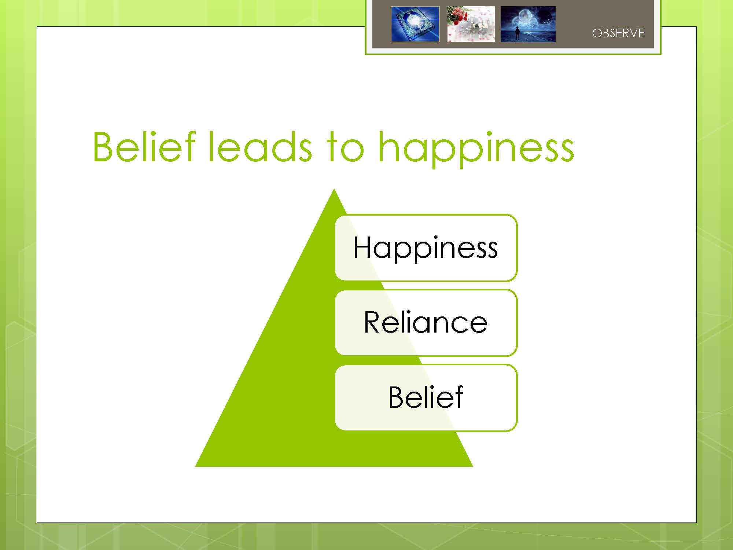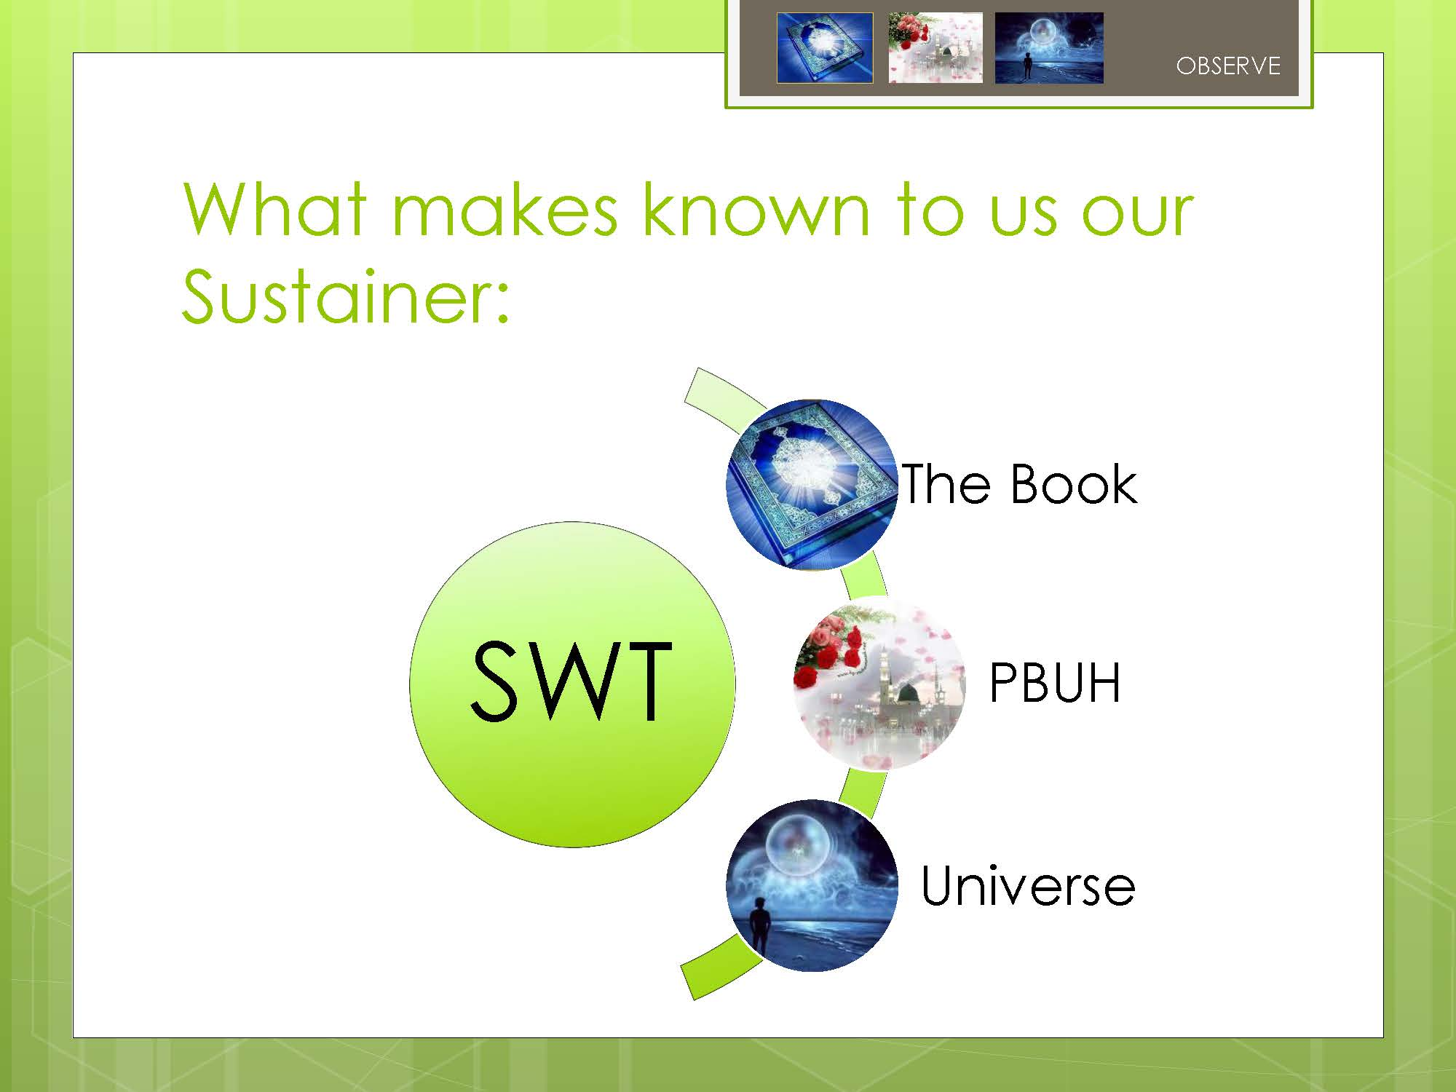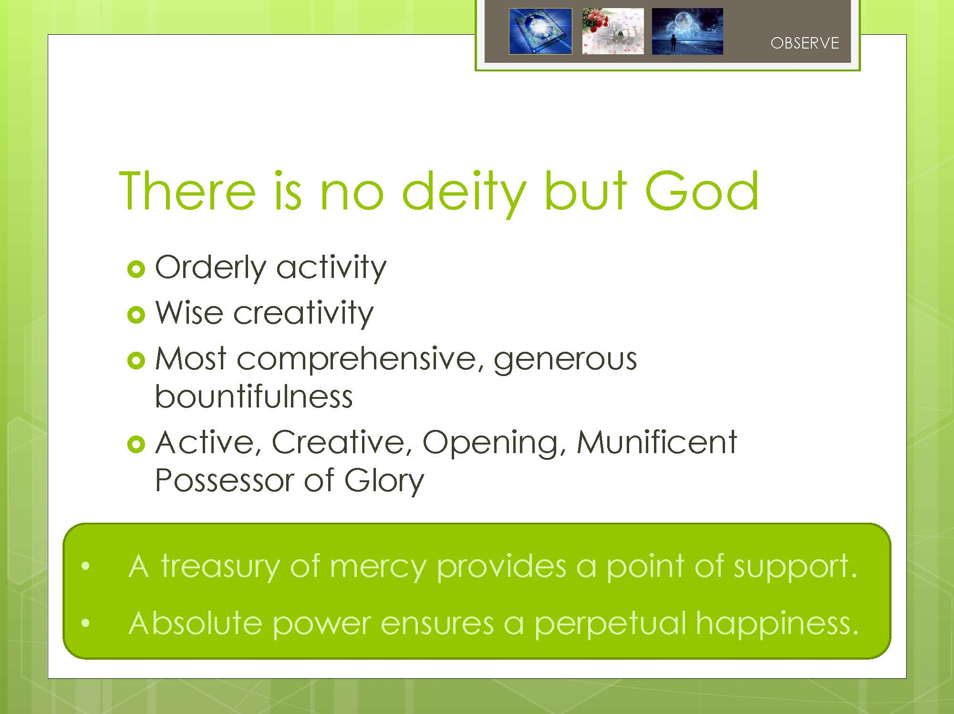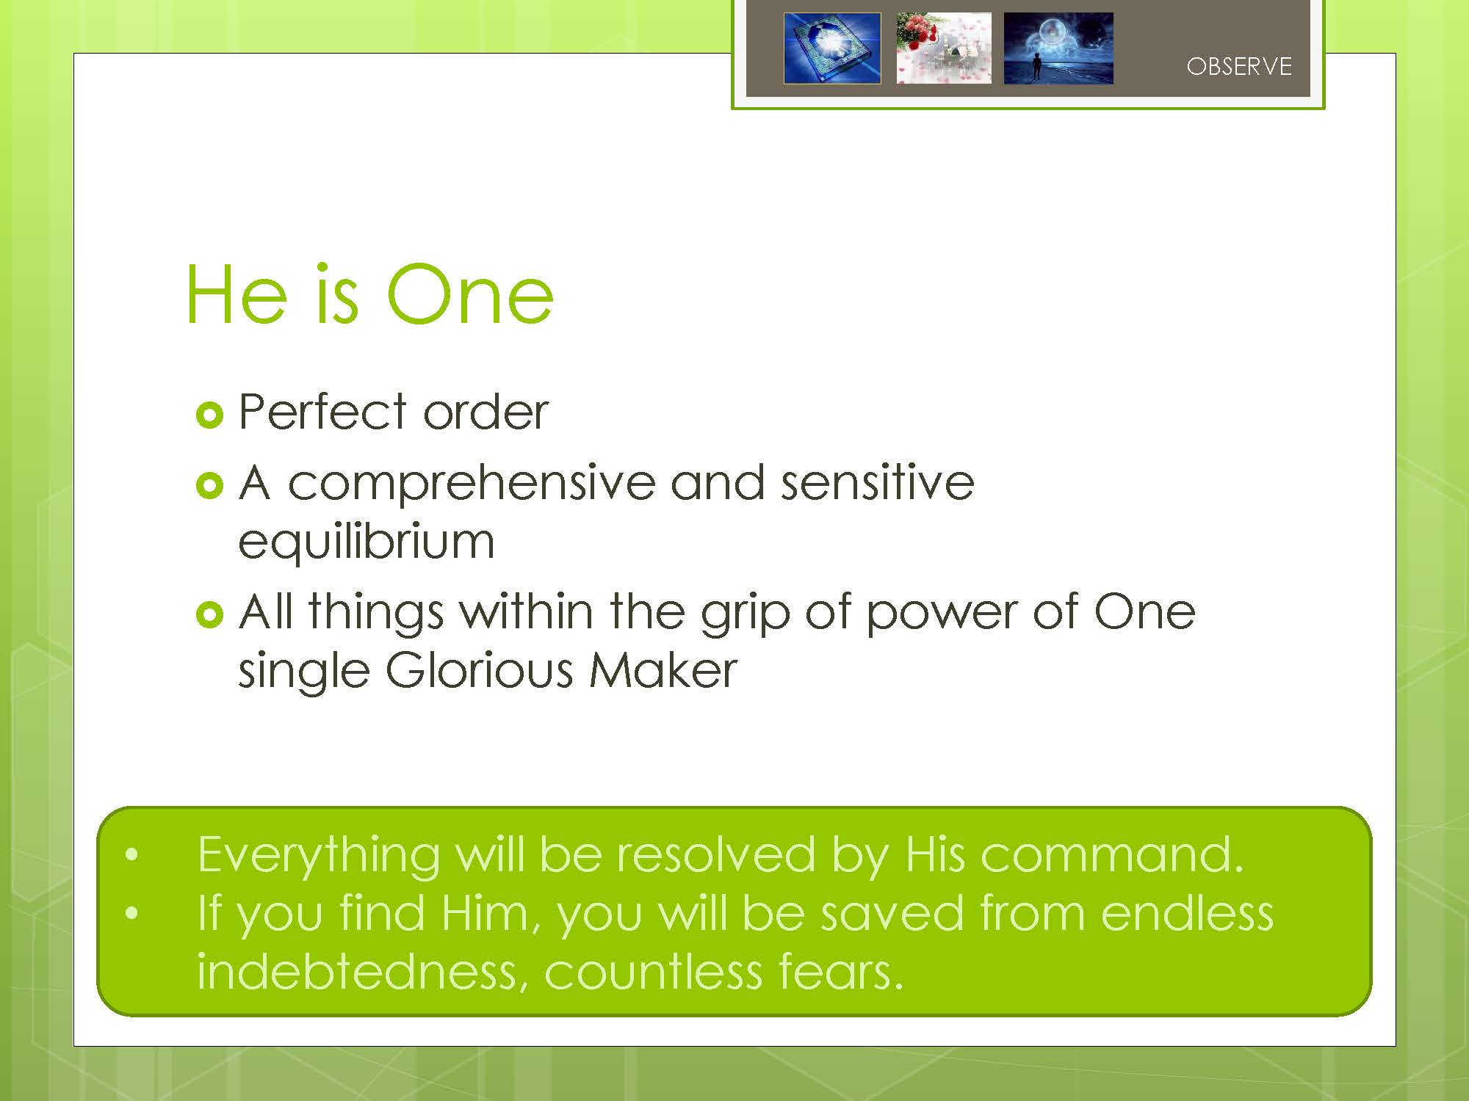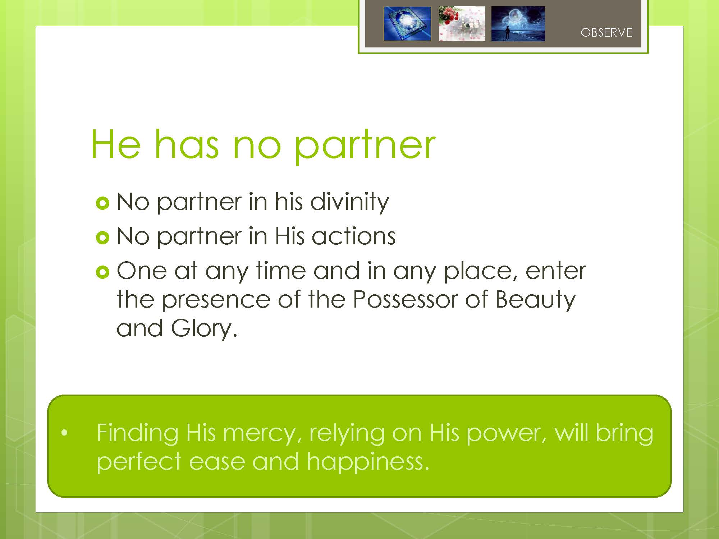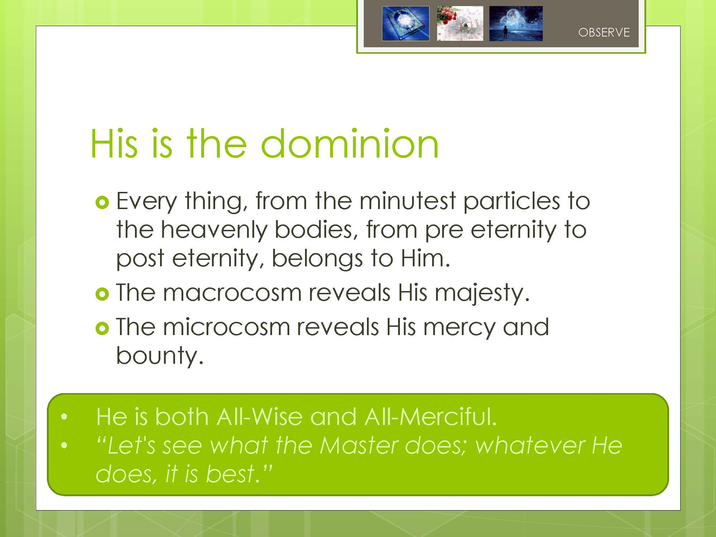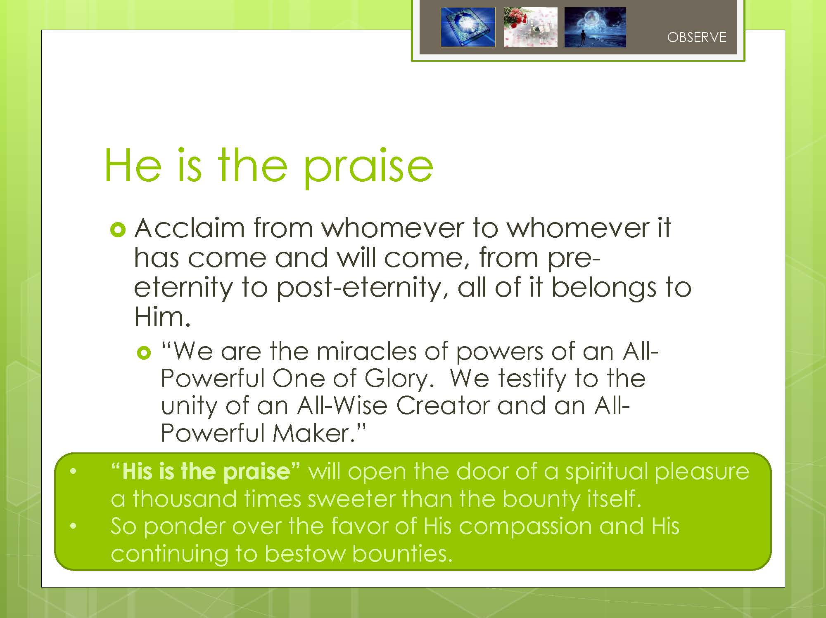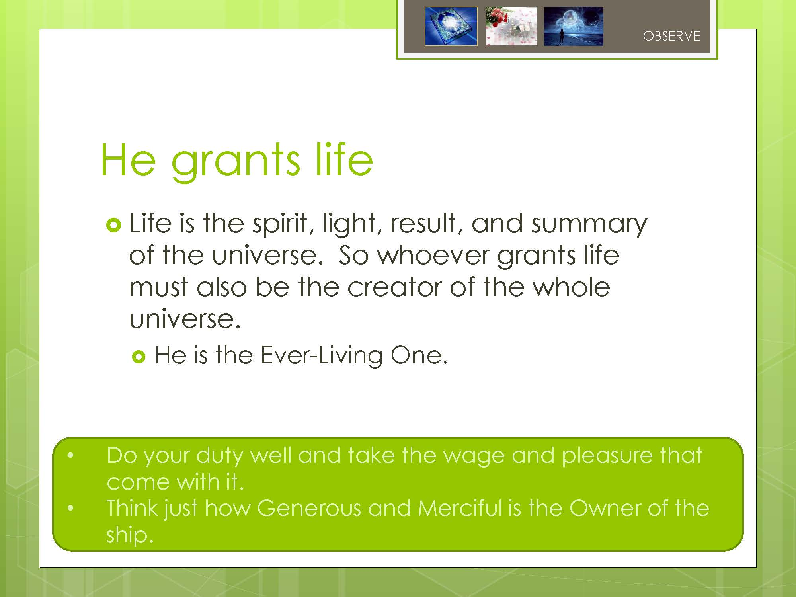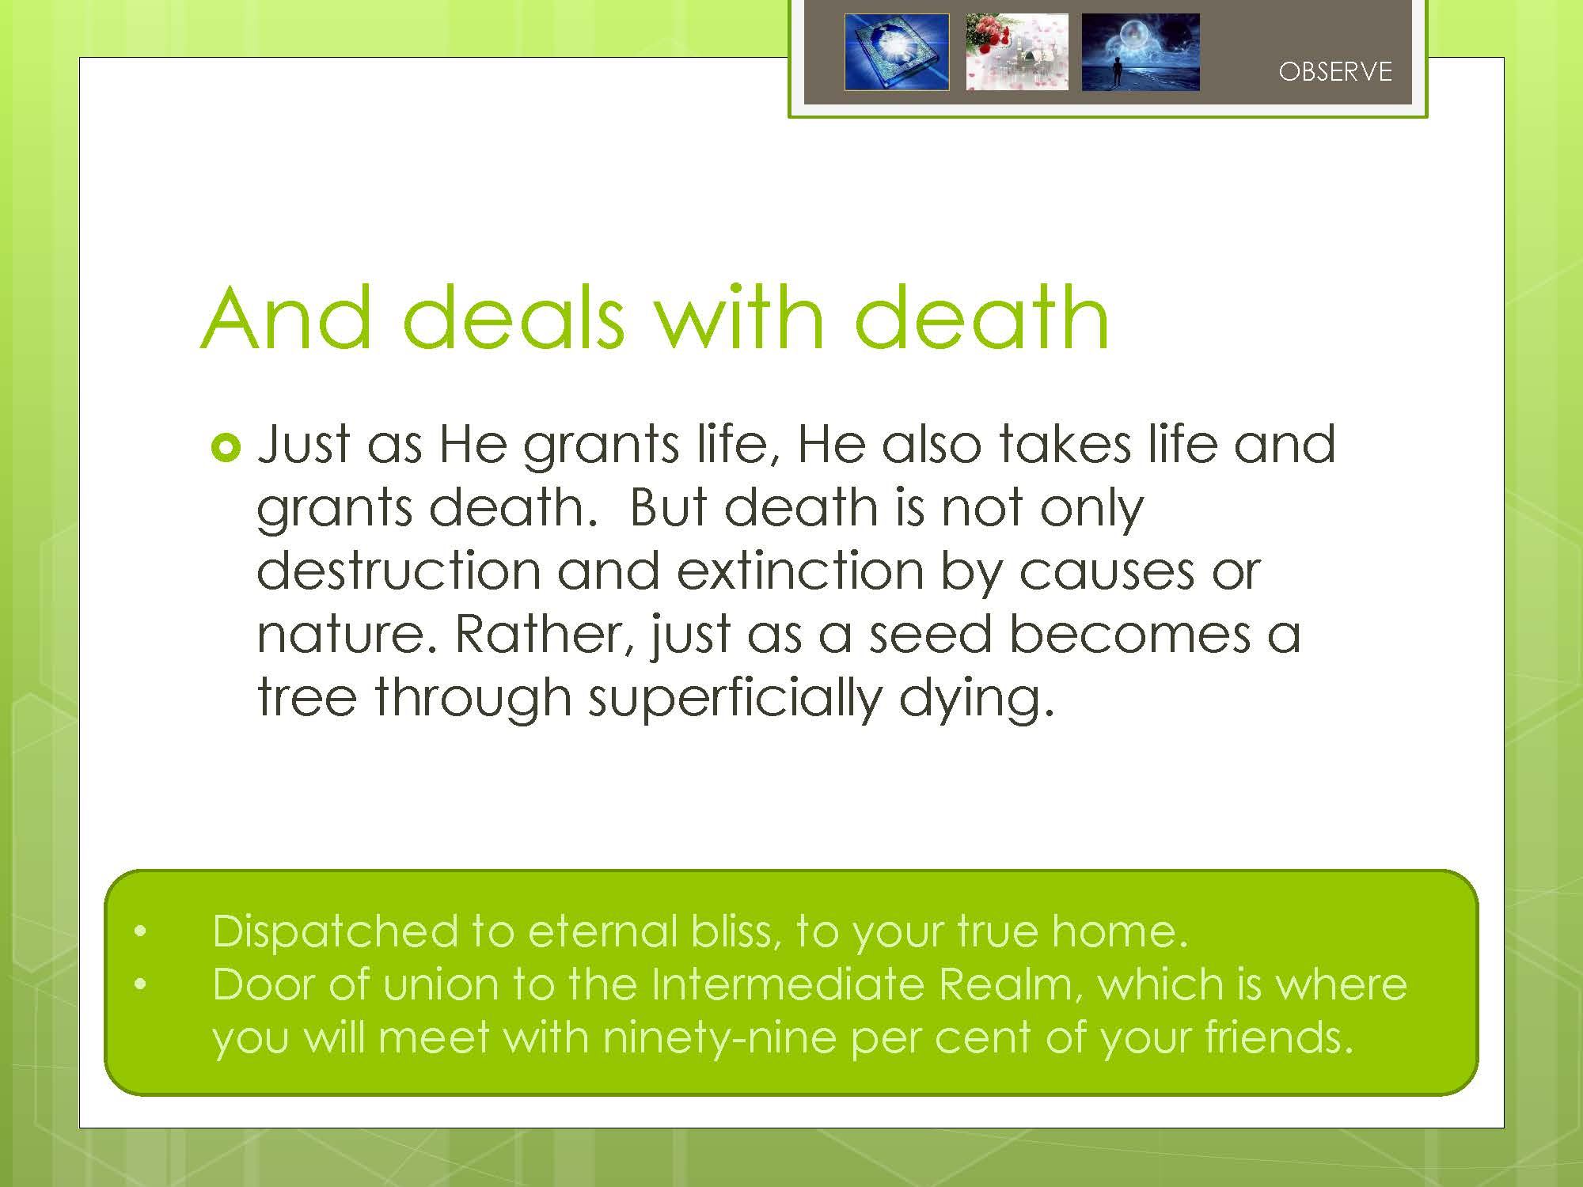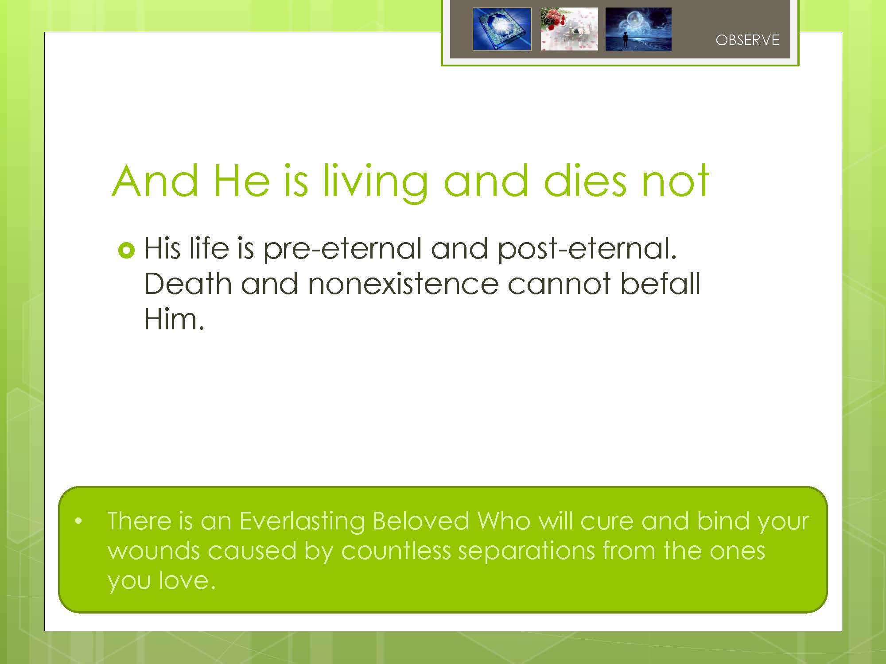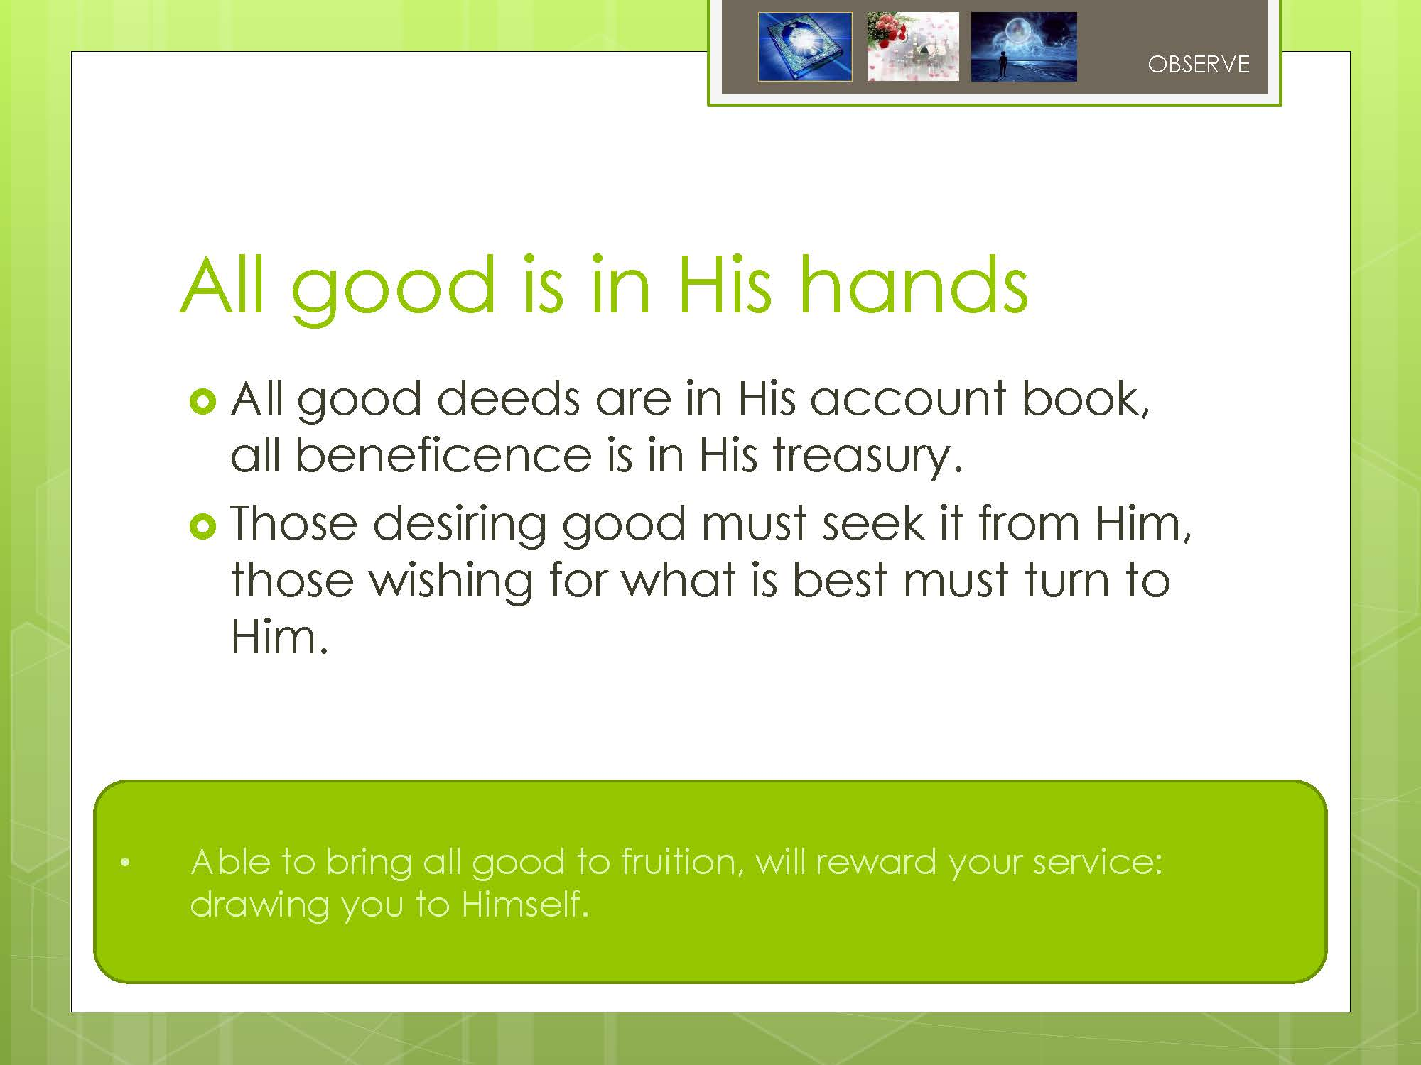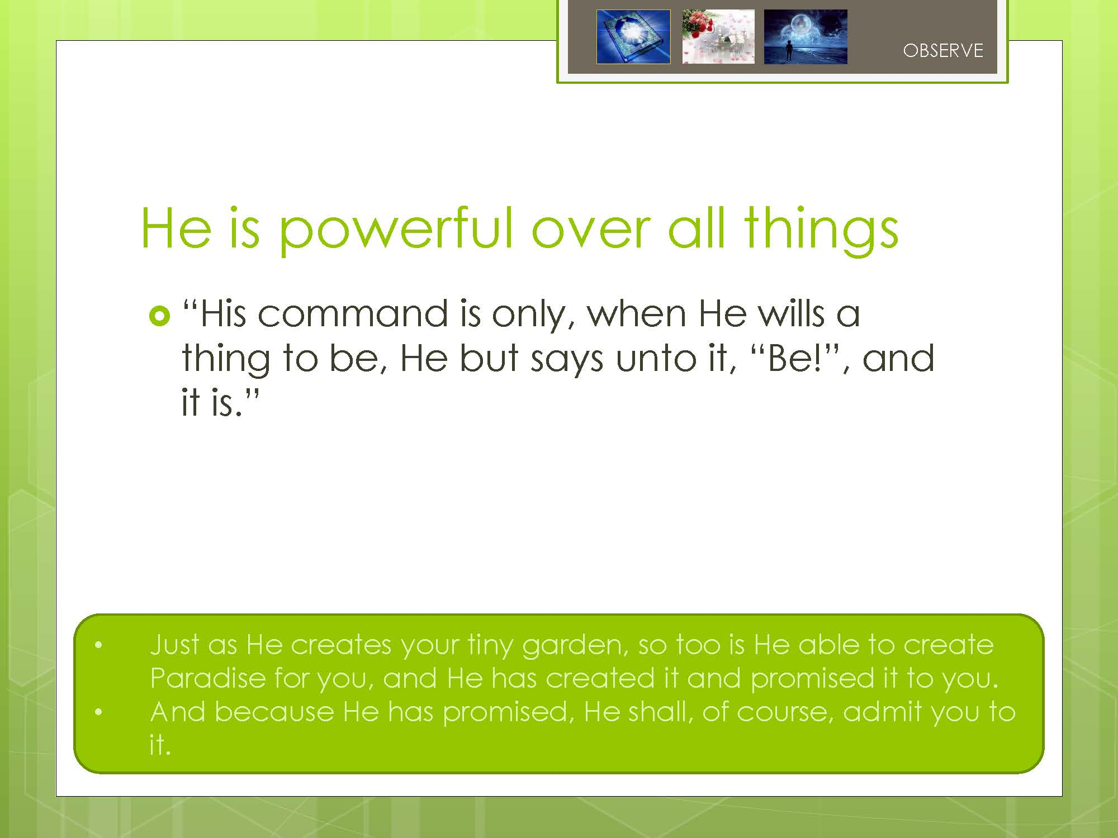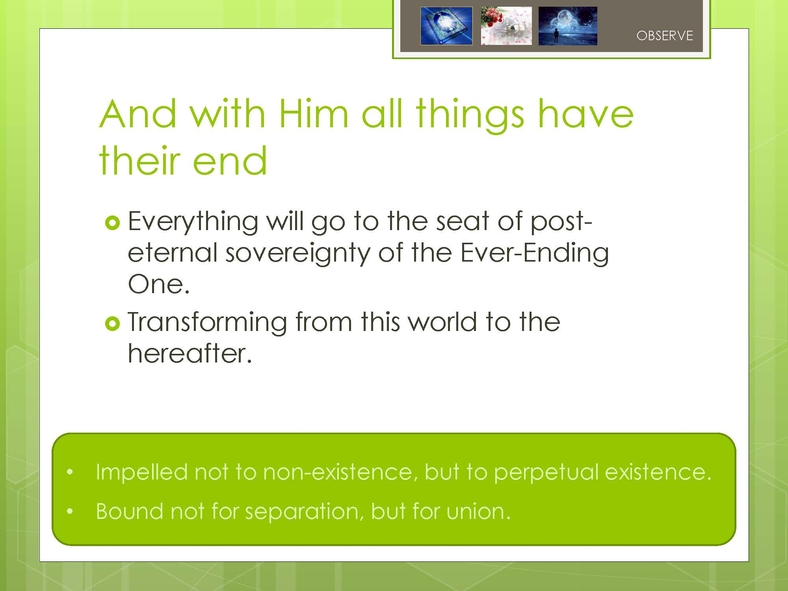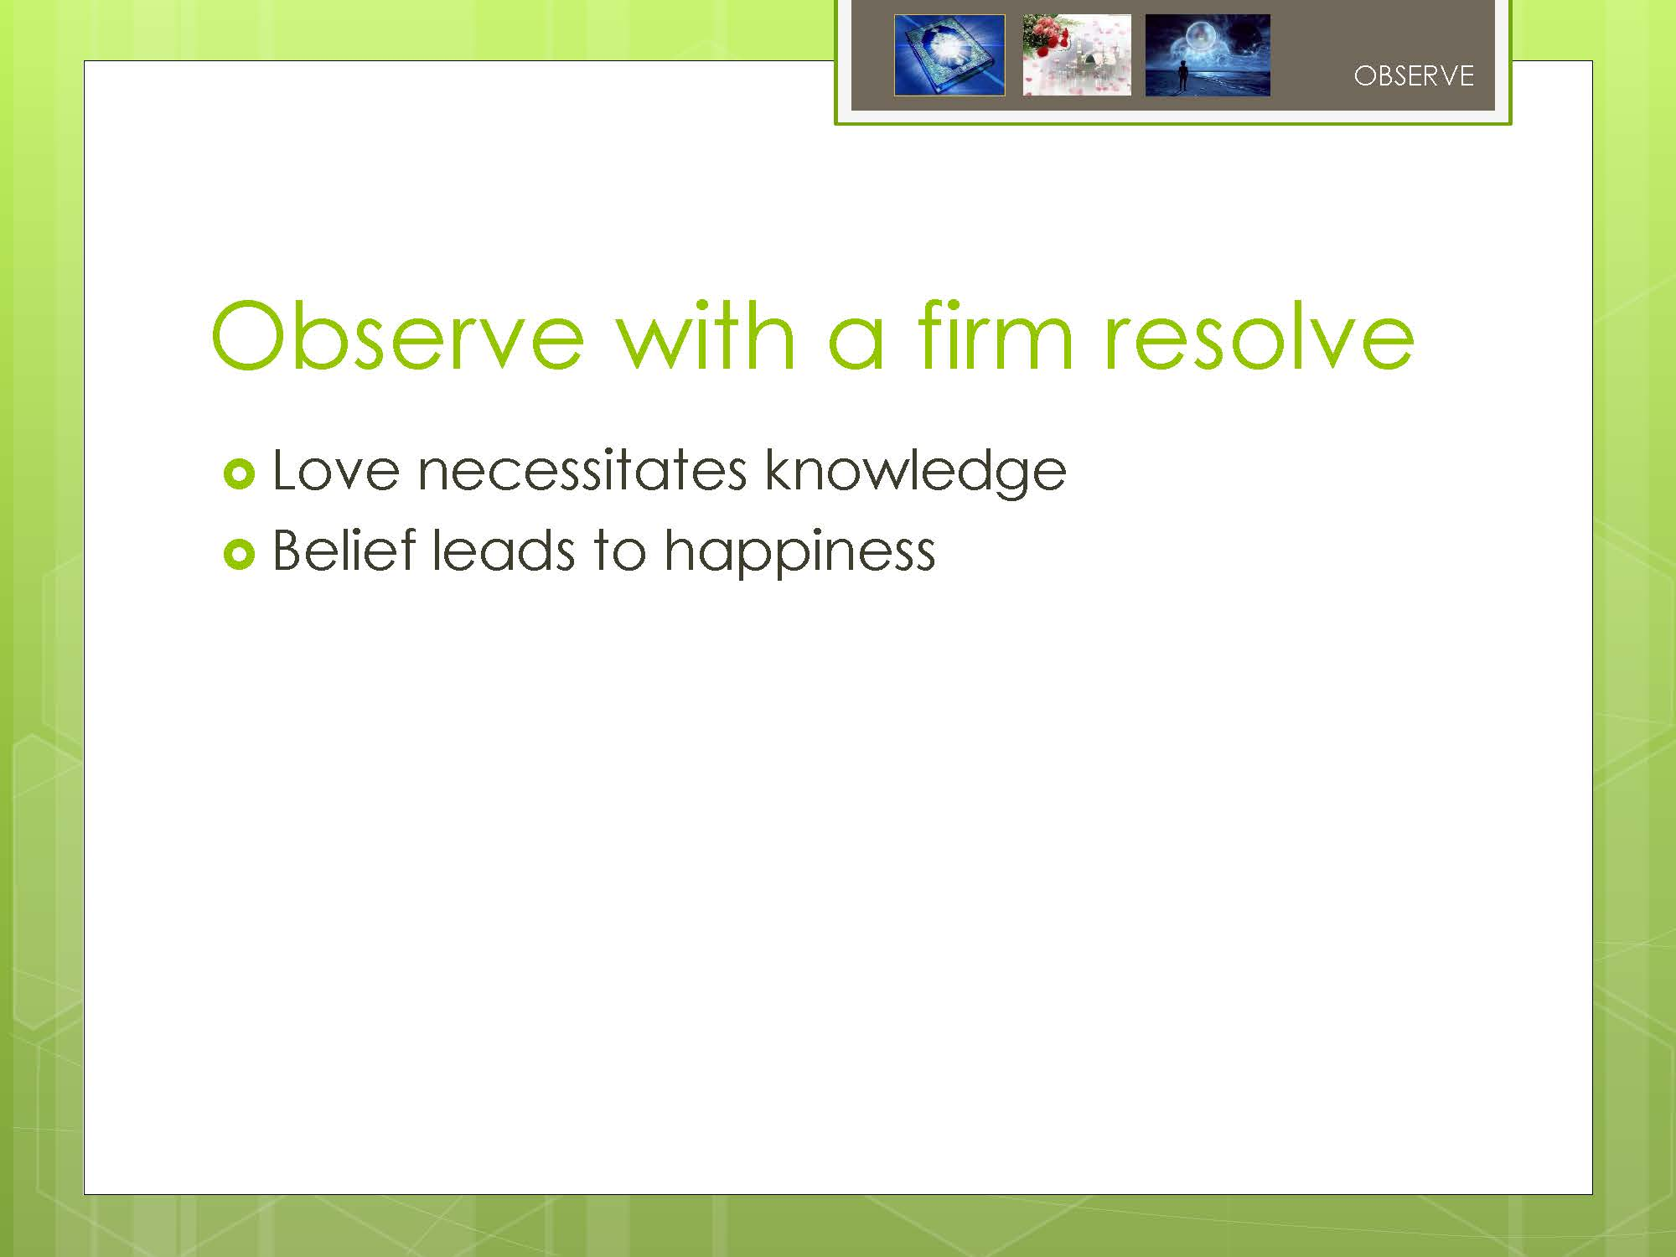

From the 27th Letter, The Letters, BSN
From the 20th Letter, The Letters, BSN
From the 19th Word, The Words, BSN

