**بِسْــمِ الله الرَّحْمنِ الرَّحِيم**

**اَلْحَمْدُ للهِ. اَلْحَمْدُ للهِ. اَلْحَمْدُ للهِ الَّذِى هَدَانَا لِهذَاوَمَا كُنَّا لِنَهْتَدِيَ لَوْ لاَ أَنْ هَدَانَا اللهُ. وَ مَا تَوْفِيقِي وَ لاَ اعْتِصَامِي إِلاَّ بِاللهِ. عَلَيْهِ تَوَكَّلْتُ وَ إِلَيْهِ أُنِيبُ.**

**أَشْهَدُ أنْ لاَ إِلهَ إِلاَّ اللهُ وَحْدَهُ لاَ شَرِيكَ لَهُ وَ لاَ نَظِيرَ لَهُ وَ لاَ مِثَالَ لَهُ. اَلَّذِى لاَ أُحْصِي ثَنَاءً عَلَيْهِ. كَمَا أَثْنَي عَلَى نَفْسِهِ. عَزَّ جَارُهُ وَ جَلَّ ثَنَاؤُهُ وَ لاَ يُهْزَمُ جُنْدُهُ وَ لاَ يُخْلَفُ وَعْدُهُ وَ لاَ إِلهَ غَيْرُهُ.**

**وَ نَشْهَدُ أَنَّ سَيِّدَنَا وَ سَنَدَنَا وَ مَوْلاَنَا مُحَمَّدًا عَبْدُهُ و حَِبيبُهُ وَ رَسُولُهُ. اَلسَّابِقُ إِلَى الأَنَامِ نُورُهُ. وَ رَحْمَةٌ لِلْعَالَمِينَ ظُهُورُهُ.**

**صَلَّى اللهُ تَعَالَى عَلَيْهِ وَ عَلَى آلِهِ وَ أَوْلاَدِهِ وَ أَزْوَاجِهِ وَ أَصْحَابِهِ وَ أَتْبَاعِهِ وَ أَحْفَادِهِ أَجْمَعِينَ.**

**أَمَّا بَعْدُ فَيَا عِبَادَ اللهِ؛ إِتَّقُوا اللهَ تَعَالَى وَ أَطِيعُوهُ. إِنَّ اللهَ مَعَ الَّذِينَ اتَّقَوْا وَ الَّذِينَ هُمْ مُحْسِنُونَ. فَقَدْ قَالَ اللهُ تَعَالَى فِي كِتَابِهِ الْكَرِيمِ.**

**أَعُوذُ بِاللهِ مِنَ الشَّيْطَانِ الرَّجِيمِ. بِسْــمِ الله الرَّحْمنِ الرَّحِيم**

Surat al Muddessir

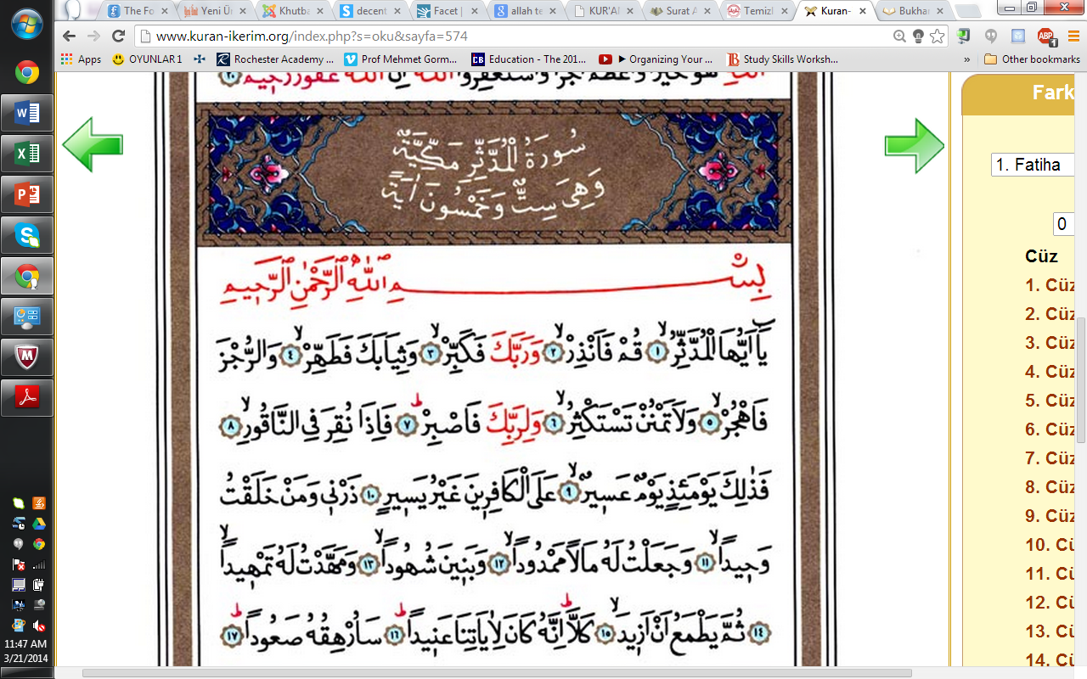

**Surat Al Baqara, v 222.**

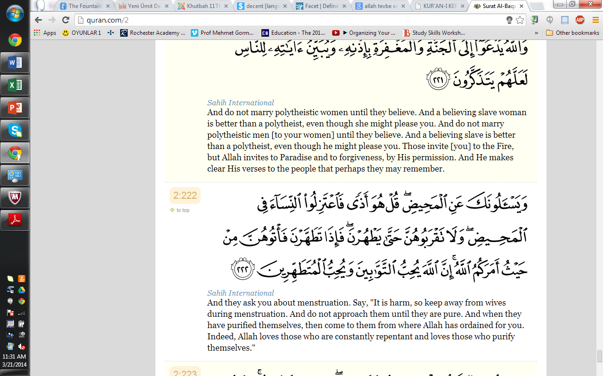



Abu Malik at-Ash'ari reported: The Messenger of Allah (may peace be upon him) said: Cleanliness is half of faith.**(Rawaahul Muslim filkitabittaharah)**

**CLEANLINESS AND DECENCY**

Islam is the only religion that provided guidance for all facets of the life of human being. It established the unity of Allah (Tawheed), jurisdiction and every sort of good morality the world has ever known. It is a religion that recognizes for all to consume good, wear decent dress, to appear in a beautiful form of looking. Cleanliness and beauty have become the second integral aspect of Islam after spiritual purity. Allah elaborated this in Surat Al-Muddathir, v 1-5: “O you (Muhammad SAW) enveloped (in garment)! Arise and warn! And your Lord (Allah) magnify! And your garments purify!  And all abomination shun! ” The scholars of tafseer pointed outthat, in this ayat, the word "SIYAB" not only means clothing but also refers to heart and soul, that is to say; purifying heart from every sort of polytheism (shirk) and injustice, contaminated emotions and feelings from heart and mind, innovation in religion, and possessing high level of morality (akhlaq) are related to purification of body, clothes and environment. Their evidence is the concept of the word "taharah". Instead of nazaafah, which means physical cleanliness, taharah is used in the ayat, which has a more comprehensive meaning including physical and spiritual cleanliness. Keeping our environment & our garments clean and also appearing decent are part of the purification and civilization that our religion of Islam brought to humanity thereby distinguishing its followers from the others. Indeed Allah has conferred a favour upon us on the blessing of dress. Allah SWT says in Al-A’araf, v; 26: “O you Children of Adam! Let not Satan seduce you, in the same manner as He got your parents out of the Garden, stripping them of their raiment (dress), to expose their shame: for he (Satan) and his tribe watch you from a position where you cannot see them: We made the evil ones friends (only) to those without faith.”.

And in the Hadith of Prophet Muhammad (SAW), narrated by Abu Hurairah (may Allah be pleased with him): the Messenger of Allah said: “The characteristics of the true tradition are five: circumcision, shaving the pubic region, depilating the armpits hair, clipping the nails, and cutting the moustaches short.” [Al-Bukhari. Volume; 4, Hadith Number; 5889]. Without Islam, we would not able to know what it means by cleanliness and decency. Mankind lived nude and naked but Islam taught them how to cover their private parts and to live life different from that of animals. These indeed will manifest the exemplary morality of Islam if put into practice by Muslims. Due to the significance of cleanliness and purity, it is being considered half of Eeman (Faith). Acceptance of Salat (Prayer), one of the pillars of Islam is conditional on cleanliness and purity (taharatunnajaasat, taharatulhadath). Narrated Salman Al-Farisi (Allah be pleased with him): the Prophet (SAW) said: “Whoever takes a bath on Friday, purifies himself as much as he can, then uses his (hair) oil or perfumes himself with the scent of his house, then proceeds (for the Friday prayer) and does not separate two persons sitting together in line (in the Mosque), then prays as much as (Allah has) written for him and then remains silent while the Imam is delivering the sermon, his sins in between the present and the previous Friday would be forgiven”[Al-Bukhari. Volume; 1, Hadith No: 883]

This measure of excellence is not only for the Universities or assembly/meeting places, but for the entire circle of Muslims’ life. It was narrated in the Hadith of Prophet Muhammad (SAW): purify your body, Allah will purify you, in deed no servant spends his night in purity, except an Angel spends that night with him praying: “O Allah forgive your servant, he has in deed spend the night in purity”. The Ummah (Nation) of Muhammad (SAW) will be recognized on the Day of Judgement by the shining of their faces and limbs. Muslim males are required to get circumcised to avoid faint traces of urine entrapped in the foreskin of the genitals. They are also instructed to trim their moustaches in order to avert oral intakes. Islam has directed attention in taking care of mouth by using any purifying agents. Brushing the teeth with toothpastes (once or twice a day) is very recent development of the near past, but Muslims are accustomed this practice for the past 1400 years, five times a day prior to each ablution. Apart from body, Islam requires a Muslim to keep his clothes, houses and streets clean. Muslims are asked to use clean water and keep it safe from impurities and pollution. Moreover, Islam instructed Muslims to maintain the cleanliness of the roads and streets.

This is considered a charity to ridding the streets of impurities and filth. In an authentic hadith, Muhammad A.S. said "Iman has 60 branches. The smallest branch is to clear obstacles and filth from the roads/streets." The Prophet (Peace be upon him) strictly warned against it and considered it one of the reasons to provoke Allah's curse and the people's curse, saying: "Beware of the three acts that cause others to curse you: relieving yourselves in a watering place, on foot paths or shaded places." (Abu Dawud). Wearing clean and good-looking dress is always required in Islam, though away from vying or Riya (showing up). Narrated Al-Ahwas Al- Jushami: Prophet Muhammad (SAW) saw me wearing a faded clothe. He (the Prophet) asked me: “do you have money?” I said: yes. He then asked me again: “where did you get it?” I said: from the camels and goats that Allah has given me. He (the prophet) said: “Allah loves to see the sign of his blessings on his servant”. That is if Allah gives you wealth, you should not be stingy with it to the extent you cannot even benefit yourself from it.

And in another Hadith on the authority of Abdullah bin Mas'ud that the Apostle of Allah (May peace be upon him), observed: “He who has in his heart the weight of a mustard seed of arrogance shall not enter Paradise.A companion said: Verily a person loves that his dress should be fine, and his shoes should be fine. Muhammad A.S. remarked: Verily, Allah is Graceful and He loves Grace. Arrogance is to disdain the truth (out of self-conceit) and contempt for the people. [narrated in Sahih Muslim. Hadith no: 164]. Therefore, there is a strong link between dress and fear of Allah, both are clothes (SIYAAB). Fear of Allah is the cloth that shields heart from Shirk, while dress covers our private part and beautifies us and distinguishes between us and animals. That is to say covering our body is not just a mere culture or something that western civilization brought like the way materialists and their like think, but it is a nature that Allah has created human being with and it is part of what He has ordered believers to do in order to earn His garden of Paradise.

Allah says: “O Children of Adam! Wear your beautiful apparel (dress) at every time and place of prayer: eat and drink: But waste not by excess, for Allah loves not the wasters. Say: Who has forbidden the beautiful (gifts) of Allah, which He has produced for His servants, and the things, clean and pure, (which He has provided) for sustenance? Say: They are, in the life of this world, for those who believe, (and) purely for them on the Day of Judgment. Thus do we explain the signs in detail for those who understand. Say: the things that my Lord has indeed forbidden are: shameful deeds, whether open or secret; sins and trespasses against truth or reason; assigning of partners to Allah, for which He has given no authority; and saying things about Allah of which you have no knowledge. To every people is a term appointed: when their term is reached (i.e. death), not an hour can they cause delay, nor (an hour) can they advance (it in anticipation).” [Al - A’araf, v31-34]

**أَلاَ إِنَّ أَحْسَنَ الْكَلاَمِ وَ أَبْلَغَ النِّظَامِ. كَلاَمُ اللهِ الْمَلِكِ الْعَزِيزِ الْعَلاَّمِ. كَمَا قَالَ اللهُ تَبَارَكَ وَ تَعَالَى فِي الْكَلاَمِ. وَ إِذَا قُرِئَ الْقُرْآنُ فَاسْتَمِعُوا لَهُ. وَ أَنْصِتُوا لَعَلَّكُمْ تُرْحَمُونَ. أَعُوذُ بِاللهِ مِنَ الشَّيْطَانِ الرَّجِيمِ. بِسْـمِ اللهِ الرَّحْمنِ الرَّحِيمِ:**

**إن الدين عند الله الإسلام**

**اَلْحَمْدُ للهِ. اَلْحَمْدُ للهِ. اَلْحَمْدُ للهِ حَمْدَ الْكَامِلِينَ كَمَا أَمَرَ. نَشْهَدُ أَنْ لاَ إِلهَ إِلاَّ اللهُ وَ نَشْهَدُ أَنَّ مُحَمَّدًا عَبْدُهُ وَ رَسُولُهُ النَّبِيُّ الْمُعْتَبَرُ. تَعْظِيمًا لِنَبِيِّهِ وَ تَكْرِيمًا لِفَخَامَةِ شَانِ شَرَفِ صَفِيِّهِ. فَقَالَ اللهُ عَزَّ وَ جَلَّ مِنْ قَائِلٍ مُخْبِرًا وَ آمِرًا: {إِنَّ اللهَ وَ مَلاَئِكَتَهُ يُصَلُّونَ عَلَى النَّبِيِّ. يَا أَيُّهَا الَّذِينَ آمَنُوا صَلُّوا عَلَيْهِ وَ سَلِّمُوا تَسْلِيمًا}. لَبَّيْكَ...**

**{ إِنَّ اللهَ يَاْمُرُ بِالْعَدْلِ وَ الإِحْسَانِ وَ إِيتَاءِ ذِي الْقُرْبَي وَ يَنْهَي عَنِ الْفَحْشَاءِ وَ الْمُنْكَرِ وَ الْبَغْيِ. يَعِظُكُمْ لَعَلَّكُمْ تَذَكَّرُونَ }**

**(An-Nahl, 16/90**) Allah enjoins justice (and right judgment in all matters), and devotion to doing good, and generosity towards relatives; and He forbids you indecency, wickedness, and vile conduct (all offenses against religion, life, personal property, chastity, and health of mind and body). He exhorts you (repeatedly) so that you may reflect and be mindful!