Eid Al-Adha

Today is a day of celebration: and as Muslims we should feel great joy today. But what is the reason for our celebration? Today is Eid Al-Adha – the celebration of the sacrifice. And this is the season of Hajj – when the Muslims have come from around the world to the house of Allah in humility and submission.

In Islam we have three Eids: three celebrations – the Eid of Al-Fitr after Ramadan, the Eid Al-Adha that we are in now, and the Eid of Jumuah every Friday.

The Eid Al-Fitr is really a celebration that we were able to pass the test of Ramadan – that we submitted to our Allah, followed his commandments.
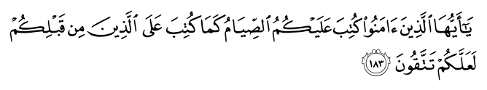
O you who believe! Observing As-Saum (the fasting) is prescribed for you as it was prescribed for those before you, so that you may have fear of God…2.183 sūrat l-baqarah (The Cow)

The Eid of Jumuah is a celebration that we were able to follow Allah's commandment to;
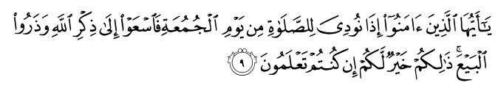
O you who have believed, when [the adhan] is called for the prayer on the day of Jumu'ah [Friday], then proceed to the remembrance of Allah and leave trade. That is better for you, if you only knew.62.9 sūrat l-jumuʿah (Friday)
And now we turn to the Eid that is upon us: Concerning the act of sacrifice, Allah(S) says

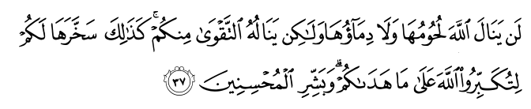

Their meat will not reach Allah, nor will their blood, but what reaches Him is piety from you. Thus have we subjected them to you that you may glorify Allah for that [to] which He has guided you; and give good tidings to the doers of good.22.37 sūrat l-ḥaj (The Pilgrimage)
So Allah has qualified sacrifice as an act that demonstrates TAQWA (piety, god-consciousness). And why does sacrifice do this? How does the sacrifice of an animal demonstrate piety? The essential element here is that Allah asks man to give something up – an animal that he owns, for no reason other than Allah has commanded it.
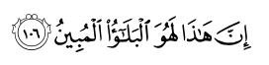
Indeed, this was the clear trial.37.106 sūrat l-ṣāfāt (Those Ranges in Ranks)
So the trial that was placed on Ibrahim is very clear – and a story that we can gain much from. After his people tried to burn him in the fire, and Allah saves Ibrahim, Ibrahim asks Allah for righteous offspring. And then Allah grants him this child. And we all know that soon after Ismail is born, Ibraheem his commanded to leave the baby and his mother in the middle of the desert all alone. But Ibraheem would travel back occasionally to visit the family. And after some time has passed, and Ibrahim has watched his child grow from infancy into a young lad that can now accompany his father – Ibrahim has a dream. Allah says

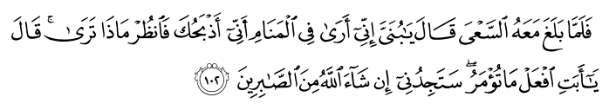
And when he reached with him [the age of] exertion, he said, "O my son, indeed I have seen in a dream that I [must] sacrifice you, so see what you think." He said, "O my father, do as you are commanded. You will find me, if Allah wills, of the steadfast.37.102 sūrat l-ṣāfāt (Those Ranges in Ranks)

And we know, as the Prophet Muhammad(S) said, that the dreams of the Anbiya (the prophets) are true, so as soon as he had seen this dream, he knew that it was true and that this dream was revelation from Allah.

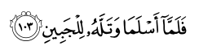
And when they had both submitted and he put him down upon his forehead, 37.103sūrat l-ṣāfāt (Those Ranges in Ranks)
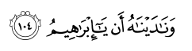
We called to him, "O Abraham, 37.104 sūrat l-ṣāfāt (Those Ranges in Ranks)
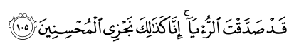
You have fulfilled the dream (vision)!" Verily! Thus do we reward the Muhsinun (good-doers - see V.2:112). 37.105 sūrat l-ṣāfāt (Those Ranges in Ranks)

Brothers and Sisters this is the essence of our religion, this is Islam. If we call ourselves Muslims, this level of submission is something we must strive to possess. Although our tests will surely not be as great as those Ibrahim faced, we will assuredly have them, and we must pass them. So this Eid is a reminder of the essence of submission. What Ibrahim did is what we must do: Submit to the commands of Allah, and obey him. Wherever that command finds us, in whatever condition, the response of our hearts must be submission.

The Prophet (peace and blessings of Allaah be upon him) said: “Islam is built on five(pillars): testimony that there is no god except Allaah and that Muhammad is the Messenger of Allaah, establishing regular prayer (salaah), paying the zakaah, fasting in Ramadaan, and pilgrimage to the House.

These commandments are for us from our Allah. We should obey and submission to Allah..

