"
Dear Brothers and Sisters In Islam!
Today, I want us to focus on four diseases and how we can cure them.

As we learn from the Holy Quran, The Devil was removed from the mercy of Allah and also from the Cenneh.
So The Devil has been a clear enemy and attacking us in many different ways. ELABORATE!!!

First disease: Despair
Those who fear the punishment of Hell and cannot
fulfill their duty of servanthood to God desire the non-existence of punishmentand an argument against it. When they see signs that seem to confirmsuch an argument, they begin to be recruited by devils into their legions.

If you are in such a state, give a sincere and attentive ear to the following
Qur’anic verse:

In SuratAzZumer verse 53:

Second disease: Self-admiration (due to good deeds)
When despair causes us to look for support against Hell’s punishment, we lookat our good deeds and deviate into self-admiration. In reality, we have no rightto own our good deeds. Also, you have no right to claim ownership of yourbody, for you neither created it nor found it on the way, and it is neither theresult of blind chance nor the product of lifeless causes. Rather, through itsamazing design and the marvels of the art it exhibits, your body testifies thatit is the handiwork of an All-Wise Maker Who continually looks after it.

Our part in our body’s operations is mi-nute. Although humanity is the
noblest cause and has the most comprehensive willpower among creation,
the amount of free will we exercise is quite small. The area for freedom of
action is, despite its apparent comprehensiveness, very narrow. If reason cannotcontrol such a faculty as imagination, how can other faculties be consideredwithin the realm of human free will? How can anyone take personalpride in them?

Furthermore, many things work for or against us. Although we might be
unaware of many of them, they evidently serve many deliberate purposes.
This means that the One Who causes them to occur is an All-Hearing, All-
Seeing One with infinite consciousness, and not the individual or other deaf
and blind causes. Thus there is no reason to claim personal ownership of gooddeeds, for one’s share in them is quite limited.We are rather susceptible to the faults and defects engendered by misusingour free will. Such misuse changes the quality of the virtues pouring intothe world due to the incessant manifestations of Divine Perfections. Your body,your dwelling place, is a free loan in which you are a guest. Good deeds aregifts [that the Almighty enables us to do]; sin and evil are the result of misusedwillpower.

So say: LEHUL MULKU VELEHUL HAMD VELA HAVLE VELA QUVVETE ILLA BILLAH:

He owns (all things in the universe), to Him is allpraise, and there is no power and strength except with Him.

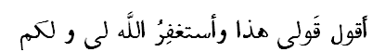

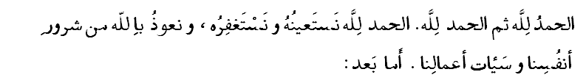

Third disease: Vanity

Vanity causes a “distant view” of past virtuous (morally excellent role models) and illustrious (highly distinguished)individuals and causes people to belittle them. Such people are deprived ofthe blessing and benefits coming from their good deeds and virtues, for theyare blinded by illusion and have a negative opinion of them.

So, [to eradicate this disease], view them closely and see how in 40 days they accomplishedwhat we cannot accomplish in 40 years.

Fourth disease: Suspicion
Suspicion of others causes people to think that others suffer the same defectsand vices that they do. This view causes them to condemn everyone and blindthemselves to the virtues of present and past illustrious people, from whomthey could derive some benefit. Thus they turn daylight into night for themselves.May God save us from despair, self-admiration, vanity, and suspicion.Amen.

Indeed, Allah orders justice and good conduct and giving to relatives and forbids immorality and bad conduct and oppression. He admonishes you that perhaps you will be reminded. Aqimissalah! ……

