PILGRIMAGE (HAJJ)

QUR’AN

Sura Bakara/Ayat 196:
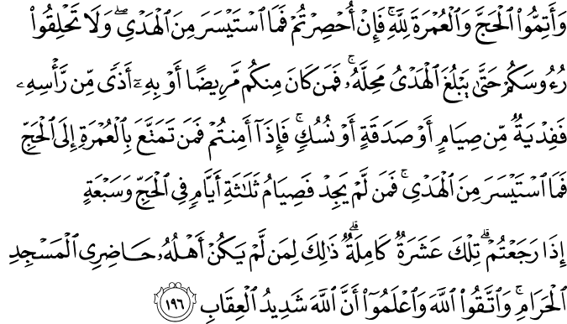
Complete the Hajj (the Major Pilgrimage) and the ‘Umrah (the Minor Pilgrimage) for God, and if you are impeded (after you have already put on the Pilgrimage attire), then send (to Makkah) a sacrificial offering you can afford. Do not shave your heads (to mark the end of the state of consecration for the Pilgrimage) until the offering has reached its destination and is sacrificed. However, if any of you is ill (so that he is obliged to leave the state of consecration) or has an ailment of the head, he must make redemption by fasting, or giving alms, or offering a sacrifice. When you are secure (when the Pilgrimage is not impeded, or the impediment is removed), then whoever takes advantage of the ‘Umrah before the Hajj must give a sacrificial offering he can afford. For whoever cannot afford the offering, a fast for three days during the Hajj, and for seven days when you return home, that is, ten days in all. This is for those whose families do not live in the environs of the Sacred Mosque. Act in due reverence for God and piety (avoiding disobedience to Him and obeying His ordinances), and know that God is severe in retribution.(1)

SuraBakara/Ayat 197:
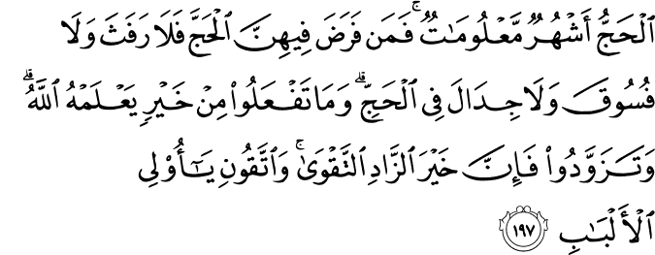
The Hajj is in the months well-known.¹⁴¹ Whoever undertakes the duty of Hajj in them, there is no sensual indulgence, nor wicked conduct, nor disputing during the Hajj. Whatever good you do (all that you are commanded and more than that, especially to help others), God knows it. Take your provisions for the Hajj (and do not be a burden upon others). In truth, the best provision is righteousness and piety, so be provided with righteousness and piety to guard against My punishment, O people of discernment!(2)

(1) 2:196/The Quran with Annotated Interpretation in Modern English by Ali Unal
(2)2:197/The Quran with Annotated Interpretation in Modern English by Ali Unal

HADITH

Narrated Abu Huraira:

The Prophet was asked, "Which is the best deed?" He said, "To believe in Allah and His Apostle." He was then asked, "Which is the next (in goodness)?" He said, "To participate in Jihad in Allah's Cause." He was then asked, "Which is the next?" He said, "To perform Hajj-Mabrur.(3)

Narrated Abu Huraira:
The Prophet (p.b.u.h) said, "Whoever performs Hajj for Allah's pleasure and does not have sexual relations with his wife, and does not do evil or sins then he will return (after Hajj free from all sins) as if he were born anew." (4)

Narrated 'Aisha:
(the mother of the faithful believers) I said, "O Allah's Apostle! We consider Jihad as the best deed." The Prophet said, "The best Jihad (for women) is Hajj Mabrur. " (5)

(3) SahihBukhari, Volume 2, Book 26, Number 594
(4)SahihBukhari, Volume 2, Book 26, Number 596
(5)SahihBukhari, Volume 2, Book 26, Number 595
The Hajj:
Its Spiritual Meaning and Aspects of Worship
As one of the most spectacular religious assemblies in the world, the annual Muslim hajj (pilgrimage) to Mecca is more than just visiting holy lands and connecting with the historical legacy of Islam. There are important spiritual meanings enclosed within the rites of hajj, which has to be performed once in the lifetime of all adult Muslims who can afford the journey (Qur'an 3:197). Foremost in this consideration, hajj is a form of collective worship, and a way of establishing a strong bond with monotheism and its human legacy, respectively symbolized by the Prophet Abraham, and the first human and Prophet, Adam. Large scale phenomena, with almost similar religious zeal, can also be observed in the natural world. The Qur'anic verse, "All that is in the heavens and on the earth extols and glorifies God, for He is the Tremendous, the Wise," (57:1) tells us that all creatures of God glorify, praise and, hence, worship God in a language of their natural disposition. When a seed lifts a tall tree or a bud on a branch opens into a beautiful flower, they reflect the Power, Wisdom, and Glory of God. Just as this occurs individually when creatures display the wonders of the Creator and live in accordance with the purpose of their creation, they also worship God collectively by obeying the call of God in large numbers. All dramatic animal migrations, with their millions of creatures moving as one, and the synchronized blossoming of all plants in the spring, are examples of collective acts of worship in the natural world. In Africa, wildebeests migrate - tens of thousands of them, all going at the same time - to greener pastures in the continent's highland steppes. In North America, millions of monarch butterflies migrate thousands of kilometers every winter. A recent discovery spectacularly demonstrated that corals along the length of the Great Barrier Reef, on the east coast of Australia, germinate at the same time, even down to the hour. Similarly, Muslims also display a mass act of worship by hearing the invitation of God for pilgrimage, and turning up in their millions, at the same time and place. Cosmic objects and sub-atomic particles orbiting around a central point can be seen as another common act of worship expressed in the tongue of natural disposition. While electrons ceaselessly orbit the nucleus of an atom, the earth and planets tirelessly traverse space in an orbit around the sun. In turn, the solar system becomes the whirling dervish orbiting the centre of the Milky Way. It seems that circling a central point of reference is a universal act of worship. Muslims join in this cosmic mode of worship and synchronize with the whole universe and all existence by circling the Ka'bah as the reference point of monotheism. The central aims of worship – exalting, glorifying and praising God – are realized individually and collectively. Muslims exalt God by showing up in mass as though saying "O Lord! You are greater than my self and You are far exalted above the whole humanity; here we are ready to worship you in mass." They glorify God by going around the Ka'bah as though saying "just as we circle the single point of reference, the one and only Ka'bah, the oldest place of worship on earth, we only obey You, the Absolute One worthy of worship." They praise God through the collective supplication and remembrance of God in the plains of Mt Arafat. Muslims believe that the Ka'bah was the first place of worship built by the first human, and the first prophet, Adam. It was later rebuilt on the same foundations by Abraham and his son, Ishmail, and declared as a shrine dedicated to the belief and worship of one God (2:125-127) – the central tenet of monotheism. Abraham called on people to make pilgrimage to the site. Before the days of Islam, the Hebrew Bible confirmed the existence of this pilgrimage to Mecca: "O Lord Almighty, my King and my God. Blessed are those who dwell in Your house; they are ever praising You. Blessed are those whose strength is in You, who have set their hearts on pilgrimage. As they pass through the Valley of Beca, they make it a place of springs; the autumn rains also cover it with pools" (Psalms 84:4-6). The climax of Pilgrimage occurs on the plains of Mt Arafat, about twenty kilometers outside of Mecca. All pilgrims have to be present in this location at the same time, simulating the day of resurrection when all humanity will be gathered before the court of God. Everyone wears the same simple garment and supplicates to God with no distinction of race, color, wealth or status. Mt Arafat has a very significant place in the history of humanity. According to Islam, this is the place where the first man, Adam, and his partner, Eve, sincerely repented and received forgiveness for their mistake committed in Paradise. Similarly, Muslims repent for their sins and ask forgiveness in the same place. The plea and petition of millions of people at the same time is a compelling spiritual force that begs forgiveness. If three million people walked to the home of a president and asked for something, it would be impossible to ignore them. According to Prophet Muhammad, peace and blessings be upon him, God will not send away empty handed a pilgrim who sincerely asks for forgiveness. His or her sins will be wiped clean and they will attain the sinless state of a newborn. Over time, it has become a tradition for pilgrims to visit their family and friends before going for hajj, where they ask for forgiveness of any unsettled grievances or transgressions of human relations. While there are other spiritual meanings expressed within the rites of hajj , Muslims especially announce their commitment to God through the two fundamental aspects of hajj – the circumambulation of the Ka'bah and the collective prayer offered on the plains of Mt Arafat. As people from all races and nations gather at the spiritual epicenter of the world, they affirm their common paternal ancestry with Adam and their spiritual ancestry with Abraham, peace be upon them. Mehmet Ozalp is an author and PhD candidate at the University of Sydney, Australia. References 1- These quotations are mine. They are intended to express the sentiments of pilgrims. 2- In ancient times, Mecca was known as Bakkah. 3- Ghazzali, Ihya'ulUlumuddin, TugraNesriyat (Tr): Istanbul, Vol 1, 622. Hadith was narrated by Abu Hurayrah in Bukhari and Muslim hadith collections. Note that some scholars interpret this hadith to say that human rights violations are not included in this overarching forgiveness. 4- All rituals of hajj relate the story of Abraham, his son Ishmail, his wife Hagar and their dramatic ordeal to survive as monotheist in the largely polytheist world. Rituals of hajj include being present at Mt Arafat; circumambulation of the Ka'bah; offering ritual prayers after circumambulation; sa'y the fast walk between two hills; stopping at Muzdalifa on the first day of the festival; symbolic stoning Satan's pillars; wearing of ihram; and cutting of the hair at the end.

THE FOUNTAIN MAGAZINE

