Ritual Bathing (Ghusl) – Obligatory Acts & Performance

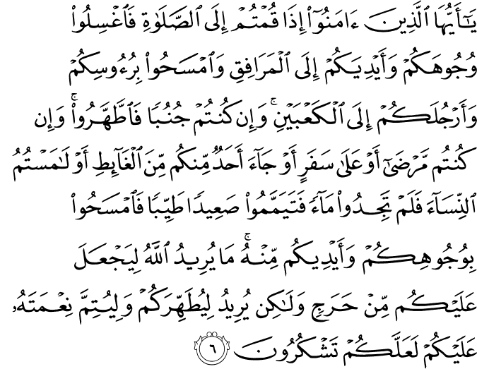

O you who believe! When you rise up for the Prayer, (if you have no ablution) wash your faces and your hands up to (and including) the elbows, and lightly rub your heads (with water), and (wash) your feet up to (and including) the ankles. And if you are in the state of major ritual impurity (requiring total ablution), purify yourselves (by taking a bath). But if you are ill, or on a journey, or if any of you has just satisfied a want of nature, or if you have had contact with women, and can find no water, then betake yourselves to pure earth, passing with it lightly over your face and your hands (and forearms up to and including the elbows). God does not will to impose any hardship upon you, but wills to purify you (of any kind of material and spiritual filth), and to complete His favor upon you, so that you may give thanks (from the heart, and in speech and action by fulfilling His commandments). (1)
----------------------------------------------------------------------------------------------------------

Abu Said al-Khudri, may Allah be pleased with him, reported that the Messenger of Allah, peace and blessings be upon him, said, “Doing ghusl (major ablution) on the day of Jumu’ah is obligatory for every male who has reached puberty.” (2)

I placed water for the bath of the Prophet. He washed his hands twice or thrice and then poured water on his left hand and washed his private parts. He rubbed his hands over the earth (and cleaned them), rinsed his mouth, washed his nose by putting water in it and blowing it out, washed his face and both forearms and then poured water over his body. Then he withdrew from that place and washed his feet. (3)
-------------------------------------------------------------------------------------------

Ghusl: The Complete Ablution

What is the meaning of ghusl?

Ghusl means washing the whole body (bathing). The Islamic meaning of ghusl is washing the entire body with clean water, ensuring that no area of the body remains dry. Another word for ghusl is the full ablution.

When must ghusl be performed?

There are three conditions of impurity that require ghusl, or full ablution:
1. The state of major impurity (junub). One of the states of major impurity is the emission of semen from the male sexual organ. This is the ejaculation of semen due to touching and the thought or sight of the opposite sex that sexually arouses a person.

Semen is a white thick substance emitted from the male sexual organ due to sexual lust. If a person who, after experiencing the emission of semen, performs ghusl immediately or before urinating and later notices even a tiny drop of semen discharged from the sexual organ, he must repeat the ghusl again. Ghusl is not necessary if the discharge of semen is not due to sexual lust.
Anyone who experiences the discharge of semen while sleeping must perform ghusl even if they cannot remember the wet dream or cause of the discharge. Ghusl is not necessary if a person wakes from sleep assuming they are in a state of impurity but sees no mark of semen on either the body or clothing.
Ghusl is not necessary if the emission of mazi (a clear, sticky prostatic fluid) occurs; this is emission from the sexual organ which is not due to sexual lust. However, this kind of emission does invalidate ablution. This may be because of the cold, an illness, or even lifting something heavy. On some occasions, a thick white cloudy substance known as wadi can sometimes be emitted from the sexual organ after urinating. This invalidates ablution, but does not invalidate ghusl. Ghusl is also obligatory for any man or woman following sexual intercourse.
2. The second case in which ghusl is necessary is due to bleeding after childbirth. This is called nifas. Performing ghusl is necessary for a woman whose bleeding ceases after the birth of a child.
3. The third case in which ghusl is obligatory is following the menstruation of women. Ghusl is necessary when the monthly menstrual bleeding of the woman ends. Non-menstrual vaginal bleeding after the completion of the monthly cycle is not, however, considered impure and thus does not necessitate repeating the ghusl.

In addition to the situations stated above, performing ghusl is necessary for every person who embraces Islam. A woman who embraces Islam during her menstrual period must perform ghusl immediately after her monthly cycle ends.

What are the fard (obligatory) acts of performing ghusl?

There are three obligatory acts of performing ghusl:
1. Filling and gargling the mouth with water once.
2. Breathing water up into the nostrils once.
3. Washing the entire body so that no area of the body remains dry.

What are the sunnah acts of performing ghusl?

1. Beginning ghusl by reciting the A‘ûdhu-Basmala.
2. Making the intention for performing ghusl.
3. Washing the hands up to the wrists and the sexual organ before beginning ghusl and then performing the ritual of ablution.
4. Following ablution, washing the head three times, then pouring water over the right, then the left shoulders three times.

Important Matters to Consider While Performing Ghusl

1. Water must reach the roots of the hair and beard.
2. Rings must be removed or moved to enable water to reach beneath the ring, and earrings in pierced ears must be moved so that water enters the holes.
3. It is necessary to cleanse the body of any substance which may prevent water from reaching the skin. Any material which does not absorb water, for instance, paint or nail polish must be completely removed. Coloring substances like henna and ink which do not prevent water from reaching the skin do not affect ghusl in any way.
4. If anyone realizes that the nose or mouth was not washed, or a certain part of the body remained dry after performing ghusl, washing the specific area is sufficient to validate the ghusl. Repeating the bath is not necessary.
5. Removing unwanted hair from the body or cutting the nails when the body is in a state of purity is more appropriate, but this does not affect the validity of the ghusl in any way.

How to Perform Ghusl

We begin by making the intention for ghusl, “I intend to perform the ritual of purification for the sake of God,” and after reciting the A‘ûdhu-Basmala, the sexual organ is washed to remove any impurities. Following this, the ritual ablution is performed just as it is for the prayer. Then finally the entire body must be washed, preferably rubbed so that no area of the body remains dry.

Only the obligatory acts of the ritual of purification may be executed if the person is short of time. First, by rinsing and gargling the mouth with water and taking water into the nostrils, and then by pouring water over the head, the right and left shoulders, and washing the entire body to ensure that no area remains dry. When water has reached every part the body and the individual is certain that there is no dry area remaining on the body, both the physical and spiritual purification of ghusl is complete.

Can we pray after ghusl without performing ablution?

The prayer or any form of worship can be performed without having to perform ablution after ghusl, and a person can continue to worship until any of the conditions that invalidate the ablution occurs. If a discharge which usually invalidates ablution, for example blood or urine, is emitted from the body during ghusl, the ghusl is not invalid. The individual is purified of the major impurity, but cannot perform the prayers or recite the Qur’ân in this state and is therefore required to perform ablution for worship. (4)

References:
(1) 5:6/The Quran with Annotated Interpretation in Modern English by Ali Unal
(2) Sahih al-Bukhari, Adhan, 161; Jumu’ah, 2; Sahih Muslim, Jumu’ah, 5
(3) Sahih al-Bukhari 257
(4) The Young Person’s Guide to Living Islam, Asli Kaplan, Tughrabooks

