Ablution (Wudu) – Obligatory Acts & Performance

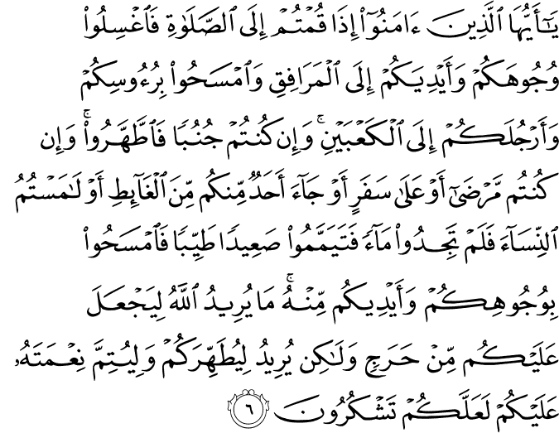

O you who believe! When you rise up for the Prayer, (if you have no ablution) wash your faces and your hands up to (and including) the elbows, and lightly rub your heads (with water), and (wash) your feet up to (and including) the ankles. And if you are in the state of major ritual impurity (requiring total ablution), purify yourselves (by taking a bath). But if you are ill, or on a journey, or if any of you has just satisfied a want of nature, or if you have had contact with women, and can find no water, then betake yourselves to pure earth, passing with it lightly over your face and your hands (and forearms up to and including the elbows). God does not will to impose any hardship upon you, but wills to purify you (of any kind of material and spiritual filth), and to complete His favor upon you, so that you may give thanks (from the heart, and in speech and action by fulfilling His commandments).(1)
----------------------------------------------------------------------------

Abu Hurayra, may Allah be pleased with him, reported that the Messenger of Allah, peace and blessings be upon him, said, “When the Muslim does wudu and washes his face, every wrong thing at which his eyes have looked leaves with the water—or with the last drop of water. When he washes his hands, every wrong thing which his hands have touched leaves with the water—or with the last drop of water. When he washes his feet, every wrong thing to which his feet have walked leaves with the water—or with the last drop of water, until he emerges cleansed of sins.” (2)

---------------------------------------------------------------------------------------------------------

What is a fard, or obligatory, duty?

These are the duties clearly prescribed by God and deemed obligatory upon every Muslim, namely the five daily prayers, the fast, giving prescribed alms, and so on. We gain reward for performing these obligatory duties; however, neglecting these duties is a huge sin. A human who rejects a fard, or obligatory duty, is rejecting one of the Divine commands and disobeying God and is therefore rejecting faith. The obligatory duties are divided into two categories, referred to as fard al-‘ayn and fard al-kifâyah. Fard al-‘ayn defines the duties every individual Muslim is required to perform according to the Islamic faith. These are duties that are a prescribed obligation of the individual, duties that do not cease to be the duty of individuals when carried out by others, for example the prayer and fasting. Fard al-kifâyah is a duty that is not prescribed upon the individual alone, but incurred upon Muslims as a (local) community. This obligation is fulfilled for all Muslims when performed by a few members of that community. However, if the entire community abstains from performing this communal obligation, all Muslims in that community are deemed responsible, and all will be classified as sinners. For example the funeral prayer, if the funeral prayer is performed by a group of the Muslim community, it ceases to be obligatory upon all, but if the whole community abstains from performing the funeral prayer, the entire community is responsible and considered sinners.

Ablution – The Purification of Spiritual Impurities

The word wudû’, or ablution, literally means water used to wash the hands and face. As a religious term described in the Qur’ân and traditions of the Prophet, ablution is purification of certain organs of the body with water or by performing tayammum (purification using sand or dust when water is not available).

Ablution is the means of physical and spiritual protection. A Muslim who performs ablution at least five times a day becomes accustomed to cleanliness which protects him from various cases of illness. The ritual purification is the means of expiating minor sins and conveys excellence and contentment to the soul. A person who regularly performs ablutions, or who is in the state of ritual purity at all times, will be more capable of guarding himself from evil thoughts and sin. The Prophet explained the virtues of ritual purification in one of the hadith: “Whoever performs the ritual of purification as prescribed, and then prays as prescribed, his past minor sins will be forgiven.”

The ritual ablution was deemed obligatory in this verse of the Qur’ân:

O you who believe! When you rise up for the Prayer, wash your faces and your hands up to the elbows, and lightly rub your heads (with water), and (wash) your feet up to the ankles. (Mâedah 5:6)

What are the fard (obligatory) acts of ablution?

There are four obligatory acts of ablution:
1. Washing the whole face, from the hairline to below the chin once.
2. Washing the hands and arms including the elbows once.
3. Wiping one fourth of the head with wet hands, also known as masah.
4. Washing the feet including the ankles once.

What are the sunnah acts of ablution?

It is Sunnah to perform the following acts of ablution:
1. Cleaning the teeth with a miswak or toothbrush before performing the ablution.
2. Reciting the A‘ûdhu-Basmala1 at the beginning of ablution.
3. Proclaiming the intention of performing the ablution.
4. Washing the hands up to the wrists three times.
5. Washing the limbs necessary in ablution three times each.
6. Rinsing the mouth and breathing water into the nostrils three times.
7. Performing the ablution in accordance with the order prescribed in the Qur’ân.
8. Washing the right limbs first.
9. Wiping the head from the forehead to the neck with wet hands.

1 A‘ûdhu-Basmala is the Arabic expression of A‘ûdhu billâhi min ash-shaytânirrajîm Bismillahir-Rahmânir-Rahîm. It means “I seek refuge in God from Satan eternally rejected (from God’s Mercy). In the Name of God, the All- Merciful, the All-Compassionate.”

10. Wiping the two ears and neck with wet hands.
11. While washing the hands and feet, beginning with the tips of the toe and fingertips.

Although abandoning any of the sunnah acts does not invalidate the ablution, it does reduce the reward for performing a sunnah of the Prophet. Therefore, when we perform the rituals of purification, we should follow the Prophet’s actions as an example just as we do in every aspect of our lives and worship.

Important Matters to Consider While Performing Ablution

1. Ensuring that no area of the limbs washed during ablution remains dry.
2. Removing any substance that could prevent water being absorbed into the skin or from coming into contact with the nails, such as clay, paint, and nail varnish.
3. Henna does not invalidate ablution as it does not prevent water from coming in contact with the skin or the nails.
4. While performing ablution, moving any rings on the fingers to ensure water reaches the skin beneath the rings.
5. Ensuring that the feet are washed up to the ankles.
6. Washing between the toes.
7. If any of the limbs to be washed during ablution has a wound or condition which may be harmed by water, wiping over the wound with wet hands is sufficient. However, it is unnecessary to wipe the wound if this too can cause harm.
8. If a wound or a limb of the body is covered with a bandage, and removing the bandage may be harmful, wiping over the bandage with wet hands is enough.
9. Although not abiding by the prescribed order of washing the organs does not invalidate the ablution, it does reduce the rewards for performing the purification.
10. Pausing while performing the ritual of purification is an undesirable act, but it does not invalidate the ablution.
11. A person who has lost the whole or part of a limb that must be washed during ablution should wash the existing part of the limb. (3)

Resources:
(1) 5:6/The Quran with Annotated Interpretation in Modern English by Ali Unal
(2) Sahih Muslim, Taharah, 32
(3) The Young Person’s Guide to Living Islam, Asli Kaplan, Tughrabooks

