Things That Nullify Ablution

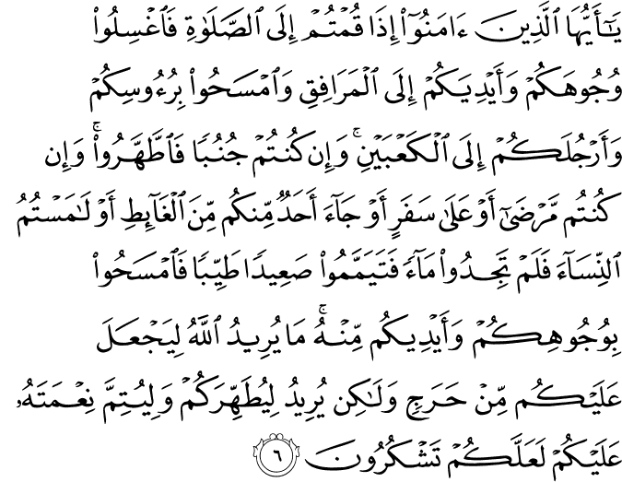

O you who believe! When you rise up for the Prayer, (if you have no ablution) wash your faces and your hands up to (and including) the elbows, and lightly rub your heads (with water), and (wash) your feet up to (and including) the ankles. And if you are in the state of major ritual impurity (requiring total ablution), purify yourselves (by taking a bath). But if you are ill, or on a journey, or if any of you has just satisfied a want of nature, or if you have had contact with women, and can find no water, then betake yourselves to pure earth, passing with it lightly over your face and your hands (and forearms up to and including the elbows). God does not will to impose any hardship upon you, but wills to purify you (of any kind of material and spiritual filth), and to complete His favor upon you, so that you may give thanks (from the heart, and in speech and action by fulfilling His commandments). (1)

----------------------------------------------------------------------------------------------------------

Ablution is nullified by urinating, defecating (Almighty Allah says, "...or one of you comes from relieving himself," thus proving that such an act obligates a new purification), and releasing gas from the anus. Abu Hurairah reported that the Messenger of Allah (peace and blessings be upon him) said, "Allah does not accept the prayer of a person who has released gas until he makes a new ablution.” A person from Hazhramaut asked Abu Hurairah, "What does ‘releasing gas’ mean?" He answered, "Wind with or without sound." (Reported by Al-Bukhari and Muslim.) He also quoted the Prophet (peace and blessings be upon him) as saying, "If one of you finds a disturbance in his abdomen and is not certain if he has released any gas or not, he should not leave the Prayer unless he hears its sound or smells its scent." (Reported by Muslim) Hearing the escaping gas or smelling it is not a condition for nullifying ablution, but the Prophet (peace and blessings be upon him) stressed that one should be certain of the action. (2)

If a person does not keep his buttocks firmly seated on the floor while sleeping, he must make a new ablution. If one's buttocks are kept firmly on the floor during one’s sleep, no new ablution is necessary. This is implied by the Hadith of Anas who said, "The Companions of the Prophet (peace and blessings be upon him) were waiting for the late night Prayer until their heads began nodding up and down (from drowsiness and sleep). They would then pray without performing ablution." (Reported by Ash-Shafi`i, Muslim, Abu Dawud and At-Tirmidhi). The wording that At-Tirmidhi recorded from the chain of Shu`bah is, "I have seen the Companions of the Prophet (peace and blessings be upon him) sleeping to the extent that one could hear some of them snoring. But, they would stand for Prayer without a new ablution." Ibn Al-Mubarak said, “In our opinion, this happened when they were sitting.” (3)
-------------------------------------------------------------------------------

Important Matters to Consider While Performing Ablution

1. Ensuring that no area of the limbs washed during ablution remains dry.
2. Removing any substance that could prevent water being absorbed into the skin or from coming into contact with the nails, such as clay, paint, and nail varnish.
3. Henna does not invalidate ablution as it does not prevent water from coming in contact with the skin or the nails.
4. While performing ablution, moving any rings on the fingers to ensure water reaches the skin beneath the rings.
5. Ensuring that the feet are washed up to the ankles.
6. Washing between the toes.
7. If any of the limbs to be washed during ablution has a wound or condition which may be harmed by water, wiping over the wound with wet hands is sufficient. However, it is unnecessary to wipe the wound if this too can cause harm.
8. If a wound or a limb of the body is covered with a bandage, and removing the bandage may be harmful, wiping over the bandage with wet hands is enough.
9. Although not abiding by the prescribed order of washing the organs does not invalidate the ablution, it does reduce the rewards for performing the purification.
10. Pausing while performing the ritual of purification is an undesirable act, but it does not invalidate the ablution.
11. A person who has lost the whole or part of a limb that must be washed during ablution should wash the existing part of the limb.

What invalidates ablution?

1. Passing urine or fecal excrement.
2. Passing gas.
3. The discharge of blood or pus which flows from any part of the body.
4. Vomiting a mouthful of vomit or more (even if vomited in small amounts at a time).
5. Sleeping while lying or leaning against something.
6. Fainting.
7. Intoxication.
8. Laughing aloud during the prayer to the extent that others can hear.

What does not invalidate ablution?

1. Vomiting less than a mouthful of vomit.
2. Emitting phlegm.
3. Dozing in the sitting or kneeling position while not leaning against something.
4. Crying and laughing aloud (not during the prayer). If crying is because of some divine or religious thoughts, it is desirable and certainly does not harm ablution or the prayers.
5. Smiling during the prayer.
6. Cutting the hair or nails.
7. Laughing during the prayer to the extent that others cannot hear invalidates the prayer but does not invalidate ablution.
8. If any blood or discharge of pus from the body is no larger than prick of a needle and does not flow or spread, ablution is not invalidated.

What is not permitted without performing ablution?

1. Prayer (salâh)
2. Performing the tawaf
3. Handling the Qur’ân.
The Qur’ân can only be touched or handled without having ablution (wudû’) if it is covered or held by a clean item. The important point here is that the cover should not be attached to the Qur’ân itself. Other than the glorious book of the Qur’ân, however, various religious books that contain verses of the Qur’ân can be held and read without performing ablutions. Though having ablution is a must to hold and read the Qur’ân, memorized verses of the Qur’ân can be recited without ablution.

Why is being in constant state of purity such a virtue?

Being in a constant state of purity is a means of great reward and spiritual blessings. A Muslim can perform acts of excellence and any form of worship at any time while in a constant state of purity. Prophet Muhammad, peace and blessings be upon him, said that the angels pray and ask forgiveness for whoever is in a state of purity and performed ablution before going to bed. Purification is so important that it was reported that whoever is in a state of purity at all times:
- His every limb glorifies God constantly.
- Is protected by the angels during the night from anything that may cause harm.
- Will constantly be under the protection of his Creator. (4)

Resources:
(1) 5:6/The Quran with Annotated Interpretation in Modern English by Ali Unal
(2) Reported by Al-Bukhari and Muslim
(3) Reported by Ash-Shafi`i, Muslim, Abu Dawud and At-Tirmidhi.
(4) The Young Person’s Guide to Living Islam, Asli Kaplan, Tughrabooks

