Faith and Hope
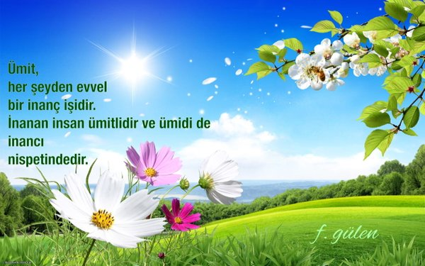

Topics
- Introduction
- The Inheritors of the Earth
- The Statue of our Souls
- The Devout: The Architect of Our Souls
- The Consciousness of Responsibility
- Consultation
- The World We Long For
- Reunion with Ourselves
- Toward Tomorrow
- The Entire Cosmos is a Mirror to the Divine
- Implications of the Birth of the Prophet
- Speech and Power of Expression
- Ideal Generations
- The Generations of Hope – I
- The Generations of Hope – II
- The Power of Literature
- Language and Thought
- The Hero of Thought and Action
- The World Awaited
- Our Philosophy of Life

