Cuma Hutbesi
- اَلْحَمْدُ للهِ. اَلْحَمْدُ للهِ. اَلْحَمْدُ للهِ الَّذِى هَدَانَا لِهذَا.وَمَا كُنَّا لِنَهْتَدِيَ لَوْ لاَ أَنْ هَدَانَا اللهُ. وَ مَا تَوْفِيقِي وَ لاَ اعْتِصَامِي إِلاَّ بِاللهِ. عَلَيْهِ تَوَكَّلْتُ وَ إِلَيْهِ أُنِيبُ. أَشْهَدُ أنْ لاَ إِلهَ إِلاَّ اللهُ وَحْدَهُ لاَ شَرِيكَ لَهُ وَ لاَ نَظِيرَ لَهُ وَ لاَ مِثَالَ لَهُ. اَلَّذِى لاَ أُحْصِي ثَنَاءً عَلَيْهِ. كَمَا أَثْنَي عَلَى نَفْسِهِ. عَزَّ جَارُهُ وَ جَلَّ ثَنَاؤُهُ وَ لاَ يُهْزَمُ جُنْدُهُ وَ لاَ يُخْلَفُ وَعْدُهُ وَ لاَ إِلهَ غَيْرُهُ. وَ نَشْهَدُ أَنَّ سَيِّدَنَا وَ سَنَدَنَا وَ مَوْلاَنَا مُحَمَّدًا عَبْدُهُ وَ رَسُولُهُ. اَلسَّابِقُ إِلَى الأَنَامِ نُورُهُ. وَ رَحْمَةٌ لِلْعَالَمِينَ ظُهُورُهُ. صَلَّى اللهُ تَعَالَى عَلَيْهِ وَ عَلَى آلِهِ وَ أَوْلاَدِهِ وَ أَزْوَاجِهِ وَ أَصْحَابِهِ وَ أَتْبَاعِهِ وَ أَحْفَادِهِ أَجْمَعِينَ. أَمَّا بَعْدُ فَيَا عِبَادَ اللهِ؛ إِتَّقُوا اللهَ تَعَالَى وَ أَطِيعُوهُ. إِنَّ اللهَ مَعَ الَّذِينَ اتَّقَوْا وَ الَّذِينَ هُمْ مُحْسِنُونَ. فَقَدْ قَالَ اللهُ تَعَالَى فِي كِتَابِهِ الْكَرِيمِ

. أَعُوذُ بِاللهِ مِنَ الشَّيْطَانِ الرَّجِيمِ. بِسْــمِ اللهِ الرَّحْمنِ الرَّحِيمِ:
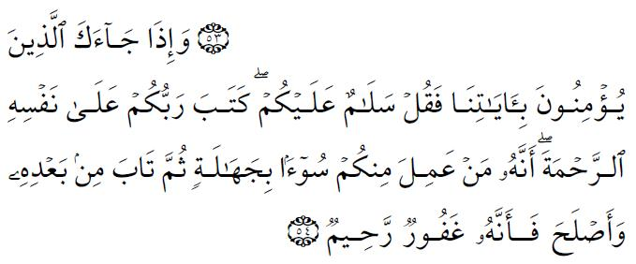
Dear Brothers,
Allah (SWT) created us in the best mold when we did not exist. He (SWT) is the One Who keeps us alive, blesses us with numerous bounties and covers us with His love and mercy. As the servants of Allah, it is one of our primary responsibilities to remember, glorify and thank Allah (SWT), who shows us the way of happiness in this world and in the hereafter.
Imam Bukhari and Muslim reported that the prophet (S.A.W.) said, "When Allah completed the creation, He wrote in His book which is with Him on His throne, "My mercy has overcome my anger.""
Allah (S.W.T.) has told us that among His names are "Ar-Rahman and Ar-Rahim" the Most Beneficent and the Most Merciful. He also told us in His Book about Himself, saying in Surat Al-An’am, (verse 54), "…Your Lord has written mercy for Himself…"
He (S.W.T.) also said about His mercy in Surat Al-‘Araf, (verse 156), "…And My mercy embraces all things…"
Imam Bukhari and Muslim reported that the prophet (S.A.W.) said, "If a disbeliever knows of all the mercy which is in the hand of Allah, he would never lose hope of entering Paradise…"
These verses and many prophetic traditions that talk about the mercy of Allah (S.W.T.), its extent, and its greatness, constitute an important aspect about the divine reality in the mind of a Muslim. It is a beautiful and reassuring concept that manifests itself in the merciful relationship between Allah (S.W.T.) and His servants.
The mercy of Allah (S.W.T.) is manifested in all of His creatures in this universe. This is so especially in the lives of human beings; its magnitude can not be measured, but we can point to some examples of His mercy, so that we can be remind ourselves, and reflect on many others aspects of Allah’s immense mercy.
Dear Muslims,
The love and mercy of Allah (SWT) toward us, His servants, is so deep and so great that in a hadith, Prophet Muhammad (SAV) said as follows:
“Some prisoners of war were brought to Allah’s Messenger (SAV) among whom there was a woman who was running (in searching for someone). When she saw a child among the prisoners, she took hold of him, pressed him against her chest and breast-fed him. Allah's Messenger (SAV) said, “Do you think this woman would ever afford to throw her child in a fire?" We said, “By Allah, so far as it lies in her power, she would never throw the child in the fire." Thereupon Allah's Messenger (SAV) said, “Allah is more kind to His servants than this woman is to her child."
(Riyad-us-Saliheen, No: 418.)
As human beings, we are all prone to error. Each one of us does something from time to time which is not acceptable in the sight of God - what we call a sin. How should we react when we commit such sins?
In Islam, the solution is to stay between hope and fear. A sinner is encouraged to ALWAYS have hoped that God will forgive him. At the same time, the sinner is told to fear God and REPENT to him for committing the sin.
In the Quran, God has informed mankind of His mercy through the fact that He forgives each and every sin when the sinner repents to Him and asks for forgiveness:
God accept the repentance of those who do evil in ignorance and repent soon afterwards; to them will God turn in mercy: For God is full of knowledge and wisdom. (4:17)
Unless he repents, believes, and works righteous deeds, for God will change the evil of such persons into good, and God is Oft-Forgiving, Most Merciful, (25:70)
And whoever repents and does good has truly turned to God with an (acceptable) conversion. (25:71).
As a practical example of repentance, even after continually committing one of the worst sins, the prophet Muhammed (PBUH) told us this story. He related to us the story of a man who murdered not one, two, or even a dozen of people. He slew 100 people but was still eager to repent and turn over a new leaf.
How did God receive such a person? Did God accept him or kick him out of His mercy? Let’s start our journey with this man and try to take lessons from each juncture in his story:
The Prophet (PBUH) said: “He was directed to a monk. He came to him and told him that he had killed 99 people and asked him if there was any chance for his repentance to be accepted.”
Ninety-nine people were murdered by this man, but his heart was still alive. His conscience pricked him and he felt the innate disposition towards good. He was ashamed of his black record and wanted to rectify it. He actually made the decision to repent and followed this decision with the first practical steps.
Now, did the person to whom our remorseful murderer was referred rise up to the expectations? Let’s see:
“He replied in the negative and the man killed him also, completing one hundred. He then asked about the most learned man on the earth. He was directed to a scholar.”
Now, the murderer is referred to a reliable scholar.
“He [the murderer] told him that he had killed 100 people and asked him if there was any chance for his repentance to be accepted. The scholar replied in the affirmative and asked, ‘Who stands between you and repentance?’”
This is the right answer. God’s mercy is wide open and He Almighty is ready to receive the sincere repentant. But, is it enough to just say “I repent”? Is repentance a matter of lip service and ritual formalities? Let’s see what the advice of the knowledgeable scholar was:
“‘Go to such-and-such land; there (you will find) people devoted to worship of God. Join them in worship, and do not come back to your land because it is an evil place.’”
“So he went away and hardly had he covered half the distance when death overtook him; and there was a dispute between the angels of mercy and the angels of torment. The angels of mercy pleaded, ‘This man has come with a repenting heart to God,’ and the angels of punishment argued, ‘He never did a virtuous deed in his life.’ Then there appeared another angel in the form of a human being and the contending angels agreed to make him arbiter between them. He said, ‘Measure the distance between the two lands. He will be considered belonging to the land to which he is nearer.’ They measured and found him closer to the land (of piety) where he intended to go, and so the angels of mercy collected his soul.”
This is the happy ending. True, this person did not do one single good act and his record was as black as coal. But, no problem; since he embarked upon the journey to God, God would not reject him. So here is a man, who killed 100 people, but his repentance was accepted and he was welcomed.
To further display the forgiving and merciful character of our Lord, God who created us, we can take a look upon what God said on the tongue of his prohpet Muhammed (PBUH):
O My servants, you sin by night and by day, and I forgive all sins, so seek forgiveness of me and I shall forgive you.
A servant [of God's] committed a sin and said: O God, forgive me my sin. And He (glorified and exalted be He) said: My servant has committed a sin and has known that he has a Lord who forgives sins and punishes for them. Then he sinned again and said: O Lord, forgive me my sin. And He (glorified and exalted be He) said: My servant has committed a sin and has known that he has a Lord who forgives sins and punishes for them. Then he sinned again and said: O Lord, forgive me my sin. And He (glorified and exalted be He) said: My servant has committed a sin and has known that he has a Lord who forgives sins and punishes for sins. Do what you wish, for I have forgiven you.
God knows that a human being is weak. One can stop doing a certain sin, but is so weak in front of it. There can be moments of weakness, and a human could get back to doing this sin again. Doing a sin again doesn't mean that you are a bad person, or that everything you've done's in vain! God knows how humans can be weak, but if they keep sinning, they should keep repenting, and asking for forgiveness from their Creator.
- أَلاَ إِنَّ أَحْسَنَ الْكَلاَمِ وَ أَبْلَغَ النِّظَامِ. كَلاَمُ اللهِ الْمَلِكِ الْعَزِيزِ الْعَلاَّمِ. كَمَا قَالَ اللهُ تَبَارَكَ وَ تَعَالَى فِي الْكَلاَمِ. وَ إِذَا قُرِئَ الْقُرْآنُ فَاسْتَمِعُوا لَهُ. وَ أَنْصِتُوا لَعَلَّكُمْ تُرْحَمُونَ.

Böylece birinci hutbe bitmiş olur ve hatip oturur. Otururken için den şöyle duâ eder:

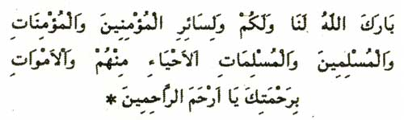

"Almighty God, forgive the Muslim men and women,
Forgive the believing men and women,
Those who are alive and those who died,
You are indeed the One who listens and accepts all supplications"

اَلْحَمْدُ للهِ. اَلْحَمْدُ للهِ. اَلْحَمْدُ للهِ حَمْدَ الْكَامِلِينَ كَمَا أَمَرَ. نَشْهَدُ أَنْ لاَ إِلهَ إِلاَّ اللهُ وَ نَشْهَدُ أَنَّ مُحَمَّدًا عَبْدُهُ وَ رَسُولُهُ النَّبِيُّ الْمُعْتَبَرُ. تَعْظِيمًا لِنَبِيِّهِ وَ تَكْرِيمًا لِفَخَامَةِ شَانِ شَرَفِ صَفِيِّهِ. فَقَالَ اللهُ عَزَّ وَ جَلَّ مِنْ قَائِلٍ مُخْبِرًا وَ آمِرًا: {إِنَّ اللهَ وَ مَلاَئِكَتَهُ يُصَلُّونَ عَلَى النَّبِيِّ. يَا أَيُّهَا الَّذِينَ آمَنُوا صَلُّوا عَلَيْهِ وَ سَلِّمُوا تَسْلِيمًا}.

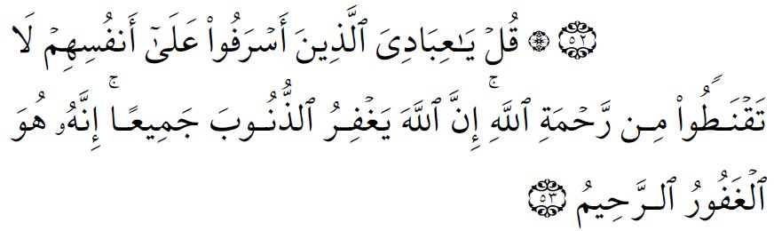

Say: "O my Servants who have transgressed against their souls! Despair not of the Mercy of God: for God forgives all sins: for He is Oft-Forgiving, Most Merciful" (39:53)
In repentance there is not despair; on the contrary, because of the mercy of God, there is always hope in the forgiveness of God when we turn to him sincerely.
May the Blessings of Allah be upon our Prophet Muhammed, upon his family, his Companions and upon all those who follow Guidance until the Last Day.
Ibadallah;
Ittekullaha ve atiu,
{ إِنَّ اللهَ يَاْمُرُ بِالْعَدْلِ وَ الإِحْسَانِ وَ إِيتَاءِ ذِي الْقُرْبَي وَ يَنْهَي عَنِ الْفَحْشَاءِ وَ الْمُنْكَرِ وَ الْبَغْيِ. يَعِظُكُمْ لَعَلَّكُمْ تَذَكَّرُونَ }
""Servants of Allah:
Indeed Allah orders us to be just and to excel in what we do,
Be generous and to take care of our kin and relatives,
Never do what is forbidden of all sins and
Not to transgress,
He almighty advises you so you can remember""

Aqimi Salah,

