GOOD DEEDS

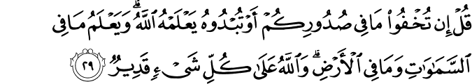

3.29. Say (to the believers): "Whether you keep secret what is in your bosoms or reveal it, God knows it. He knows whatever is in the heavens and whatever is on the earth. God has full power over everything. "(1)

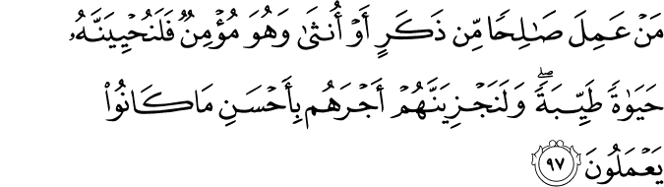

16.97. Whoever does good, righteous deeds, whether male or female, and is a believer, most certainly We will make him (or her) live a good life, and most certainly We will pay such as these their reward in accordance with the best of what they used to do.(2)

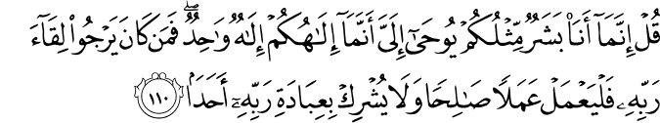

18.110. Say: "I am but a mortal like you, but it is revealed to me that your God is the One and Only God. So, whoever is looking forward to meeting his Lord, let him do good, righteous deeds, and let him not associate any partner in the worship of His Lord. "(3)

HADITH

“Deeds are judged by their intentions and every man shall have only that which he intended. The migration of those who migrated for the sake of God and His Messenger was for God and his Messenger, while the migration of one whose migration was to achieve some worldly benefit or to take someone in marriage was for that which he migrated.” (4)

DEEDS ARE TO BE JUDGED ACCORDING TO INTENTIONS

“Deeds are judged by their intentions and every man shall have only that which he intended. The migration of those who migrated for the sake of God and His Messenger was for God and his Messenger, while the migration of one whose migration was to achieve some worldly benefit or to take someone in marriage was for that which he migrated.”
(Muslim, Imara, 155; Abu Dawud, Talaq, 10)
The prime topic of this hadith is the migration, and it was uttered in connection with the following incident: During the period when everyone began migrating from Mecca to Medina in the hope of obtaining the pleasure of the Creator, one of the Companions, migrated to be with a woman he loved dearly called Umm Qays. This Companion without doubt was a devoted and faithful man, but the motive of his migration was his intention for marriage.
He had also migrated, but for the sake of the woman he loved, he bore great difficulties and hardships that should only be endued for the sake of God and this is reflected in the hadith. The hadith is not just a comment aimed at a particular subject; rather it is a ruling that is concerned with every aspect of a person’s life.
Everybody is rewarded according to the intention of their act; if they immigrate for the sake of God and his Messenger, then they will be rewarded accordingly. This is also the case with praying, fasting and giving charitable alms. Those who seek merit and grace from the Creator will be constantly rewarded with the compassion, kindness, and beneficence of the Almighty.
When a human being reaches this level of compassion they will persist in increasing their affection and relationship by prostrating before their Creator, totally overwhelmed with joy, excitement and aspiration. As they become closer to their Lord, this enthusiasm and emotion will prevail over every action. When one surpasses the universe they will stand before the Creator wherever they go, be it in the grave, in the abode of torment, on the Day of Judgment or on the bridge that stretches over hellfire. If a person’s actions are successful in reaching the Liva al-Hamd they will encounter the Prophet of the Universe, an event that is beyond anything they could ever imagine.
If the sole intention of a person is not the the quest for Divine pleasure, any difficulty they endure will be in vain; if their intention to migrate was to be with the woman they loved then they suffer hardship and adversity for the material pleasures of this life. A person who ignores the voice that emerges deep from their soul, the emotions of their conscience, a person who lives for the pleasures of the world and wastes their life seeking enjoyment wherever possible will never prosper or obtain the pleasures of those whose every action is carefully calculated to please their Creator.
In another hadith the Prophet says that the intention of a believer is more important than his deed. However great an effort one exerts it is nearly impossible to have one’s actions match the sincerity of their intentions, but the Creator of great compassion rewards a person according to the sincere intention of their soul, not their actions. Thus, it is quite clear that a believer’s intentions are a greater advantage than their physical actions.
I would like to focus on another hadith that is related to the same subject: “Indeed, there is in the body a piece of flesh which if it is sound then the whole body is sound and if it is corrupt then the whole body is corrupt. Indeed it is the heart” (Bukhari, Iman, 39). If a believer is sincere in their soul, then every seed of prosperity they sow in life will mature and then flourish into branches of benevolence. These branches will be their shade on the Day of Judgment. The seeds sown with sincerity of heart will grow in prosperity and appear before us on the Day of Questioning in the form of the benevolent fruits of Paradise.
The ordinary chores of a Muslim’s daily life are transformed into acts of worship through good intentions; every single breath of the believer who sleeps with the intention of waking for prayer during the night will be considered as a part of their worship. If we consider our lifespan on this earth, how could we possibly attain Paradise in such a short span of time? Because of our intention of eternal servitude to God, believers are blessed with admittance into the gardens of Paradise, whereas disbelievers are doomed by their intention of eternal ungratefulness.
Good intentions, ranging from the most insignificant to the greatest of actions, are the only aspect that enhances the true value and worthiness of human life in this world and the rewards in the Hereafter. The intention of kindness is a great benefit in this life. If a person has the intention of evil in their soul, but refrains from performing this evil action, they will be rewarded accordingly; however, if the intention of evil remains this is not classed as a sin. Only when this evil action is actually put into practice will it be recorded as one sin. Still, we should not underestimate any sins.
We should not ignore the significance of migration in this hadith. Every believer who leaves his homeland, family, wife and children to convey the truth to others is in a perpetual circle of compassion and, without a doubt, will be rewarded in the Hereafter for their sincere intentions. No specific reward for such great actions has been mentioned; this can be owing to a surprise reward to be granted in the Hereafter.
The definite article in Arabic (al-) at the beginning of the word “deeds” denotes that deeds gain a true value only through intention. No form of worship can be accepted without sincere intention, and therefore if a person continuously prays, fasts, spends of their wealth, performs the rituals of Hajj without the intention to do so in their heart, then their actions are in vain. Prayer, fasting, charity and Hajj are only acceptable forms of worship if a person has a sincere intention in their soul, thus making it the actual intention that transforms actions into worship.
If we take another look at the topic of the hadith, we can see that the Prophet first defined the vast subject of “intention” in three short words, and then with a few sentences he expressed the gist of an important matter like hijra—whose meaning covers a wide scope of acts, from abandoning sins to all of the migrations to be realized for the sake of God until the end of the world.
It may be of use to elaborate on this with another hadith: “The greatest muhajir (emigrant) is he who abandons sin” (Nasai, Iman, 9) One day Ibrahim ibn Adham prayed to his Lord: “O Lord! With Your love in my heart, I have forsaken everything and come to You. After finding You, I do not see anything else wherever I look.” At a time when his soul was so full of spiritual emotion Ibrahim ibn Adham saw his son next to the Ka‘ba. When the young man recognized his father they ran to each other in a state of elation and embraced one another. Just then Ibrahim heard a voice saying: “O Ibrahim, there cannot be two objects of love in one heart” and Ibrahim started praying: “O God, take from me what prevents Your love,” and his son instantly dropped dead.
Avoiding the sins and evil in this world and turning to the Creator in a state of repentance, asking forgiveness until one’s prayers are accepted by the Almighty is a form of hijra which has been beautifully expressed in the following prayer:
“O God, Your sinful servant stands before You. Seeking Your forgiveness, professing his sins and begging to be forgiven.
If You grant forgiveness, this is out of Your glory.
And if You dismiss him, there is no one else to show mercy.”
A person who abandons their past sins and acknowledges that the repetition of these sins deserves a punishment that is greater than the fire of hell is on the true path of hijra. Those who avoid the forbidden boundaries of Islam, perceiving it to be like a field of hidden mines waiting to explode, those who refrain from the prohibited aspects of religion with their actions and speech, continuing to perform a holy migration throughout their lives, whether they are among others or in seclusion, maintain the emotion of hijra in their souls.
Nevertheless, seclusion is another distinct aspect of hijra, for this is where devoted believers reach a true understanding of divinity.
We can examine the main subjects and explanations of this hadith as follows:
a- Intention is the spirit of any action; actions with no intention have no significance.
b- Intention is the light of spirituality which turns evil into good and good into evil.
c- A person’s actions are transformed into good deeds with intentions, thus hijra with no sincere intention would be a migration of no importance, Hajj a deceptive journey, prayer a routine of physical action and fasting nothing more than abstinence. Pure intention of the soul is the only possible way to convert these actions into good deeds and forms of worship that will lead us to the gates of Paradise.
d- Eternal Paradise is the result of the sincere intention of eternal servitude, whereas the eternal flames of hell are the consequence of eternal denial and blasphemy.
e- A minimal degree of effort opens the doors of opportunity. A believer can achieve rewards of great value both for this world and the Hereafter simply with the sincere intention of the soul.
f- Those who know the value of sincere intention in the sight of God will be in a position to aspire great achievements. (5)
References
(1)3:29./The Quran with Annotated Interpretation in Modern English by Ali Unal
(2)16:97./The Quran with Annotated Interpretation in Modern English by Ali Unal
(3)18:110./The Quran with Annotated Interpretation in Modern English by Ali Unal
(4) Muslim, Imara, 155; Abu Dawud, Talaq, 10
(5) 40 Hadiths, Tughrabooks, The Light Inc

