The Rights of Parents

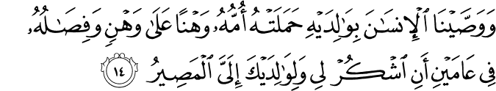

31.14. We have enjoined on human in respect with his parents: his mother bore him in strain upon strain, and his weaning was in two years. (So, O human,) be thankful to Me and to your parents. To Me is the final homecoming.(1)
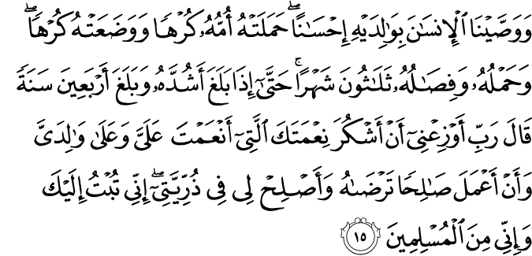

46.15. Now (among the good deeds), We have enjoined on human is the best treatment towards his parents. His mother bore him in pain, and in pain did she give him birth. The bearing of him and suckling of him (until weaned) is thirty months. When he has finally reached his full manhood and reached forty years of age, he says: "My Lord! Arouse me that I may be thankful for all Your favors (life, health, sustenance, faith, and submission, and more) that You have bestowed on me and on my parents, and that I may do good, righteous deeds with which You will be pleased; and grant me righteous offspring (so that they treat me righteously, as I treat my parents). I have turned to You, and I am one of those who have submitted to You. "(2)

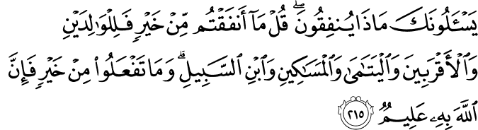

2.215. They ask you what they will spend (to provide sustenance for the needy). Say: "Whatever you spend of your wealth is for (your) parents and the near relatives, and the (needy) orphans, the destitute, and the wayfarer. " Whatever good you do, surely God has full knowledge of it.(3)
HADITH

It was narrated that Abu Hurairah (RA) said: A man came to Allah’s Messenger (PBUH) and asked, “Which of the people is most deserving of my best companionship?” He said, “Your mother.” He said, “Then who?” He said, “Then your mother.” He said, “Then who?” He said, “Then your mother.” He said, “Then who?” He said, “Then your father.”(4)

Abdullah bin Amr narrated that the Prophet (PBUH) said, “The Lord’s pleasure is in the parent’s pleasure and the Lord’s anger is in parent’s anger.” (5)

Narrated Ibn Umar (RA): The Prophet (PBUH) said, “All of you are guardians and are responsible for your words. The ruler is a guardian and the man is a guardian of his family; the lady is a guardian and is responsible for her husband’s house and his off-spring; and so all of you are guardians and are responsible for your wards.”(6)

The Rights of Parents

The father and mother are two sacred beings that must be respected above everyone else. If you do not respect your parents, you are disobeying God Almighty. Those who treat their parents badly eventually are treated badly by others.
* * *
From the very moment of conception, a growing and developing child is a care and responsibility for its parents. One cannot estimate the depth of attachment and compassion parents feel for their children, or calculate the troubles and hardships they endure because of them. For this reason, respecting parents is a debt of human gratitude as well as a religious obligation.
* * *
Those who value their parents and regard them as a means to obtain God’s mercy are the most prosperous in both worlds. Those who regard their parents’ existence as a burden or who become weary of them inevitably suffer the most severe hardship in life.
* * *
The more you respect your parents, the greater the respect and awe you feel before your Creator. If you do not feel and show respect to them, this means that you feel no fear, awe, or respect toward God. It is a curious thing today that both those who disrespect God and those who claim they love God disobey their parents.
* * *
Children should respect and obey their parents as much as possible. Parents should give as much importance to their children’s moral and spiritual education as they do to their physical growth and health, and should entrust them to the care of the most honorable teachers and guides. How ignorant and careless are those parents who neglect their children’s moral and spiritual training, and how unfortunate are the children who experience such neglect.
* * *
Children who are inconsiderate of their parents’ rights and disobey them are “monsters derived from a deteriorated human being.” Parents who do not secure their children’s moral and spiritual welfare are merciless and cruel. Most brutish and pitiless of all are parents who paralyze their children’s moral and spiritual development after they have found their way to human perfection.
* * *
Families form a society’s foundation. The reciprocal respect of rights and obligations within a family results in a healthy and strong society. When such familial relationships disappear, the society loses its compassion and respect for others. [Criteria or Lights of the Way, vol.1, 9th edition, Izmir, 1996, pp.98-101]

The Rights of Children

A child has the same meaning for humanity's continuation as a seed for a forest's continued growth and multiplication. People who neglect their children decay gradually, and those who abandon them to a foreign culture risk losing their identity.
* * *
Children form the most active and productive part of a community after every thirty or forty years. Those who ignore their young children should consider how important an element of their own community's life they are disregarding, and then shudder.
* * *
The vices observed in today's generation, the incompetence of some administrators, and other social problems are the direct result of the conditions prevailing thirty years ago, and of that time's ruling elite. Likewise, those entrusted with educating today's young people are responsible for the vices and virtues that will appear thirty years from now.
* * *
Those who want to secure their future should apply as much energy to raising their children as they devote to other problems. While the energy devoted to many other things may go in vain, whatever is spent for raising a young generation elevates them to the rank of humanity. Such people will be like an inexhaustible source of income.
* * *
Those people in our community who are miserable and lost, such as drug addicts, alcoholics, and other dissolute people, were once children. We failed to educate them properly. I wonder whether we are sufficiently aware of the kind of people we are preparing to walk our streets tomorrow.
* * *
Communities that pay close attention to the family institution and their young people's education, as opposed to those who are more advanced in sciences and technology, will have the upper hand in the future. Communities that neglect the family institution and the young people's education will be crushed by the pitiless wheels of time.(7)

References
(1) 31:14.The Quran with Annotated Interpretation in Modern English by Ali Unal
(2) 46:15. The Quran with Annotated Interpretation in Modern English by Ali Unal
(3) 2:215. The Quran with Annotated Interpretation in Modern English by Ali Unal
(4) (Hadith No. 5971, Book of Al-Adab, Sahih Bukhari, Vol. 8; Hadith No. 6500 (2548), Book of Al-Birr, Sahih Muslim, Vol. 6).
(5) (Hadith No. 1899, Chapters on Righteousness, Jami’ At-Tirmidhi, Vol. 4).
(6) (Hadith No. 5200, Book of Nikah, Sahih Bukhari, Vol. 7).
(7)Gulen, Fethullah. As a Teacher. http://fgulen.com/. September 2001

