DESTINY AND HUMAN FREE WILL

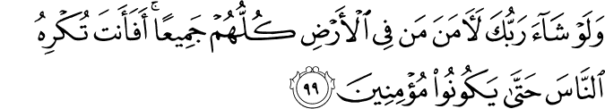

10.99. If your Lord had so willed (and, denying them free will, compelled humankind to believe), all who are on the earth would surely have believed, all of them. Would you, then, force people until they become believers?(1)

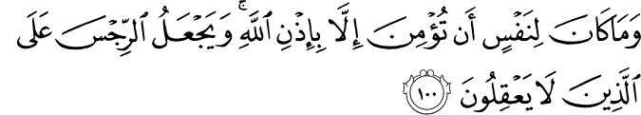

10.100. It is not for any person to believe save by God's leave. God sets those who do not use their reason in a mire of uncleanness.(1)

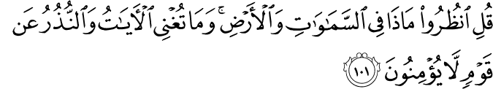

10.101. Say: "Consider what there is (and what happens) in the heavens and on the earth. " But all such signs (of the truth of the essentials of faith) and the warnings cannot avail a people who will not believe.(1)

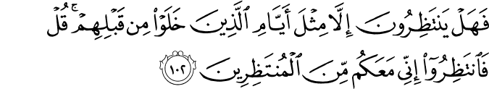

10.102. For what do they watch and wait but the like of the days of punishment which befell those (unbelievers) who passed away before them? Say: "Then watch and wait, and I will be with you watching and waiting. "(1)

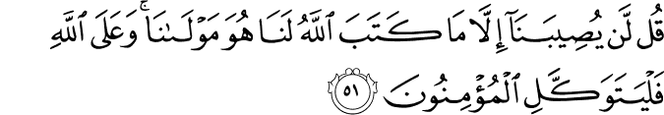

9.51. Say: "Nothing befalls us except what God has decreed for us; He is our Guardian and Owner; and in God let the believers put all their trust. "(2)

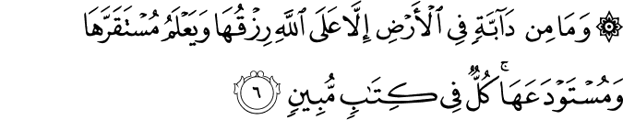

11.6. No living creature is there moving on the earth but its provision depends on God, and He knows its every lodging and disposition (every stage of its life), and the duration of its stay, and the moment of its transition therefrom. All is in a Manifest Book.(3)

Abu Huraira reported Allah's Messenger (pbuh)as saying:

A strong believer is better and is more lovable to Allah than a weak believer, and there is good in everyone, (but) cherish that which gives you benefit (in the Hereafter) and seek help from Allah and do not lose heart, and if anything (in the form of trouble) comes to you, don't say: If I had not done that, it would not have happened so and so, but say: Allah did that what He had ordained to do and your" if" opens the (gate) for the Satan.(4)

DESTINY AND HUMAN FREE WILL

We feel remorse when we do something wrong. We beg God’s forgiveness for our sins. If we trouble or harm someone, we ask that person to excuse us. These actions show that we choose to act in a particular way. If we could not choose our actions and were compelled to do them by a superior power, why should we feel remorse and seek forgiveness for anything?
Obviously, we choose to move our hands, speak, or stand up to go somewhere. Nothing compels us to do or not to do something. We decide to read a book, watch television, or pray to God. We are not forced to do any of these things. We hesitate, reason, compare, assess, choose, and then decide to do something. For example, if our friends invite us to go somewhere or do something, we first hesitate, compare, and then decide whether we will accompany them or not. We repeat this very process maybe a hundred times a day before deciding to do or say something.
When we are wronged, we sometimes go to court to sue the one who wronged us. The court does not ascribe the wrong done to a compelling superior power like Destiny, and neither do we. The one accused does not excuse himself or herself by blaming that power. Virtuous and wicked people, those who are promoted to high social ranks and those who waste their time, those who are rewarded for their good acts or success and those who are punished for their crimes—all of this proves that each of us has free will.
Our free will is not visible and does not have material existence. However, such factors do not render its existence impossible. Everyone has two (physical) eyes, but we also can see with our third (spiritual) eye. We use the former to see things in this world; we use the latter to see things beyond events and this world. Our free will is like our third eye, which you may call insight. It is an inclination or inner force by which we prefer and decide.
Humanity wills and God creates. A project or a building’s plan has no value or use unless you start to construct the building according to it, so that it becomes visible and serves many purposes. Our free will resembles that plan, for we decide and act according to it, and God creates our actions as a result of our decisions. Creation and acting or doing something are different things. God’s creation means that He gives actual existence to our choices and actions in this world. Without God’s creation, we can do nothing.
To illuminate a magnificent palace, we must install a lighting system. However, the palace cannot be illuminated until we flick the switch that turns on the lights. Until we do so, the palace will remain dark. Similarly, each man and woman is a magnificent palace of God. We are illuminated by belief in God, Who has supplied us with the necessary lighting system: intellect, reason, sense, and the abilities to learn, compare, and prefer.
Nature and events, as well as Divinely revealed religions, are like the source of electricity that illuminates this Divine palace of the human individual. If we do not use our free will to flick the switch, however, we will remain in darkness. Turning on the light means petitioning God to illuminate us with belief. In a manner befitting a servant at his or her lord’s door, we must petition the Lord of the Universe to illuminate us and so make us a “king” in the universe. When we do this, the Lord of the Universe treats us in a way befitting Himself, and promotes us to the rank of kingship over other realms of creation.
God takes our free will into account when dealing with us and our acts, for He uses it to create our deeds. Thus we are never victims of Destiny or wronged by Fate. However insignificant our free will is when compared with God’s creative acts, it is still the cause of our deeds. God makes large things out of minute particles, and creates many important results from simple means. For example, He makes a huge pine tree from a tiny seed, and uses our inclinations or free choice to prepare our eternal happiness or punishment.
To better understand our part and that of our willpower in our acts and accomplishments, consider the food we consume. Without soil and water, air and the sun’s heat, none of which we can produce or create despite our advanced technology, we would have no food. We cannot produce a single seed of corn. We did not create our body and establish its relationship with food; we cannot even control a single part of our body. For example, if we had to wind our heart like a clock at a fixed time every morning, how long would we survive?
Obviously, almost all parts of the whole complex and harmonious universe, which is like a most developed organism, work together according to the most delicate measures to produce a single morsel of food. Thus, the price of a single morsel is almost as much as the price of the whole universe. How can we possibly pay such a price, when our part in producing that morsel is utterly negligible, consisting of no more than our own effort?
Can we ever thank God enough for even a morsel of food? If only a picture of grapes were shown to us, could all of us work together and produce it? No. God nourishes us with His bounty, asking in return very little. For example, if He told us to perform a thousand rak‘ats (units) of prayer for a bushel of wheat, we would have to do so. If He sent a raindrop in return for one rak‘a, we would have to spend our whole lives praying. If you were left in the scorching heat of a desert, would you not give anything for a single glass of water?
In sum: Almost everything we have is given to us for practically nothing, and our part in the bounty we enjoy here is therefore quite negligible. Similarly, our free will is equally negligible when compared with what God Almighty creates from our use of it. Despite our free will’s weakness and our own inability to really understand its true nature, God creates our actions according to the choices and decisions we make through it.
Concluding points
• Divine Destiny, also called Divine determination and arrangement, dominates the universe but does not cancel our free will.
• Since God is beyond time and space, everything is included in His Knowledge, and He encompasses past, present and future as a single undivided point. For example, when you are in a room, your view is restricted to the room, but if you look from a higher point, you see the whole city. As you rise higher and higher, your vision continues to broaden. Earth, when seen from the moon, appears to be a small blue marble. It is the same with time. So, God encompasses all time and space as a single, undivided point, in which past, present, and future are united.
• Since all time and space are included in God’s Knowledge as a single point, God recorded everything that will happen until the Day of Judgment. Angels use this record to prepare a smaller record for each individual.
• We do not do something because God recorded it; God knew beforehand that we would do it and so recorded it.
• There are not two destinies—one for the cause, one for the effect. Destiny is one and relates to the cause and the effect simultaneously. Our free will (our acts) is included in Destiny. That is, God Almighty pre-determined our acts by knowing beforehand in what direction we would use our free will how we would act.
• God guides us to good things and actions, and allows and advises us to use our willpower for good. In return, He promises us eternal happiness in Paradise.
• Our free will, if not used properly, can cause our destruction. Therefore we should use it to benefit ourselves by praying to God so that we may enjoy the blessings of Paradise, a fruit of the chain of good deeds, and attain eternal happiness. Furthermore, we should always seek God’s forgiveness so that we might refrain from evil and be saved from the torments of Hell, a fruit of the accursed chain of evil deeds. Prayer and trusting in God greatly strengthen our inclination towards good, and repentance and seeking God’s forgiveness greatly weaken, even destroy, our inclination toward evil and transgression.3

DIVINE DESTINY AND DECREE AND HUMAN FREE WILL

The Qur’anic word translated as “destiny” is qadar. In its derivations, this word also means “determination,” “giving a certain measure and shape,” “dividing,” and “judging.” Muslim scholars of Islam define it as “Divine measure,” “determination,” and “judgment in the creation of things.”
As terms, qadar or Destiny means to predetermine or preordain within a certain measure, while Decree means to execute or put into effect. To be more precise, Destiny means that everything that exists, from subatomic particles to the universe as a whole, is known by God Almighty and measured, identified and established by Divine Eternal Will. His Knowledge includes all space and time, while He Himself is absolutely free of both of them. Everything exists in His Knowledge, and He assigns to each a certain shape, life span, function or mission, and certain characteristics:
God knows what any female bears and what the wombs diminish and what they increase; and everything with Him is by a determined measure. (13:8)
The sun and the moon are by an exact calculation . And the stars and the trees both prostrate (before God in perfect submission to His laws). And the heaven—He has made it high, and He has set up the Balance; so you must not go beyond (the limits with respect to) the Balance, and observe the Balance with full equity, and do not fall short in it. (55:5–9)
The universe’s exact measure and balance, order and harmony, as well as that of all it contains, clearly show that everything is determined and measured, created and governed by God Almighty. All seeds, measured and proportioned forms, and the universe’s extraordinary order and harmony, which has continued for billions of years without any interruption or deviation, demonstrates that everything occurs according to God Almighty’s absolute determination. Each seed or ovum is like a case formed by Divine Power into which Divine Destiny inserts the future life history of a plant or a living being. Divine Power employs atoms or particles, according to the measure established by Divine Destiny, to transform each seed into a specific plant, and each fertilized ovum into a specific living being. This means that the future life history of these entities, as well as the principles governing their lives, are pre-recorded in the seed or the fertilized ovum as determining factors and processes. Plants and living beings are formed from the same basic materials. However, there is an almost infinite variety of species and individuals. Plants and living beings grow from the same constituent basic elements, and display great harmony and proportion. Yet there is such abundant diversity that we are forced to conclude that each entity receives a specific form and measure. This specific form and measure is established by Divine Destiny, that is, Divine measuring, determining, and establishing.(5)

References
(1)10:99-102 /The Quran with Annotated Interpretation in Modern English by Ali Unal
(2)9:51 /The Quran with Annotated Interpretation in Modern English by Ali Unal
(3)11:6 /The Quran with Annotated Interpretation in Modern English by Ali Unal
(4) Sahih Muslim 2664
(5) Gulen, Muhammed Fethullah. “The Essentials of the Islamic Faith” The Light, Inc. 2005.

