DEFINING THE QURAN

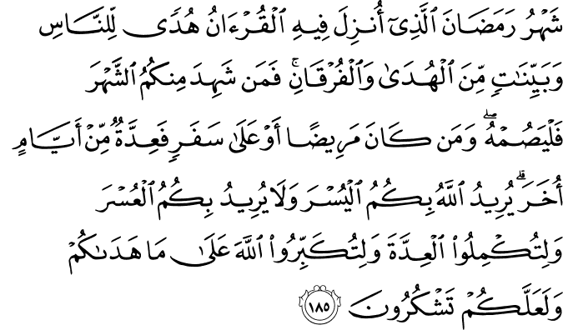

2.185. The month of Ramadān, in which the Qur'ān was sent down as guidance for people, and as clear signs of Guidance and the Criterion (between truth and falsehood). Therefore whoever of you is present this month must fast it, and whoever is so ill that he cannot fast or is on a journey (must fast the same) number of other days. God wills ease for you, and He does not will hardship for you, so that you can complete the number of the days required, and exalt God for He has guided you, and so it may be that you will give thanks (due to Him).(1)

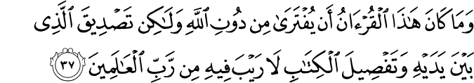

10.37. And this Qur'ān is not such that it could possibly be fabricated by one in attribution to God, but it is a (Divine Book) confirming (the Divine origin of, and the truths that are still contained by,) the Revelations prior to it, and an explanation of the Essence of all Divine Books – wherein there is no doubt, from the Lord of the worlds.(2)

12.2. We send it down as a qur'ān (discourse) in Arabic so that you may reflect (on both its meaning and wording) and understand.(3)

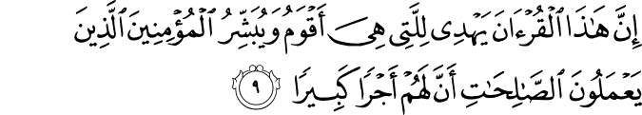

17.9. This Qur'ān surely guides (in all matters) to that which is most just and right, and gives the believers who do good, righteous deeds the glad tidings that for them there is a great reward.(4)

HADITH

“O people I am leaving behind among you the Holy Book (Quran) and the Sunnah (way of Prophet (SAW)), if you follow these in letter and spirit you will never be strayed.” (5)

DEFINING THE QURAN

Literally, the Quran means the thing arranged or collected and established in the heart, and recited. As a term, the Quran is the name of God’s miraculous or inimitable Word which was revealed to Prophet Muhammad, upon him be peace and blessings, written down and transmitted to succeeding generations by many reliable channels, and which collects and contains the “fruit” of all previous Scriptures and knowledge, and whose recitation is an act of worship and obligatory in the daily Prayers.1 The Qur’an itself describes some of its features as follows:
The month of Ramadan, in which the Quran was sent down as guidance for people, and as clear signs of Guidance and the Criterion (between truth and falsehood). (2:185)
And this Quran is not such that it could possibly be fabricated by one in attribution to God, but it is a (Divine Book) confirming (the Divine origin of and the truths that are still contained by) the Revelations prior to it, and an explanation of the Essence of all Divine Books—wherein there is no doubt, from the Lord of the worlds. (10:37)
We send it down as a Quran (discourse) in Arabic so that you may reflect (on both its meaning and wording) and understand. (12:2)
This Quran surely guides (in all matters) to that which is most just and right, and gives the believers who do good, righteous deeds the glad tidings that for them there is a great reward. (17:9)
And, indeed, (by revealing it through human language) We have made the Quran easy for remembrance (of God, and taking heed). Then is there any that remembers and takes heed? (54:17)
Most certainly it is a Quran (recited) most honorable, in a Book well-guarded. (56:77–78)
The Quran has other titles, each of which describes an aspect and so can be considered an attribute, such as: the Book, the Criterion, the Remembrance, the Advice, the Light, the Guidance, the Healer, the Noble, the Book in Pairs, the Mother of the Book, the Truth, the Admonishment, the Glad Tiding, the Book Gradually Revealed, the Knowledge, and the Clear.2
God’s Messenger, upon him be peace and blessings, declares:
The Qur’an is more lovable to God than the heavens and earth and those in them.
The superiority of the Qur’an over all other words and speeches is like God’s superiority over His creatures.3
The Quran is a definite decree distinguishing between truth and falsehood. It is not a pastime. Whoever rejects it because of his or her despotism, God punishes him harshly. It contains the history of previous peoples, the tiding of those to come after you, and the judgment on the disagreements among you. Whoever searches for guidance in something other than it, God leads him or her astray. It is God’s strong rope. It is the wise instruction. It is the Straight Path. It is a book which desires cannot deviate and tongues cannot confuse, and which scholars do not tire of, never worn-out by repetition, and has uncountable admirable aspects. It is such a book that they could not help but say: “We have indeed heard a wonderful Quran, guiding to what is right in belief and action and so we have believed in it.” Whoever speaks based on it speaks truth; whoever judges by it judges justly and whoever calls to it calls to truth.4
We close with Said Nursi’s definition:
The Qur’an is an eternal translation of the great book of the universe and the everlasting translator of the various “languages” in which Divine laws of the creation and operation of the universe are “inscribed”; the interpreter of the books of the visible, material world and the world of the Unseen; the discoverer of the immaterial treasuries of the Divine Names hidden on the earth and in the heavens; the key to the truths which lie beneath the lines of events; the tongue of the Unseen world in the visible, material one; the treasury of the favors of the All-Merciful One and the eternal addresses of the All- Glorified One coming from the world of the Unseen beyond the veil of this visible world; the sun of the spiritual and intellectual world of Islam and its foundation and plan; the sacred map of the worlds of the Hereafter; the expounder, the lucid interpreter, articulate proof, and clear translator of the Divine “Essence,” Attributes, Names and acts; the educator and trainer of the world of humanity and the water and light of Islam, which is the true and greatest humanity; the true wisdom of humanity and their true guide leading them to happiness; and for human beings it is both a book of law, a book of prayer, a book of wisdom, a book of worship and servanthood to God, and a book of commands and invitation, a book of invocation, and a book of reflection, a holy book containing books for all the spiritual needs of humanity, and a heavenly book which, like a sacred library, contains nu-merous booklets from which all the saints and the eminently truthful, and all the purified and discerning scholars have derived their ways peculiar to each, and which illuminates each of these ways and answers the needs of all those with different tastes and temperaments who follow them.
Having come from the Supreme Throne of God, and originated in His Greatest Name, and issued forth from the most comprehensive rank of each Name, the Qur’an is both the word of God as regards His being the Lord of the worlds, and His decree in respect of His having the title of the Deity of all creatures, and a discourse in the name of the Creator of all the heavens and earth, and a speech from the perspective of the absolute Divine Lordship, and an eternal sermon on behalf of the universal Sovereignty of the All-Glorified One, and a register of the favors of the All-Merciful One from the viewpoint of the all-embracing Mercy, and a collection of messages some of which begin with a cipher, and a holy book which, having descended from the surrounding circle of the Divine Greatest Name, looks over and surveys the circle surrounded by the Supreme Throne of God.
Because of this, the title of “Word of God” has been, and will always be, given to the Quran most deservedly. After the Quran come the Scriptures and Pages which were sent to some other Prophets. As for the other countless Divine words, some of them are conversations in the form of inspirations coming as the particular manifestations of a particular aspect of Divine Mercy, Sovereignty, and Lordship under a particular title with particular regard. The inspirations coming to angels, human beings and animals vary greatly with regard to their universality or particularity.
The Qur’an is a heavenly book, the six sides of which are bright and absolutely free of the darkness of doubts and whimsical thoughts; whose point of support is with certainty Divine Revelation and the Divine eternal Word, whose aim is manifestly eternal happiness, and whose inside is manifestly pure guidance.
And it is surrounded and supported: from above by the lights of faith, from below by proof and evidence, from the right by the submission of the heart and the conscience, and from the left by the admission of reason and other intellectual faculties. Its fruit is with absolute certainty the mercy of the All-Merciful One, and Paradise; and it has been accepted and promoted by angels and innumerable human beings and jinn through the centuries.(6)

References
(1) 2:185/The Quran with Annotated Interpretation in Modern English by Ali Unal
(2) 10:37/The Quran with Annotated Interpretation in Modern English by Ali Unal
(3) 12:2/The Quran with Annotated Interpretation in Modern English by Ali Unal
(4) 17:9/The Quran with Annotated Interpretation in Modern English by Ali Unal
(5) Hakim Al-Mustadrik, Book1 Hadith 318
(6) Ünal, Ali. Living in the Shade of Islam. Somerset, NJ: Tughra, 2009.

