RESPECT

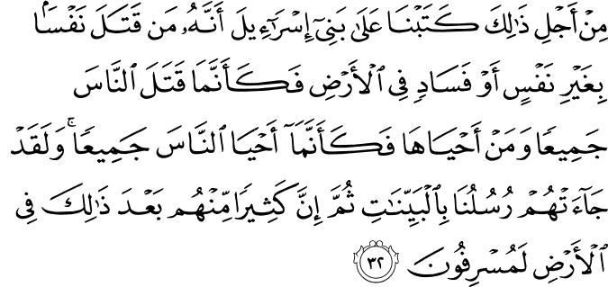

5.32. It is because of this that We ordained for (all humankind, but particularly for) the Children of Israel: He who kills a soul unless it be (in legal punishment) for murder or for causing disorder and corruption on the earth will be as if he had killed all humankind; and he who saves a life will be as if he had saved the lives of all humankind. Assuredly, there came to them Our Messengers (one after the other) with clear proofs of the truth (so that they might be revived both individually and as a people). Then (in spite of all this), many of them go on committing excesses on the earth.(1)

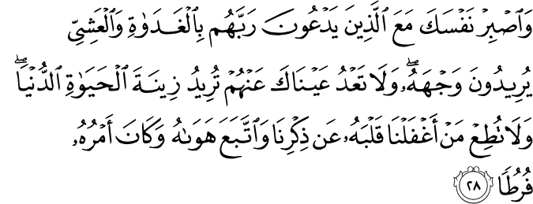

18.28. And keep yourself patient, along with those who invoke their Lord morning and evening, seeking His "Face" (His eternal, good pleasure, and the meeting with Him in the Hereafter); and do not let your eyes pass beyond them, desiring the beauties of the life of this world (by the participation of those of leading positions among people in your assemblies). And pay no heed to (the desires of) him whose heart We have made unmindful of Our remembrance, who follows his lusts and fancies, and whose affair exceeds all bounds (of right and decency).(2)

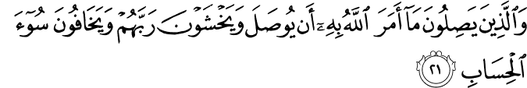

13.21. And those who unite the bonds God has commanded to be joined (among kin as a requirement of blood relationship, and among people as required by human social interdependence), and stand in awe of their Lord, and fearful of (facing) the most evil reckoning;(3)

Respecting the Rights of the Muslims, and Having Compassion and Mercy for Them

(4) 129. An-Nu’man ibn Bashir, may Allah be pleased with him, reported that the Messenger of Allah, peace and blessings be upon him, said, “The metaphor of the believers in their mutual love, mercy and affection is that of the body. When one limb of it complains, the rest of the body collapses with sleeplessness and fever.” (Sahih al-Bukhari, Adab, 27; Sahih Muslim, Birr, 66).
(5) 130. Abu Hurayra, may Allah be pleased with him, said, “The Prophet, peace and blessings be upon him, kissed al-Hasan ibn Ali, may Allah be pleased with him, while Al-Aqra ibn Habis was with him. Al-Aqra said, ‘I have ten children and have never kissed any of them.’ The Messenger of Allah, peace and blessings be upon him, looked at him and said, ‘Anyone who does not show mercy will not be shown mercy.” (Sahih al-Bukhari, Adab, 18; Sahih Muslim, Fadail, 65).
(6) 132. Jarir ibn Abdullah, may Allah be pleased with him, reported that the Messenger of Allah, peace and blessings be upon him, said, “If someone does not show mercy to people, Allah will not show mercy to him.” (Sahih al-Bukhari, Adab, 18; Sahih Muslim, Fadail, 66).

Respecting One’s Parents, Relatives, Scholars and the Virtuous People

(7) 188. Abdullah ibn Amr, may Allah be pleased with him, said, “The Messenger of Allah, peace and blessings be upon him, said, ‘Anyone who does not show mercy to our young people nor honor our old people is not one of us.” (Abu Dawud and at-Tirmidhi) In the variant of Abu Dawud, “…respect the rights of our old.” (Sunan Abu Dawud, Adab, 58; Sunan at-Tirmidhi, Birr, 15).
(8) 195. Abu Hurayra, may Allah be pleased with him, reported that the Prophet, peace and blessings be upon him, said, “A man follows the religion of his close friend, so each of you should be very careful about whom he takes as a close friend.” (Sunan Abu Dawud, Adab, 16; Sunan at-Tirmidhi, Zuhd, 45).
(9) 199. Umar ibn al-Khattab, may Allah be pleased with him, said, “I asked the Prophet’s permission to make Umra and he gave me permission and said, ‘My brother, do not forget us in your supplication.’ He spoke a word which I would not be happy to exchange for the whole of this world.” In one variant, he said, “Give us a share in your supplication, my brother.” (Sunan Abu Dawud, Witr, 23; Sunan at-Tirmidhi, Da’awat, 109).

RESPECTING PRIVACY AT HOME

Members of the family should respect the sanctity of each other’s privacy in the family. The adab of asking for permission before entering a room is especially important for privacy in home life, and this adab can be gained and developed with practice.
According to the Quran, mothers and fathers should train their children to ask for permission and they should follow a pro- gressive pedagogical method to this end. Until adolescence, chil- dren should knock and wait for permission before entering the room of their parents, at three particular times of the day. These are times when the mother and father need privacy because they may be wearing nightclothes. The private times are before dawn, in the early afternoon, when they may be sleeping, and after the night prayers. In the Qur’an God says:
O you who believe! Let those whom your right hands possess (as slaves), as well as those of you (your children) who have not yet reached puberty, ask for your permission (before they come into your private room) at three times (of the day)—be- fore the Morning Prayer, and when you lay aside your gar- ments in the middle of the day for rest, and after the Night Prayer. These are your three times of privacy. Beyond these occasions, there is no blame on you nor on them if they come in without permission—they are bound to move about you, some of you attending on others. Thus God makes clear for you (the instructions in) the Revelations. God is All-Knowing, All-Wise. (Nur 24:58)
When children reach maturity, they should knock and wait for permission before entering any room when the door is closed, be it in their own home or someone else’s. The following verse makes this clear:
And when your children reach puberty, let them ask you for permission (whenever they want to enter your private room), even as those (who have already reached the same age) before them ask for it. Thus God makes clear for you (the instruc- tions in) His revelations. God is All-Knowing, All-Wise. (Nur 24:59)(10)

Respect for the Sacred

Question: What is the right stance and attitude that become believers in the face of insults and disrespect against religion and sacred values?
Answer: When insults and disrespect are directed toward a certain individual, it is a very important virtue in Islam to show patience without reacting, take such “stones” into his or her atmosphere of tolerance and let them disappear, like meteors hurled into the atmosphere of the earth. However, there are such rights as the rights of Allah (SWT), the Prophet (SAW), and the Quran that, since they are not personal issues to be shown personal tolerance, individual believers are not authorized to forgive insult and disrespect toward these. True believers cannot overlook them, show forbearance, or remain unresponsive. However, as they do in everything else, they must always act in a way that becomes a believer. Their actions should reflect a believer’s character; they should show their reaction in a civilized fashion, take their style as their honor, and never consent to lower this down.

Those Who Expect Respect Need to Be Respectful First

Unfortunately, we witness very different forms of extreme behaviors in our time. Every day so many events triggered by grudge, hatred, and animosity are taking place. There are various unbecoming remarks and behaviors coming from different sides. Sometimes, an unfortunate event occurs somewhere; even before the doers are identified, somebody remarks—with a horrible grudge and hatred—that it is necessary to do away with all Muslims. Then another one makes a different insult. At another place you see people trying to provoke others by hanging posters. In all this confusion, one point is being missed: if somebody makes an insult against the Prophets, angels, Allah Almighty and His Divine Names, he also is insulting all of the people who cherish these values. We can even say that an insult related to certain issues, such as resurrection after death and the otherworldly bliss, disturbs not only Muslims but also followers of other religions as well, because with respect to their essence, such matters of belief are also accepted by people who follow other faiths. For this reason, when you add the followers of other faiths with a belief in the Hereafter to the nearly 1.5 billion Muslims, the total number will amount to 4 or 5 billion people; you can picture the actual scale of the insolence. Therefore, such a person should expect the same scale of a responsive insult toward himself or herself. If someone does not mind stabbing a dagger into the sacred values of 4 or 5 billion people, he or she should not be disturbed by the needle that stings in return. No matter who you are, whenever you insult another person, you trigger a relevant response, whereas showing respect toward that person will elicit respect toward you.
Nevertheless, it is definitely not acceptable for a person to comment on a field in which he or she has no knowledge. For example, if a man who never studied philosophy severely criticizes a certain school of philosophy, he will both expose himself to ridicule and commit disrespect toward those scholarly methods. In the same way, if a man who has nothing to do with music starts making remarks about musical keys like an authority, he becomes an object of ridicule. The same is true for journalism and other fields of expertise. Still, so many people can become experts in such fields after a certain deal of effort and relevant study.
When you view the situation today, however, some people who have no serious knowledge about Islam—a faith that has realized significant transformations and breakthroughs in world history and, at the same time, conduced to a dizzying renaissance that had continued for about five centuries in a vast territory—are making insulting remarks about the faith and its followers, and then call it, “freedom of thought and expression.” We are living at a time when there are fields of expertise. When someone makes offhanded remarks about a subject without having any expertise whatsoever, it is sheer disrespect toward that field, to oneself, to sound reason, commonsense, and conscientiousness. If someone who commits such disrespect receives certain responses from some inflamed people, they should not complain about it, since they personally presented improper behavior at the beginning. As the scale of the insult covers as many as 4 or 5 billions of people, it is always possible that some people in such a large population will act upon their emotions.

If Your Home Is Made of Crystal…

The devoted believers, on the other hand, are always supposed to be very sensitive about their words, attitudes, and behaviors; they need to consider how the words they utter will be responded to and carefully refrain from sudden outbursts of emotion. It should never be forgotten that words uttered in an angry mood are always prone to abuse. And others’ feelings need to be taken into consideration before speaking. If your home is made of crystal, you should not hurl anything harmful toward others people’s houses. Otherwise, you indirectly cause damage to your own building. This fact is pointed out in the Qur’an as follows: “And do not (O believers) revile the things or beings that they have, apart from Allah, deified and invoke, lest (if you do so) they attempt to revile Allah out of spite and in ignorance” (al-An’am 6:108). If you begin to insult others’ deities, they will do the same for what is sacred to you. Indeed, there is no command or recommendation in Islamic sources to insult the idols and deities others worship. Believers always voice the truth and proclaim the Oneness and Unity of Allah (SWT): this is a different issue. But believers have no responsibility to revile things that bear no value in their sight. In this respect, I wish we could always speak, write, and act in accordance with the criteria of the Quran and Sunnah, because certain attitudes and behaviors that have their root in emotional reactions may cause grave effects with respect to our values. As it will be remembered, the Holy Qur’an was insulted recently. Right after that churches were attacked and buildings were destroyed in another place. Certainly, it is an outrageous behavior to insult the Qur’an. But destroying buildings and places of worship in reaction to such insolence is another type of extremism. Therefore, before resorting to offensive attitudes and behaviors, individuals—whoever they are—need to consider well what the likely results will be, and speak and act accordingly. Those who are subjected to insults should keep their reaction within acceptable limits; they should prefer correcting ugliness through scholarly and legal means, never sacrificing their refined character and adopting mistaken manners. The response toward such an attack should be a civilized one, later regrets will be of no use.
How we wish an international agreement on respecting the sacred could be maintained! Freedom of thought and expression in our time is an issue that has much emphasis placed on it. Unfortunately, as insulting faith, religion, and sacred values are seen as a form of freedom of expression and thought in some circles, similar ugly remarks and comments concerning other fields are not acceptable; on the contrary, they are considered hate crimes. Actually, a real believer, who should be a representative of assurance and trust, must never speak against others for no reason; they should never intend to behave in an offensive and insulting way. However, declaring some acts free in certain fields and forbidding them in some other fields is an obvious double standard; it is a contradiction.
In short, there is serious need for making respect for the sacred a thought owned by the entire humanity and for evoking this feeling in everyone. It is high time international institutions, joined by all nations, settle this issue with clear-cut lines that do not allow further speculation. Certain disciplines to serve as decisive criteria must be decreed. How we wish the whole of humanity could agree on this issue! How we wish everyone knew his or her limits. Because, if the principle of respecting others’ sacred values—an important component of peaceful coexistence—is not observed, conflicts arising from such incidents of disrespect will make their presence felt as much more horrible and greater problems in today’s globalized and shrunken world.(11)
May Allah (SWT) guide us such understanding of life away from all abrupt heedless actions, instead, lead us a life full of care and thoughtfulness in all matters! Amin!

References
(1) 5:32/The Quran with Annotated Interpretation in Modern English by Ali Unal
(2) 18:28/The Quran with Annotated Interpretation in Modern English by Ali Unal
(3) 13:21/The Quran with Annotated Interpretation in Modern English by Ali Unal
(4)Nawawi, Imam. Riyad As-Salihin; The Gardens of the Righteous: A collection of authentic hadiths. Tughra Books Press, Inc. 2014
(5)Nawawi, Imam. Riyad As-Salihin; The Gardens of the Righteous: A collection of authentic hadiths. Tughra Books Press, Inc. 2014
(6)Nawawi, Imam. Riyad As-Salihin; The Gardens of the Righteous: A collection of authentic hadiths. Tughra Books Press, Inc. 2014
(7)Nawawi, Imam. Riyad As-Salihin; The Gardens of the Righteous: A collection of authentic hadiths. Tughra Books Press, Inc. 2014
(8)Nawawi, Imam. Riyad As-Salihin; The Gardens of the Righteous: A collection of authentic hadiths. Tughra Books Press, Inc. 2014
(9)Nawawi, Imam. Riyad As-Salihin; The Gardens of the Righteous: A collection of authentic hadiths. Tughra Books Press, Inc. 2014

(10) Gulcu, Dr. Musa Kazim. “Good Character” Tughra Books Press. February 2009.
(11) M.Fethullah Gulen, www.herkul.org

