The Consciousness of Responsibility

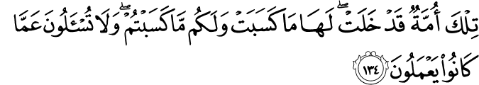

2.134. Those were a people that passed away. Theirs is what they earned, and yours is what you earn. You will not be called to account for what they used to do.(1)

2.141. Those were a people that passed away. Theirs is what they earned, and yours is what you earn. You will not be called to account for what they used to do.(2)

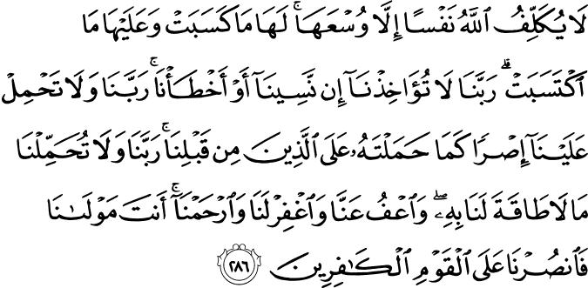

2.286. (O believers, if you are worried that God will take every soul to account even for what the soul keeps within it of intentions and plans, know that) God burdens no soul except within its capacity: in its favor is whatever (good) it earns, and against it whatever (evil) it merits. (So, pray thus to your Lord:) "Our Lord, take us not to task if we forget or make mistakes. Our Lord, lay not on us a burden such as You laid on those gone before us. Our Lord, impose not on us what we do not have the power to bear. And overlook our faults, and forgive us, and have mercy upon us. You are our Guardian and Owner (to Whom We entrust our affairs and on Whom we rely) so help us and grant us victory against the disbelieving people!"(3)

HADITH

(4) Abdullah bin Umar reported: The Messenger of Allah, peace and blessings be upon him, said, “Every one of you is a shepherd and is responsible for his flock. The leader of people is a guardian and is responsible for his subjects. A man is the guardian of his family and he is responsible for them. A woman is the guardian of her husband’s home and his children and she is responsible for them. The servant of a man is a guardian of the property of his master and he is responsible for it. Surely, every one of you is a shepherd and responsible for his flock.”(4)
(5) Prophet Muhammad (peace and blessings be upon him) said,
"The faithful, in their love for one another and in their having mercy for one another and in their kindness toward one another, are like one body; when a member of it ails, all (the parts of) the body call one another (to share the pain) through sleeplessness and fever." (5)

The Consciousness of Responsibility

The most deeply significant aspect of existence is action and effort. Inertia is dissolving, decomposition, and another name for death. Connecting or relating action to responsibility gives action its primary humane dimension. An action or effort which is not disciplined by responsibility cannot be considered to be complete.
Most human beings pursue various goals and objectives. However, unless this pursuit gains depth through responsibility, it is vain to expect anything of value in consequence. Nevertheless, the self-seeking, whose heads are turned by greed for personal interest and profit, work incessantly; politicians visit everywhere and deliver their enthralling speeches; the media produce a huge range of shows in the name of informing the public; some circles of society turn to indulgence with every breath the year round; some so-called religious men are driven by a desire for profit, and stock exchange indexes fall and rise with speculations day and night; some state offices shower favors only to particular ideologies and their adherents; and some wise men watch these numerous happenings with the utmost indifference. That is, as the mighty and the oppressors oppress, and the oppressed and crushed accept all these as “ordinary,” as “natural selection, the survival of the fittest,” so many things which need to be done become harder to do.
It is wrong if they say a society can live with such insensitivity,
Show me a nation, which has survived with a dead spirituality?
Mehmed Akif Ersoy
And should you happen to ask such people, “Where are you heading?” they either ignore you or reproach you and continue on their way. If they do not slap or spit in your face, they will most probably respond by ignoring or mocking the consciousness of responsibility as in, “Every sheep is hung by its leg,”[1] or “He who saves the ship is the captain.”[2] Even with the utmost insolent, free and easy behavior, causing palpitations in our alert conscience, they respond nonsensically, “Long live the snake that does not bite me.” Alas, you can face many responses like this that will clash with your purest thoughts and most innocent feelings.
However, even though these are not the thoughts of believing and sensitive hearts, it is not reconcilable with our consciousness of responsibility to say “stuff and nonsense” and to pass by. For we, as an entire nation, are surrounded by enemies and enmities. As long as we are under such a siege, we cannot even claim to be ourselves with respect to our feelings, thoughts, faith, art, and free enterprise; we cannot thus retain or protect our Islamic dignity, our national honesty, save our ship and reach the shore in safety, establish our own world, live as we wish, become the inheritors of the Earth and reach God. It is time for us to open our eyes and see reality, to use our insight and stand as the protector and patron of what our accomplishments and purge ourselves of whatever is gnawing at our being and personality from the inside. Otherwise, one day it will be impossible to retain even what we have now.
Once, our enemies used to be ignorance, illiteracy, poverty, disunion, and bigotry. Now to these have been added cheating, bullying and coercion, extravagance, decadence, obscenity, insensitivity, indifference, and intellectual contamination. May those who preserve their purity of religion, clarity of thought, and patriotic feeling, and those who share concerns similar to those I have stated above, excuse my saying that for quite a long time now our younger generations and some of the simple-minded among the older generation have been led astray by virtue of their naïveté; they have been deceived by corrupt ideologies, the only merits of which lie in their elaborate presentation. Even if this is true only in some circles, to experience such a deviation of thought and personality as a nation would be the veritable invasion of this blessed country. In fact, only then Sultan Mehmed the Conqueror would be poisoned, Sultan Murad I stabbed, Sultan Y?ld?r?m Bayezid died of grief, and Sultan Yavuz Selim afflicted by a tumor. This is nothing less than the massacre of the spirit of the nation which emerged victorious from the National War; a massacre led by the evil of the age, by the heedlessness of the intelligentsia, and the indifference of the masses.
We are charged with the responsibility for endowing our world with a fresh, new spirit, woven from a love of faith, a love of our fellow human being, and a love of freedom. We have further been charged with the responsibility for being ourselves, connected to the principle of these three loves, and for preparing the ground for the shoots, the pure roots of the blessed tree of Paradise, so that it will be nurtured and grow in the loam of these loves. This, of course, depends on the existence of heroes who will take responsibility for and protect the country’s destiny and the history, religion, traditions, culture, and all sacred things that belong to the people; this will depend on heroes who are absolutely full of a love for science and knowledge, burgeoning with the thought of improvement and construction, sincere and devout beyond measure, patriotic and responsible, and, therefore, always conscientiously at work, in charge, and on duty. Thanks to these heroes and their sincere efforts, our system of thoughts and understanding and the fruit of these will prevail with our people; the sense of devoting oneself to others and to the community will gain prominence; the understanding of the division of labor, the management of time, and assisting and liaising with one another will be revived; all relationships of authority-subject, employer-employee, landlord-tenant, landowner-peasant, artist-admirer, attorney-client, teacher-student will become different aspects of the unity of the whole; all this will come about once more and all our expectations from ages past will come true, one by one. We now live in an era in which our dreams are being realized and we believe that with good timing each of the responsibilities of the age will have been accomplished by the time its day arrives.
That is the basis of our dreams and vision; the first and principle way to realize them is through the consciousness and the ethic of responsibility. As complete inertia is a death and disintegration, and irresponsibility in action is disorder and chaos, we are left with no alternative but to discipline our actions with responsibility. Indeed, all our attempts should be measured by responsibility. Our way is the way of truth, our cause is to hold and raise the truth, and our target is to seek the pleasure of God in each and every blinking of the eye. In fact, to be so is the alms we pay for being human and the reason and justification for our willpower. We hold ourselves obliged to seek the goal of life in our lives, to awaken to love in our souls, to comprehend the consciousness of responsibility in our conscience, to show the route to science, knowledge, art, morality, and wisdom to those who are ready for reception to the source of a system whose principles, foundations, light, and driving force are faith and love; we hold ourselves as servants who will not accept release from this mission. Our efforts, which we hope to bring to fruition in the line and spirituality of all the friends of God—the saints (awliya), the sincere (asfiya), the good (abrar), and the close (muqarrabin)—will be the beginning of a second Renaissance.
So far, every age has had its wonder: the rebirth of humanity in the sixth century, the revival of the Turkish tribes and nations by Islam in the tenth century, and the metamorphosis in the province of Sögüt of a small chrysalis into the magnificent Ottoman butterfly. I suppose the wonder of the twenty-first century will appear to be that our people and the peoples related to us will attain their rightful place in the international balance of power. Such an emergence, which will change the flow and direction of the history of the world, will rotate about the axis of the soul, morality, love, and virtue. Through the spiritual struggle (jihad) which we can also call “a struggle for knowledge, morality, truth, and justice,” we believe that the generations which have so far been left without protection and ideals will experience a new resurrection in a manner like the exhilaration of reaching the banner of the Prophet in the field of resurrection, the banner under which all Muslims will gather.
[1] A Turkish proverb, each and every one is responsible for himself or what he has done; what I do is none of your business, you will not be questioned or accounted for what I do, so mind your own business.
[2] He who succeeds is acknowledged as an able person; I managed something now, I am able, I have the potentiality, or full control, therefore I will try to make the best of the opportunities arisen and harvest what it yields; if you are able then you too do it, if don’t leave me alone.(6)
References
(1) 2:134/The Quran with Annotated Interpretation in Modern English by Ali Unal
(2) 2:141/The Quran with Annotated Interpretation in Modern English by Ali Unal
(3) 2:286/The Quran with Annotated Interpretation in Modern English by Ali Unal
(4) Source: Sahih Bukhari 6719, Sahih Muslim 1829
(5) (Muslim)
(6) Gülen, Fethullah. The Statue of Our Souls. http://www.fgulen.com/. 08 August 2005

