Time Management for Path of Allah

102:8. And on that Day, you will most surely be questioned as to all the favors (bestowed on you).^{1/2}
1. That is, there are certain duties concerning all the worldly things bestowed on you. You should not be proud because of them and their abundance. Rather, you should thank God because He has given them to you; earn and spend your wealth lawfully, doing so primarily with the intention of using it in God's cause; and bring up your children as good believers.(1)

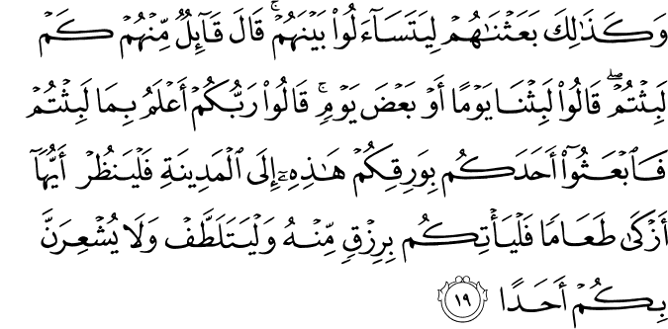

18.19. Such being their state, We raised them up so they began to ask questions of one another. One who spoke said: "How long have you stayed?" They (some among them) answered: "We have stayed a day, or part of a day. " The others said: "Your Lord knows better how long you have stayed. Now (we must deal with our hunger. So) send one of you to the city with this coin of yours: let him see what food is most pure there (and so lawful), and bring a supply from it. But let him behave with utmost care and guarded courtesy, and by no means make anyone aware of you.(2)

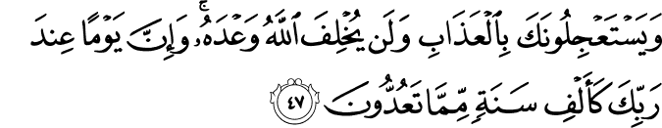

22.47. They challenge you to hasten the coming upon them of God's punishment (with which they are threatened). Let them know that God never fails to fulfill His promise; but a day with your Lord is like a thousand years in your reckoning.(3)

17.27. Surely squanderers are ever brothers of satans; and Satan is ever ungrateful to his Lord.(4)

HADITH

The Prophet (pbuh) said: ”Take advantage of five matters before five other matters: your youth before you become old; your health, before you fall sick; your wealth, before you become poor; your free time before you become preoccupied, and your life, before your death.”(5)

Question: How should a person spend one day, one week, one month, and one year in order to perform services in the path of God?

Management of time and work is one major area where many of us perform very poorly. Being hardworking and self-sacrificing is fine and believers should strive to be as such, but for some reason, many of us are indifferent to organization of our lives and live in a disorderly way. In addition to their lack of penchant for scheduling their work, they cannot systematize the idea of doing service to humankind as the primary purpose of their lives despite the fact that they already make so many sacrifices. A person should refrain from allocating only a small or limited part of his or her time to the mission of doing services in the path of God, but try to make their mission permeate to every fragment of time during a day, keeping his/her purposes or goals in sight, and leading a well-scheduled life.
There are some points that must be discussed in this context. First, a person will make the idea of doing service to God part of his or her life if s/he has sincere faith in it and is prepared to suffer to this end. If a person is painfully diligent for service, s/he will be equally meticulous about managing his or her time. S/he will make slices out of his or her day based on the prayer times such that there will be a time slice between the dawn prayer and the mid-day prayer, another between the mid-day prayer and the afternoon prayer and the sunset prayer, another between the sunset prayer and the night prayer, and s/he will say, “If I fail to labor for the sake of my mission for service during any of these time slices, then all the time slices of my life will be deemed as wasted.” Indeed, time is relative and it has no real body.
The thing that gives value, vitality and liveliness to time is what is done within that period or, in other words, its contents. When we refer to the Age of Happiness, we hail not a certain age or period of time, ipso facto, but the people who lived during that span of time as well as the deeds they performed therein. Time only takes on color in relation to what happens then and it becomes a rainbow. A moment of time lived fully in this way is worth centuries of other time. Therefore, giving real essence and value to time or putting it to good use is directly proportional to what one can do during the passage of that time.
Secondly, we have a capital of twenty-four hours. If we remember the possibility that these twenty-four hours may be the last twenty-four hours of our life and if we schedule this period of time according to our daily prayers and if we try to perform good deeds during every time slice separated by prayers, then we will attain the true value of time and our life will start to flow in a luminous manner and in a way that will fully deserve eternity.
If a person can put his/her time to good use in this way, then this means that s/he really appreciates the importance of time and the points raised in the question are automatically dealt with. Thus, the idea of doing service to humankind will be visible not only throughout our day, but also throughout our week. And these will combine to form a luminous month and an illustrious year consisting of these enlightened months.
If only our people as a whole knew how to organize time and use it to their advantage! However, doing this fully is dependent on their fully believing in our philosophy of service to others. Indeed, without this dedication, nothing can be done or ensured through compulsion. Repetitive acts of servant hood toward God faith becomes a second nature. The same applies to our case.
When time management becomes a second nature in our consciences, then we will concentrate on it and try to decorate every part of it with the wealth of our spiritual world and we will not allow any flat moment to pass. Actually, by inserting precious stretches of time such as prayer times into a day of twenty-four hours, God intends to spread the luminosity of these moments to the entire time and make sure that we can feel the passage of time as we live through it. God illuminates the week with Friday which contains in it the propitious moment. If during that sacred and most esteemed moment, people can raise their hands in supplication and turn toward God girded ready for worship, they will witness so many surprises in their lives.
Similarly, Almighty God illuminates a month with four Fridays, and a year of 365 days with Ramadan. There are sources of light scattered by God over time such as these and one can find them not only within a day or a week or a month, but also within a year or during one’s own life. In doing so, God intends to teach us how to make an efficient time management. By taking advantage of these small pieces of time, from the past to the present, people with common sense have been successful in living their whole lives in light.
Almighty God has so many favors over us and the gracious favors of our Lord are like clouds hanging overheard. But, whether we reach out and pick these favors or walk in the shade of them is up to us as we are free to use our will to do so.
May God help us succeed in using our free will to manage our time and put our time to good us!(6)

References
(1) 102:8/The Quran with Annotated Interpretation in Modern English by Ali Unal
(2) 18:19/The Quran with Annotated Interpretation in Modern English by Ali Unal
(3) 22:47/The Quran with Annotated Interpretation in Modern English by Ali Unal
(4) 17:27/The Quran with Annotated Interpretation in Modern English by Ali Unal
(5) (Narrated by Ibn Abbas in the Mustadrak of Hakim & Musnad Imam Ahmad. Sahih)
(6) Isik, Hikmet. Fountain Magazine. Issue 77 / September – October 2010

