Humility (Tawadu)

25.63. The (true) servants of the All-Merciful are they who move on the earth gently and humbly, and when the ignorant, foolish ones address them (with insolence or vulgarity, as befits their ignorance and foolishness), they respond with (words of) peace (without engaging in hostility with them);(1)

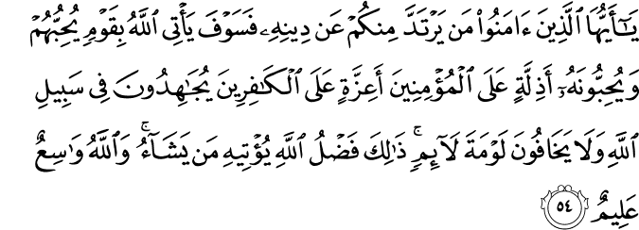

5.54. O you who believe! Whoever of you turns away from his Religion, (know that) in time, God will raise up a people whom He loves, and who love Him, most humble towards the believers, dignified and commanding in the face of the unbelievers, striving (continuously and in solidarity) in God's cause, and fearing not the censure of any who censure. That is God's grace and bounty, which He grants to whom He wills. God is All-Embracing (with His profound grace), All-Knowing.(2)

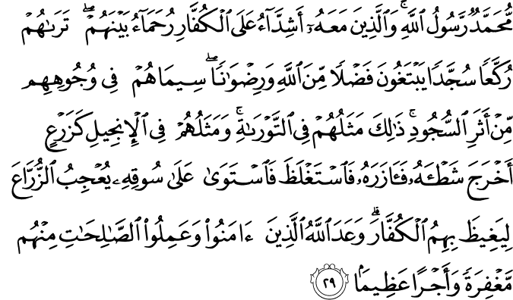

48.29. Muhammad is the Messenger of God; and those who are in his company are firm and unyielding against the unbelievers, and compassionate among themselves. You see them (constant in the Prayer) bowing down and prostrating, seeking favor with God and His approval and good pleasure. Their marks are on their faces, traced by prostration. This is their description in the Torah; and their description in the Gospel: like a seed that has sprouted its shoot, then it has strengthened it, and then risen firmly on its stem, delighting the sowers (with joy and wonder), that through them He fills the unbelievers with rage. God has promised all those among them who believe and do good, righteous deeds forgiveness (to bring unforeseen blessings) and a tremendous reward.(3)

HADITH
The Prophet (SAW) said, “…. no one is humble (for the sake of Allah) unless Allah raises him [in rank].”(4)
The Prophet (SAWS) said, “He who is humble for the sake of Allah by a degree, Allah will elevate him one degree, until he reaches the highest degrees and he who is arrogant toward Allah, Allah will lower him one degree until he reaches the lowest of low degrees.”(5)
The Prophet (SAWS) said, “Allah revealed to me that we should be humble amongst ourselves and none should show arrogance toward others.”(6)

Humility (Tawadu)

Tawadu (modesty and humility) is the opposite of arrogance, pride, and haughtiness. It can also be interpreted as one’s awareness of one’s real position before God, and as letting that realization guide one’s conduct toward God and with people. If one sees oneself as an ordinary, individual part of creation, a threshold of a door, a mat spread on a floor or a pavement stone, a pebble in a stream or chaff in a field, and if one can sincerely confess, as did Muhammad Lutfi Effendi: Everybody else is good but I am bad; everybody else is wheat but I am chaff, the inhabitants of the heavens will kiss him or her on the head.
In a narration attributed to the truthful, confirmed one, upon him be peace and blessings, it is said: Whoever is humble, God exalts him; whoever is haughty, God humiliates him. Thus, one’s true greatness is inversely proportional to behaving as if one were great, just as one’s true smallness is inversely proportional to behaving as if one were small.
Humility has been defined in many ways: seeing oneself as devoid of all virtues essentially originating in oneself, treating others humbly and respectfully, seeing oneself as the worst of humanity (unless being honored by a special Divine treatment), and being alert to any stirring of the ego and immediately suppressing it. Each definition expresses a dimension of humility. However, the last definition relates to those made sincere by God Himself and who are near to Him.
A Companion saw Caliph ‘Umar, may God be pleased with him, carrying water in a pitcher on his shoulder. He asked him: What are you doing, O Caliph of God’s Messenger? ‘Umar, one of the foremost in nearness to God, answered: Some envoys have come from other countries. I felt some conceit in my heart and wanted to suppress it. ‘Umar used to carry flour on his back. Once he accused himself while giving a sermon from the pulpit, and kept silent when people questioned and criticized his action.
Abu Hurayra carried wood while he was the deputy governor of Madina. When he was the chief judge in Madina, Zayd ibn Thabit kissed Ibn ‘Abbas’ hand, and Ibn ‘Abbas, known as the Interpreter of the Quran and the Scholar of the Umma, helped Zayd get on his horse. Hasan, the grandson of the Prophet, upon him be peace and blessings, sat with some children who were eating bread crumbs and ate with them. Once Abu Dharr offended Bilal al-Habashi and, to obtain his forgiveness, put his head on the ground and declared: If the blessed feet of Bilal do not tread on this sinful head, it will not rise from the ground. All of these events and many similar ones are instances of humility.
Both God Almighty and His Messenger emphasized humility so much that one who knows of it does not doubt that servanthood consists of humility. The Quranic verse: The servants of the All-Merciful are those who walk on the earth in modesty, and if the impudent offend them, they continue their way saying: “Peace” (25:63) praises humility, and the Divine statements extremely humble toward believers (5:54) and merciful among themselves; you find them bowing down and falling prostrate (48:29) are expressions of praise for the ingrained humility reflected in their conduct.
Concerning humility, the glory of humanity, upon him be peace and blessings, declared: God has told me that you must be humble, and that no one must boast to another ; Shall I inform you of one whom Hellfire will not touch? Hellfire will not touch one who is near to God and amiable with people, and mild and easy to get along with ; God exalts one who is humble. That one sees himself as small while he is truly great in the sight of people ; and O God, make me see myself as small.
The glory of humanity, upon him be peace and blessings, lived as the most humble of people. He stopped at the places where children were gathered, greeted them, and played with them. If someone held him by the hand and wanted to lead him somewhere, he never objected. He helped his wives with the housework. When people were working, he worked with them. He mended his shoes and clothes, milked sheep, and fed animals. He sat at the table with his servant. He always welcomed the poor warmly, looked after widows and orphans, visited the ill, followed funeral processions, and answered the call of slaves in his community.
The beloved servants of God, from God’s Messenger, upon him be peace and blessings, to Caliph ‘Umar and the Umayyad Caliph ‘Umar ibn ‘Abd al-‘Aziz and from him to numerous saints, purified and perfected scholars, and those honored with nearness to God, have held that the signs of greatness in the great are humility and modesty, while the signs of smallness in the small are arrogance and vanity. Based on this understanding, they sought to show men and women how to become perfect.
True humility means that people must know the full extent of their worth before God’s infinite Grandeur, and then make this fully realized potential an ingrained, essential part of their nature. Those who have done this are humble and balanced in their relations with others. Those who have realized their nothingness before God Almighty are balanced in both their religious lives and their relations with people. They obey the commandments of religion, for they have no objection to the revealed truths of religion, nor do they criticize its method of addressing or relating to human reason. They are convinced that what is contained in the Quran and the authentic Traditions of the Prophet, upon him be peace and blessings, is true.
If there is an apparent contradiction between these two sources and human reason or established rational or scientific facts, such people seek to learn the truth of the matter. Therefore, it is nonsense for those without humility and modesty to assert, when confronted with an apparent contradiction between reason or rational premises and the revealed and narrated principles of religion, that reason or what is rational must be preferred. Their further assertion that judgments based on reasoning and analogy must be given priority over revealed principles is also mistaken. The wonders worked and spiritual pleasures felt by following ways not followed by the Prophet, upon him be peace and blessings, is God’s way of leading people to perdition, for “success” in such endeavors leads to sin.
Those who have achieved humility are completely convinced of the truth of whatever the Prophet said or did. They never doubt it, and seek to practice it in their lives. If something else, such as a wise saying or a great accomplishment, appears to them as more beautiful or acceptable, they accuse themselves of being unable to discern the incomparable superiority of the revealed truths and expressions, saying:
There are many people who find fault with the words having no defects.
However, the fault lies in their defective understanding.
They are certain that one cannot prosper in the Hereafter by following ways opposed to the Quran and the Sunna. They find the greatest source of power in servanthood to God. In reality, one who worships God never adores anyone else, and one who serves others cannot be a true servant of God. How apt are the following words of Bediuzzaman:
Do not see anything or anybody else other than God as so much greater than you as to deserve adoration or servanthood. Do not boast of yourself in a way to see yourself as greater than others. As creatures are equal in being distant from being worshipped, so also are they equal in that they are all created.
Those who are truly humble do not attribute the fruits of their work and efforts to themselves, nor do they regard their successes or efforts in the way of God as making them superior to others. They do not care how other people regard them, and do not demand a return for their services in the way of God. They regard their being loved by others as a test of their sincerity, and do not exploit God’s favors to them by boasting to others about them.
In short, just as humility is the portal to good conduct or being characterized with the qualities of God (such as generosity, merciful, helpful, forgiving, and so on), it is also the first and foremost means of being near to both the created and the Creator. Roses grow on the earth, and humanity was created on the earth and not in the heavens. A believer is nearest to God when prostrating before Him. While recounting the Prophet’s Ascension (to the heavens), the Quran refers to him as God’s servant, as a sign of his humility and utmost modesty.(7)
References
(1) 25:63/The Quran with Annotated Interpretation in Modern English by Ali Unal
(2) 5:54/The Quran with Annotated Interpretation in Modern English by Ali Unal
(3) 48:29/The Quran with Annotated Interpretation in Modern English by Ali Unal
(4)[Authentic hadith reported by Muslim in al-Sahih al-Jami’, book 19, page/number1599, narrated by Abu-Hurayrah]
(5)[Hasan Hadith; Narrated by Abu-Said Al-Khudri on the authority of Ibnu-Hijr Al-Asqalani, number, 89.]
(6)[Authentic hadith reported by Muslim in al-Sahih al-Jami’, book 040, number 6856. Narrated by Ayad ibn-Hammar
(7)Gulen, M. Fethullah. Fountain Magazine. Issue 77 / September – October 2010

