BELIEF IN THE QUR’AN

Sura Al-Anbiya/Ayat 33:
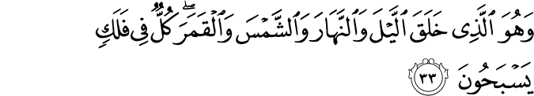

"It is He Who created the night and the day, and the sun and the moon. They swim along, each in an orbit.” (1)
SuraAr-Rahman/Ayat 19-20:
"He has let loose the two seas, converging together, with a barrier between them
they do not break through." (2)
SuraAz-Zumar/Ayat 6:

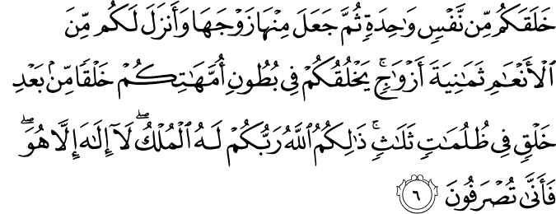

"... He creates you stage by stage in your mothers' wombs in a threefold darkness. That is God, your Lord. Sovereignty is His. There is no god but Him. So what has made you deviate?” (3)

Sura Al-Alaq/Ayat 1-3:

"Recite: In the name of your Lord Who created man from a CLING. Recite: And your Lord is the Most Generous." (4)

"The life in the uterus has three stages: pre-embryonic; first two and a half weeks, embryonic; until the end of the eighth week, and fetal; from the eighth week to labor." (5)

------------------------------------------------------------------------------------------------------------

Narrated By Abu Musa : The Prophet said, "The example of a believer who recites the Qur'an and acts on it, like a citron which tastes nice and smells nice. And the example of a believer who does not recite the Qur'an but acts on it, is like a date which tastes good but has no smell. And the example of a hypocrite who recites the Qur'an is like a Raihana (sweet basil) which smells good but tastes bitter And the example of a hypocrite who does not recite the Quran is like a colocynth which tastes bitter and has a bad smell." (6)

Narrated By Anas bin Malik : That he heard 'Umar speaking while standing on the pulpit of the Prophet in the morning (following the death of the Prophet), when the people had sworn allegiance to Abu Bakr. He said the Tashah-hud before Abu Bakr, and said, "AmmaBa'du (then after) Allah has chosen for his Apostle what is with Him (Paradise) rather than what is with you (the world). This is that Book (Quran) with which Allah guided your Apostle, so stick to it, for then you will be guided on the right path as Allah guided His Apostle with it." (7)

------------------------------------------------------------------------------------------------------------

Did Prophet Muhammad Write the Qur'an? (8)

The Qur'an is absolutely different from any human product in the transcendence of its perspective and viewpoint. Occasionally in a few scattered phrases or passages of other Scriptures, readers or listeners may feel that they are in the presence of the Divine Message addressed to humanity. In the Qur'an, every syllable carries this impression of sublime intensity belonging to a message from One who is All-Knowing and All-Merciful.

Furthermore, the Qur'an cannot be contemplated at a distance, or discussed and debated in the abstract. It requires us to understand, act, and amend our lifestyles. It also enables us to do so, for it can touch us in the very depths of our being. It addresses us in our full reality as spiritually and physically competent beings, as creatures of the All-Merciful. It is not addressed to just one human faculty, such as philosophical reasoning, poetic or artistic sensibility, our ability to alter and manage our environment or political and legal affairs, our need for mutual compassion and forgiveness, or our spiritual craving for knowledge and consolation. The Qur'an also is directed to everyone, regardless of age, gender, race, location, or time.

This transcendence and fullness can be felt in every matter that the Qur'an mentions specifically. For example, caring for one's elderly parents is placed beside belief in God's Oneness, and providing decently for a divorced wife with reminders to be conscious of the All-Knowing and All-Seeing. While the reasoning behind such placement is God's alone, His believing servants know and can report its effect: It enables the inner self-reform that makes the steady, cheerful, and humble performance of virtuous actions possible. Thus, the one who does the deed does it gracefully, and its recipient is not oppressed or humiliated by it.

The Qur'an challenges its detractors to compose a chapter that can equal it. No one has successfully met this challenge. In fact, such an achievement is impossible, for only God can assume the Qur'an's all-transcendent and all-compassionate perspective. Our thoughts and aspirations are affected and conditioned by surrounding circumstances. That is why, sooner or later, all human works fail or fade away into obsolescence, and why they are too general to have any real influence or too specific to do much good beyond the specific area they address. Whatever we produce is of limited value for just these reasons. As stated in the Qur'an: Say: if all of humanity and the jinn were to gather together to produce the like of this Qur'an, they could not produce the like of it, even if they backed each other with help and support (17:88).

The Qur'an is the Word of the All-Knowing and All-Seeing, who knows everything about His creation. It therefore comprehends and tests its audiences as it teaches. For believers, the consciousness of being before the Divine Message can make their skins shiver, in the words of the Qur'an, so suddenly and fully does the atmosphere around and within them change.

The Qur'an's substance also is a compelling argument for its Divine authorship. Those who allege that someone wrote it provide no proof to support their assertion. Other Scriptures, due to human intervention, make claims that we know to be untrue. For example, they give a particular account of creation or of a natural phenomenon (e.g., the Flood), which we know from modern scientific facts, such as fossils or astronomic discoveries, to be false. People altered those Scriptures to suit their own understanding, with the result that the progress of science has rendered their understanding and their now-corrupted Scriptures largely irrelevant and obsolete. However, the Qur'an has not been subject to such mistreatment.
If someone wrote the Qur'an, how could it be literally true on matters that were completely unknown at the time of its revelation? Do not the unbelievers realize that the Heavens and the Earth were one unit of creation before we split them asunder? (21:30). Only in the last few years have we been able to contemplate this verse about the first moment of the universe in its literal meaning.

References:

(1) 21:33/The Quran with Annotated Interpretation in Modern English by Ali Unal
(2) 55:19-20/The Quran with Annotated Interpretation in Modern English by Ali Unal
(3) 39:6/The Quran with Annotated Interpretation in Modern English by Ali Unal
(4) 96:1-3/The Quran with Annotated Interpretation in Modern English by Ali Unal
(5) Williams P., Basic Human Embryology, 3. edition, 1984, s. 64.)
(6) SahihBukhari Volume 006, Book 061, Hadith #579.
(7) SahihBukhari Volume 009, Book 092, Hadith #374.
(8) ”Did Prophet Muhammad Write the Qur'an?” by FethullahGülen on 13 September 2001. Posted in Questions and Answers

