GREETING

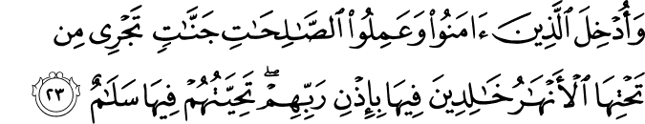

14.23. But those who believed and did good, righteous deeds are admitted to the Gardens through which rivers flow, therein to abide by their Lord's leave. Their greeting therein (among themselves and from God and the angels) will be "Peace!"(1)

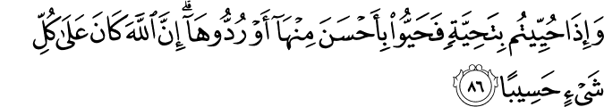

4.86. When (whether traveling or at home, or in war or at peace) you are greeted with a greeting (of peace and goodwill), answer with one better, or (at least) with the same. Surely God keeps account of all things.(2)
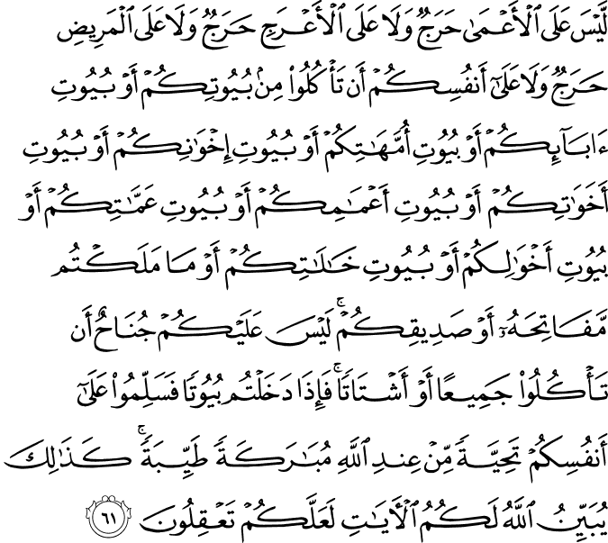
24.61. There is no blame on the blind, nor any blame on the lame, nor any blame on the sick (for eating only to satisfy their need without causing any harm and waste, in the house of any healthy, well-off person), and neither on yourselves, that (in case of need and without prior invitation) you eat in your spouse's and children's houses, or your fathers' houses, or your mothers' houses, or your brothers' houses, or your sisters' houses, or your paternal uncles' houses, or your paternal aunts' houses, or your maternal uncles' houses, or your maternal aunts' houses, or in the houses for which you are responsible, or in the houses of any of your close friends (who should be happy to see you feeling free to eat at their home). There is no blame on you if you eat together or separately. But when you enter any of these houses, greet one another with a blessed, pure and good salutation appointed by God. Thus, God makes clear for you (the instructions in) His Revelations, that you may reason and understand.(3)

HADITH

427. Abu Hurayra, may Allah be pleased with him, reported that the Messenger of Allah, peace and blessings be upon him, said, “You will not enter Paradise until you believe and you will not believe until you love one another. Shall I tell you something the doing of which will give you love of one another? Make the greeting common practice among you.” (Sahih Muslim, Iman, 93).(4)
428. Abu Yusuf Abdullah ibn Salam, may Allah be pleased with him, said, “I heard the Messenger of Allah, peace and blessings be upon him, say, ‘O people! Make the greeting common practice, provide food, maintain ties of kinship and pray while people are asleep and you will enter Paradise in safety.’” (Sunan at-Tirmidhi, Qiyamah, 42).(5)
430. Abu Hurayra, may Allah be pleased with him, reported that the Messenger of Allah, peace and blessings be upon him, said, “Someone riding should greet someone walking, and someone walking should greet someone sitting, and a small group should greet a larger group.” (Sahih al-Bukhari, Isti’zan, 5–7; Sahih Muslim, Salam, 1). In the variant of Sahih al-Bukhari, “The young should greet the old.”(6)

The Prayer of Greeting the Masjid
558. Abu Qatada, may Allah be pleased with him, reported said that the Messenger of Allah, peace and blessings be upon him, said, “When one of you enters the mosque, he should not sit down until he has prayed two units.” (Sahih al-Bukhari, Salah, 60; Sahih Muslim, Salatu’l-Musafirin, 69).(7)

Etymologically speaking, the word Muslim and the verb sa-li-ma both come from the root silm. This means that for Muslims, every matter takes place in line with silm (security), salamah (safety), and Muslim-ness. Muslims are seized by such a divine attraction that all of their actions take place around this powerful center.
They greet everyone with salaam, thereby placing love for themselves in everyone’s heart.[2] They end their prayers with salaam. All people, jinn, angels, and conscious creatures receive their salaam. That is, they exchange greetings with invisible creatures as well. Until now, no other people have extended this circle of greeting to such a degree as have the Muslims. Islam consists of performing such principal duties as fasting, giving alms, performing the Hajj, and striving to profess the faith. This means that they set sail on the sea of safety and security by obeying the command: Enter safety (Islam) whole-heartedly (2:208). Those who throw themselves into that sea emanate safety and Islam in every condition. No one sees anything but goodness in the actions and behavior of such people.
The ideal believers who enter an atmosphere of safety and security, having so immersed themselves in that atmosphere that they harm no one with their hands or tongues. This refers only to the true and ideal Muslims who leave their mark on all minds, not those who appear or claim to be so, or to those whose identity cards or passports have “Muslim” written on them.
Real Muslims are people in whom one can feel confidence and trust, so much so that other Muslims can turn their backs on them without a second thought. One can entrust a family member to such people without fear; this person will suffer no injury from the hand or tongue of the Muslim. If one were to attend a gathering with a true Muslim, one could leave in full confidence that no one will gossip about one, nor would one have to listen to gossip about others. Such Muslims are as sensitive to the dignity and honor of other people as they are to their own. They do not eat; they feed others. They do not live for themselves; they live to enable others to live. They will even sacrifice their spiritual pleasure for others.(8)

Here are some o the common sayings, greetings and their meaning.

When we meet another Muslim
“As salamu alaikum wa rahmatullah wa barakatuhu”
may the mercy, peace and blessings of Allah be upon you
( And they will reply) “wa alaikum salam wa rahmatullah wa barakatuhu” and may the peace mercy and blessings of Allah be upon you
When we sneeze we say;
“Alhamdulillah” ( all praises is due to Allah) and any Muslim present must reply “yar hamuk Allah” ( may Allah have mercy on you ) and we can reply “yah dina ve yah dikumulllah ”
We praise Allah
“Alhamdulillah” and “subhanAllah” ( All the praises are due to Allah - how free from imperfections is Allah )
When we eat
"Bismilallah" and "Allahumma barik lana fee ma razaktana wa zidna khairan minh" (In the name of Allah )
The greatest words for us to say are
La il laha il Allah, Muhammad a rasool Allah.
(There is no God but Allah and Muhammad is his messenger)
When the name of Prophet Muhammad is mentioned
“SalAllahu allehi wa salam”
( may peace and blessings of Allah be upon him )
When we want to thank someone we can make duaa for them saying
jazakAllahu khair
( may Allah reward you with good )
or “BarakAllahu feek”
( may Allah give u barakah)
When we hear of someones death
"Inna lillahi wa inna ilayhi rajiun."
(To Allah we belong and to Him we return.)
when u see something bad
audu billah
( i seek refuge in Allah )
When showing appreciation for something
masha Allah
( as Allah wills)
When making a mistake and seeking forgiveness
Astaghfirullah."
( may Allah forgive me )
When planning to do something
insha Allah ( as Allah wills)
References
(1)14:23.The Quran with Annotated Interpretation in Modern English by Ali Unal
(2)4:86.The Quran with Annotated Interpretation in Modern English by Ali Unal
(3)24:61.The Quran with Annotated Interpretation in Modern English by Ali Unal
(4)Nawawi, Imam. Riyad As-Salihin; The Gardens of the Righteous: A collection of authentic hadiths. Tughra Books Press, Inc. 2014
(5)Nawawi, Imam. Riyad As-Salihin; The Gardens of the Righteous: A collection of authentic hadiths. Tughra Books Press, Inc. 2014
(6)Nawawi, Imam. Riyad As-Salihin; The Gardens of the Righteous: A collection of authentic hadiths. Tughra Books Press, Inc. 2014
(7)Nawawi, Imam. Riyad As-Salihin; The Gardens of the Righteous: A collection of authentic hadiths. Tughra Books Press, Inc. 2014
(8)Gulen, M. Fethullah. Toward a Global Civilization of Love and Tolerance. Tughra Books. 2012

