RIGHTS OF WOMEN

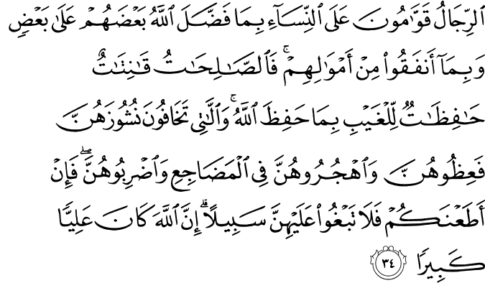

4.34. Men (those who are able to carry out their responsibilities) are the protectors and maintainers of women inasmuch as God has endowed some of people (in some respects) with greater capacity than others, and inasmuch as they (the men) spend of their wealth (for the family's maintenance). Good, righteous women are the devoted ones (to God) and observant (of their husbands' rights), who guard the secrets (family honor and property, their chastity, and their husband's rights, especially where there is none to see them, and in the absence of men,) as God guards and keeps undisclosed (what should be guarded and private). As for those women from whose determined disobedience and breach of their marital obligations you have reason to fear, admonish them (to do what is right); then, (if that proves to be of no avail), remain apart from them in beds; then (if that too proves to be of no avail), beat them lightly (without beating them in their faces). Then, if they obey you (in your directing them to observe God's rights and their marital obligations), do not seek ways against them (to harm them). (Be ever mindful that) God is indeed All-Exalted, All-Great.(1)

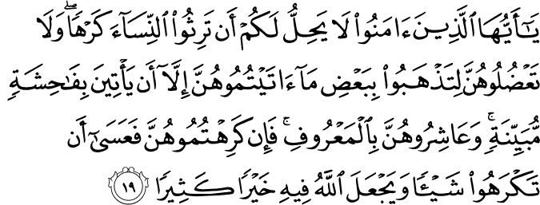

4.19. O you who believe! It is not lawful for you to become inheritors, against their will, of women (of your deceased kinsmen, marrying them against their will, without paying their bridal-due, or forcing them to marry others in return for their bridal-due, as though they were a part of heritable property); nor should you constrain your wives in order to take away anything of what you have given them (as bridal-due or bridal gift), unless they be guilty of indecency in an obvious manner (such as to justify divorce). Consort with them in a good manner, for if you are not pleased with them, it may well be that you dislike something but God has set in it much good.(2)

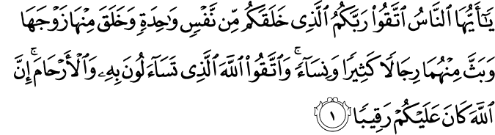

4.1. O humankind! In due reverence for your Lord, keep from disobedience to Him Who created you from a single human self, and from it created its mate, and from the pair of them, scattered abroad a multitude of men and women. In due reverence for God, keep from disobedience to Him in Whose name you make demands of one another, and (duly observe) the rights of the wombs (i. e. of kinship, thus observing piety in your relations with God and with human beings). God is ever watchful over you.(3)
HADITH

154. Abu Hurayra, may Allah be pleased with him, reported that the Messenger of Allah, peace and blessings be upon him, said, “A believing man should not hate a believing woman. If he dislikes something in her character, he should be pleased with some other or another trait of hers.” (Sahih Muslim, Rada, 61).(4)
156. Abu Hurayra, may Allah be pleased with him, said, “The Messenger of Allah, peace and blessings be upon him, said, ‘The most perfect of believers in belief is the best of them in character. The best of you are those who are the best to their women.’” (Sunan at-Tirmidhi, Rada, 11).(5)

Women’s Rights?

This is a very comprehensive subject. From one perspective it is open to debate. It’s very difficult to summarize my thoughts on this kind of platform. In one sense we don’t separate men and women. In another sense there are physical and psychological differences. Women and men should be the two sides of truth, like the two faces of a coin. Man without woman, or woman without man, cannot exist; they were created together. Adam suffered in Heaven because he had no mate, and then Heaven became a real Heaven when he found Eve. Man and woman complement each other.
Q: If we approach the matter from an Islamic perspective ?
A: Our Prophet, the Qur’aan, and Qur’aanic teachings don’t take men and women as separate creatures. I think the problem here is that people approach it from extremes and disturb the balance. There are differences on specific points. For example, men usually are physically stronger and apt to bear hardship, while women have deeper emotions; they are more compassionate, more delicate, more self-sacrificing. While looking for a place for each gender in society, we should consider these and other innate differences. God created everything, from sub-atomic particles to human beings, in pairs to form a unity.
Q: Are there examples for the female role?
A: In the social atmospheres of Muslim societies where Islam is not “contaminated” with customs or un-Islamic traditions, Muslim women are full participants in daily life. For example, during the Prophet’s time and in later centuries when the West gave women no place in society, when the West was debating whether or not women had spirits or were devils or human beings, ‘A’isha (one of the Prophet’s wives) led an army. She also was a religious scholar whose views everyone respected. Women prayed in mosques together with men. An old woman could oppose the caliph in the mosque in a judicial matter.
Even in the Ottoman period during the eighteenth century, the wife of an English ambassador highly praised the women and mentioned their roles in Muslim families and society with admiration.
Q: Can women be administrators?
A: There’s no reason why a woman can’t be an administrator. In fact, Hanafi jurisprudence says that a woman can be a judge. Maybe some women could explain certain matters more comfortably to a judge of their own gender.
Q: How did the Prophet view children?
A: He treated his children and grandchildren with great compassion, and never neglected to direct them to the Hereafter and good deeds. He smiled at them, caressed and loved them, but did not allow them to neglect matters related to the afterlife. His ultimate goal was to prepare them for the Hereafter.
All of the Prophet’s sons had died. Ibrahim, his last son born to his Coptic wife Mary, also died in infancy. The Messenger often visited his son before the latter’s death, although he was very busy. Ibrahim was looked after by a nurse. The Prophet would embrace, kiss, and caress him before returning home. When Ibrahim died, the Prophet took him on his lap again, embraced him, and described his sorrow while on the brink of tears. Some were surprised. He gave them this answer: “Eyes may water and hearts may be broken, but we do not say anything except what God will be pleased with.” He pointed to his tongue and said: “God will ask us about this.” [1]
Whenever he returned to Madina, he would carry children on his mount. On such occasions, the Messenger embraced not only his grandchildren but also those in his house and those nearby. He conquered their hearts through his compassion. He loved all children.
Q: How should parents treat their children?
A: These who bring children into this world are responsible for raising them to realms beyond the heavens. Just as you take care of their bodily health, so take care of their spiritual life. For God’s sake, have pity and save the helpless innocents. Do not let their lives go to waste.
The future of every individual is closely related to the impressions and influences experienced during childhood and youth. If children and young people are brought up in a climate where their enthusiasm is stimulated with higher feelings, they will have vigorous minds and display good morals and virtues.
The first school for children, whose souls are as bright as mirrors and as quick to record as cameras, are their homes. Their first educators are their mothers. Thus it is fundamental for a nation’s existence and stability that mothers be brought up and educated to be good educators for their children.
If parents encourage their children to develop their abilities and be useful to themselves and the community, they give the nation a strong new pillar. If, on the contrary, they do not cultivate their children’as human feelings, they release scorpions into the community.
Improving a community is possible only by elevating the young generations to the rank of humanity, not by obliterating the bad ones. Unless a seed composed of religion, tradition, and historical consciousness is germinated throughout the country, new evil elements will appear and grow in the place of each eradicated bad one.
Children should respect and obey their parents as much as possible. Parents should give as much importance to their children’as moral and spiritual education as they do to their physical growth and health, and should entrust them to the care of the most honorable teachers and guides. How ignorant and careless are those parents who neglect their children’s moral and spiritual training, and how unfortunate are the children who experience such neglect and are so victimized.
Children who are inconsiderate of their parents a rights and disobey them are “monsters derived from a deteriorated human being.” Parents who do not secure their children’s moral and spiritual welfare also are merciless and cruel. Most brutish and pitiless of all are parents who paralyze their children’s moral and spiritual development after their children have found their way to human perfection.
Q: What about young people?
A: Those who wish to predict a nation’s future can do so accurately by analyzing the education and upbringing its young people receive.
Desires resemble sweets, and virtues resemble food that is a little salty or sour. When young people are free to choose, what are they likely to prefer? Regardless of this, however, we must bring them up to be friends of virtue and enemies of indecency and immorality.
Until we help our young people through education, they are captives of their environment. They wander about aimlessly, moved by intense passions and far away from knowledge and reason. They can become truly valiant young representatives of the national thought and feeling only if their education integrates them with their past and prepares them intelligently for their future.
Think of society as a crystal vessel, and of its young people as the liquid poured into it. Notice that the liquid assumes the vessel’as shape and color. Evil-minded champions of regimentation tell young people to obey them instead of the truth. Do such people never question themselves? Should they not also obey the truth?
A nation’s progress or decline depends on the spirit and consciousness, the upbringing and education, given to its young people. Nations that have raised their young people correctly are always ready for progress, while those who have not done so find it impossible to take even a single step forward.
A young person is a sapling of power, strength, and intelligence. If trained and educated properly, he or she can become a “hero” who overcomes obstacles and acquires a mind that promises enlightenment to hearts and order to the world.
This article has been published separately in The Fountain’s April-June 2002 volume and thus is not contained in the book.
[1] Bukhari, “Jana’aiz,’a 44; Muslim, “Fada’ail,” 62; Ibn Maja, “Jana’aiz,” 53.

Women and the Qur’anic Prescriptions
One of the most sensitive and oft-debated issues with regard to Islam concerns the status and role of women in society. Arguably one of the aspects of social life which the emergence of Islam affected most was the status of women, with “the Qur’an hav[ing] more to say about the position of women than any other social question.” 1 At the time of its revelation in the seventh century, the Qur’an exacted considerable change in Arabian society regarding the question of women and continued to do so in the centuries that followed. The principles outlined in the Qur’an which determine the lives of Muslim women can be outlined in several distinct terms. These include the social, spiritual and economic status of women. In order to discuss the multiple nature of Islam’s reformations to the position of women, an exploration of pre-Islamic Arabian society, especially its sociopolitical, economic and religious landscape, and a comparison to Qur’anic principles, is required.
The social milieu that provided the background for the emergence of Islam in Arabia is described by Muslims in one term: Jahiliyya, or The Age of Ignorance. 2 Armstrong argues that this term was not used to define a historical era but to illustrate the spirit that pervaded this time of “spiritual and moral crisis,” 3 thus referring “to a state of mind that caused violence and terror in seventh-century Arabia.” 4 Women were not exempt from this violence and social crisis: infanticide, the burying alive of baby girls, was rife; marriage was not sanctioned ; 5women did not have the right of inheritance and bequest; they were not treated fairly during divorce; and women were not afforded full control of their wealth. 6 It is in placing the Qur’an and its principles against the backdrop of such a setting that the reformist spirit of Islam, which restores the true human character, can be seen.
One of the most important principles detailed in the Qur’an which regulates the lives of Muslim women is the spiritual status assigned to women. Viewed by Muslims as the literal word of God, the Qur’an is taken to be the means through which God makes Himself known and describes His laws. 7 When Islam emerged in tribal Arabia, religion reflected the tribal nature of society and its social structure. 8 Polytheism and idolatry were dominant, with the Ka‘ba, the shrine revered since the time of Abraham, housing 360 idols. Families banded together to form clans and clans came together to form tribes; tribal allegiance was the most important factor governing an individual’s position in society. One of the points discussed with reference to women in pre-Islamic society is the level of their participation in religious rites and traditions. Some have argued that, while being seen as improving the rights of women, the advent of Islam in fact restricted them. Leila Ahmed, most notably, includes among the roles of Jahiliyya women, “priestesses, soothsayers, prophetesses” and “warrior-leaders.” 9 However, in his discussion of the feminine in Islamic mysticism, Elias locates the chief reason for women’s involvement in soothsaying, blackmagic and such occupations, as being women’s exclusion from religion. 10 Islam’s emergence drastically altered the spiritual landscape of Arabia for women. One of the most important principles outlined in the Qur’an is the notion of religious, moral and spiritual, obligations being incumbent upon all individuals, regardless of sex. The Qur’an states, for example: “Those who submit to God and accept the true Faith; who are devout, sincere, patient, humble charitable, and chaste; who fast and are ever mindful of God-on these, both men and women, God will bestow forgiveness and a rich recompense.” 11 Listing this and another ten sections from the Qur’an, Stowasser claims that these Qur’anic references “converge to establish the absence of the doctrine of woman’s spiritual inferiority in Koranic teaching.” 12 Moreover, in contrast to the central concept of Original Sin in Christianity and Judaism, the Qur’an never mentions that woman is the devil’s gateway or a deceiver by nature:
The Qur’an clearly rejects any such notion of the “inherent” evil of woman. It explicitly demands respect for her “inherent” good as potential child-bearer (and primary nurturer). It places her on absolute par with men in terms of the spiritual potential (to know and serve Allah) and the potential to attain Paradise, provided she and he strive to realize such potential. 13
The Qur’anic principle of spiritual and moral obligation has meant that women, from the very early days of Islam, have played an essential role, not just in practising the faith and engaging in Islamic mysticism, 14 but also in writing the official history of Islam and compiling foundational works establishing the standards of religious and social practice for Islamic society. 15
Another essential principle pertaining to women which is woven through the fabric of the Qur’an is that of marriage. Ahmed identifies marriage as the area where Islam has introduced the greatest reform, with no institution of marriage present at the advent of Islam. 16 The reformist nature of Islam, however, lay not just in introducing new regulations, but also in overlaying new ideas to existing practice. 17 While the institution of marriage, for instance, did not exist in the traditional form in pre-Islamic Arabia, there were different forms of it that were present. 18 The Qur’an defines marriage as a contract between man and woman, with both assuming equal, though not identical, places. It sees the institution and the sexual relations between husband and wife not as shameful, but as commendable:
By another sign He created for you spouses from among yourselves, that you might live in peace with them, and planted love and kindness in your hearts. 19
The status of women and the family in Islamic society was thus the product chiefly of Qur’anic prescriptions, which endure in affecting the lives of Muslim women.
As a final point, the economic principles detailed in the Qur’an provided such rights to women that women in the rest of the “civilized” world would have to wait until the nineteenth century for these rights to be recognized and granted. 20 With the advent of Islam, women were granted the right to inherit and bequeath property, have possession and complete control of their wealth and receive a dowry, while married and after divorce. 21 The economic autonomy detailed in the Qur’an was perhaps one of the most striking reforms at the time, and still continues to be discussed today.
The principles outlined in the Qur’an which regulate the lives of Muslim women transformed the tribal society in which Islam emerged. While a satisfactory evaluation of each of these principles is beyond the scope of this paper, it is axiomatic that the transformations that Islam induced have had far-reaching implications for the lives of Muslim women and have directly impacted how these lives are played out in ever-changing societies.
Fulya Celik is coordinator of Religious Studies at a private college.(6)
Notes
1. A. Guillaume, Islam, 2nd edn, Harmondsworth, 1956, p.71.
2. H. Smith, ‘Islam’, The World’s Religions, San Francisco, 1991, p.223.
3. Karen Armstrong, Muhammad:Prophet for Our Time, London, 2006, p.34.
4. Ibid., p.19-20.
5. L. Ahmed, ‘Women and the Advent of Islam’, Signs, Summer 1986, p.668.
6. B.F. Stowasser, ‘The Status of Women in Early Islam’, in Hussein, F (ed), Muslim Women, New York, 1984, pp.15-17.
7. Smith, ‘Islam’, p.235.
8. J.L Esposito, Islam: The Straight Path, New York, 2005, p.3.
9. Ahmed, ‘Women and the Advent of Islam’, p.691.
10. J.J. Elias, ‘Female and Feminine in Islamic Mysticism’, Muslim World, July/Oct 1988, p.214.
11. N.J Dawood, The Koran, London, 2003, p.296. (Ahzab 33:35).
12. Stowasser, ‘The Status of Women in Early Islam’, pp.20–23.
13. A. Wadud, Qur’an and Woman: Rereading the Sacred Text from a Woman’s Perspective, New York, 1999, p.99.
14. See Elias, “Female and Feminine in Islamic Mysticism.”
15. Ahmed, “Women and the Advent of Islam,” p.671.
16. Ibid., p.667.
17. Esposito, Islam: The Straight Path, p.94.
18. Ahmed, “Women and the Advent of Islam,” p.670.
19. Dawood, The Koran, p.285. (Rum 30:21).
20. Esposito, 2005.
21. Stowasser, ‘The Status of Women in Early Islam’, p.15-18.
References
Ahmed, L, “Women and the Advent of Islam”, Signs, Summer 1986, pp.665–691.
Armstrong, K, Muhammad: Prophet for Our Time, Harper Press, London, 2006.
Armstrong, K, Islam: A Short History, Phoenix Press, London, 2004.
Dawood, N.J, The Koran, Penguin Books, London, 2003.
Elias, J.J, “Female and Feminine in Islamic Mysticism”, Muslim World, July/Oct 1988, pp.209–224.
Esposito, J.L, Islam: The Straight Path, OUP, New York, 2005.
Guillaume, A, Islam, 2nd edn, Penguin, Harmondsworth, 1956.
Smith, H, “Islam”, The World’s Religions, Harper, San Francisco,1991.
Stowasser, B.F, “The Status of Women in Early Islam”, in Freda Hussain (ed), Muslim Women, St. Martin’s Press, New York, 1984, pp.11–43.
Wadud, A, Qur’an and Woman: Rereading the Sacred Text from a Woman’s Perspective, OUP, New York, 1999.

References
(1)4:34.The Quran with Annotated Interpretation in Modern English by Ali Unal
(2)4:19.The Quran with Annotated Interpretation in Modern English by Ali Unal
(3)4:1.The Quran with Annotated Interpretation in Modern English by Ali Unal
(4)Nawawi, Imam. Riyad As-Salihin; The Gardens of the Righteous: A collection of authentic hadiths. Tughra Books Press, Inc. 2014
(5)Nawawi, Imam. Riyad As-Salihin; The Gardens of the Righteous: A collection of authentic hadiths. Tughra Books Press, Inc. 2014
(6)Celik, Fulya. The Fountain Magazine. Issue 66 / November – December 2008

