The Hajj

The Hajj: Its Spiritual Meaning and Aspects of Worship

3.197. It is but a brief enjoyment, with Hell thereafter as their final refuge: how evil a cradle it is!(1)

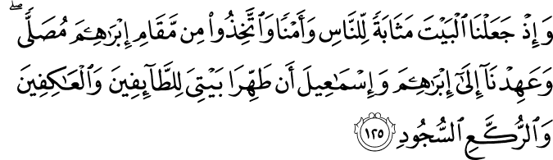

2.125. Remember, again, that We made the House (the Ka‘bah in Makkah) a resort for people, and a refuge of safety (a sanctuary, that is, a sign of the truth). Stand in the Prayer (O believers, as you did in earlier times) in the Station of Abraham. And We imposed a duty on Abraham and Ishmael: "Purify My House for those who go around it as a rite of worship, and those who abide in devotion, and those who bow and prostrate (in the Prayer). "(2)

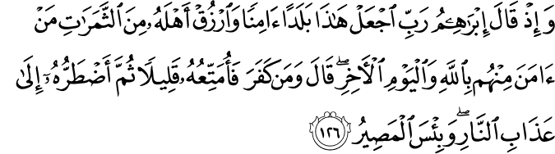

2.126. And (remember) once Abraham prayed: "My Lord! Make this (untilled valley) a land of security, and provide its people with the produce of earth, such of them as believe in God and the Last Day. " He (his Lord) answered: "(I will bestow provision upon both believers and unbelievers. But) whoever is thankless and disbelieves, I will provide for him to enjoy himself for a short while, then I will compel him to the punishment of the Fire – how evil a destination to arrive at!(2)

2.127. And when Abraham, and Ishmael with him, raised the foundations of the House (they were praying): "Our Lord! Accept (this service) from us. Surely You are the All-Hearing, the All-Knowing.(2)

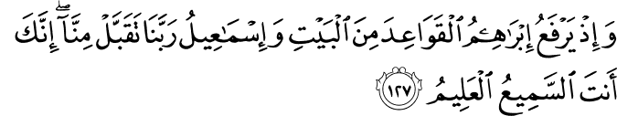

HADITH
624. Ibn Abbas, may Allah be pleased with him, reported that the Prophet, peace and blessings be upon him, said, “An Umra in Ramadan is equivalent to Hajj—or a Hajj with me.” (Sahih al-Bukhari, Umra, 4; Sahih Muslim, Hajj, 221).(3)
625. Laqit ibn Amir, may Allah be pleased with him, reported that he came to the Prophet, peace and blessings be upon him, and said, “My father is an old man who cannot do Hajj or Umra nor travel.” He said, “Do Hajj and Umra for your father.” (Sunan Abu Dawud, Manasik, 25; Sunan at-Tirmidhi, Hajj, 87).(4)
626. Ibn Abbas, may Allah be pleased with him, reported that the Messenger of Allah, peace and blessings be upon him, met a group of people at ar-Rawha and said, “Who are these people?” They said, “Muslims.” and then asked, “Who are you?” He said, “The Messenger of Allah.” A woman lifted up a child and said, “Can this one go on Hajj?” He said, “Yes, and you will have the reward.” (Sahih Muslim, Hajj, 409).(5)

The Hajj: Its Spiritual Meaning and Aspects of Worship

As one of the most spectacular religious assemblies in the world, the annual Muslim hajj (pilgrimage) to Mecca is more than just visiting holy lands and connecting with the historical legacy of Islam. There are important spiritual meanings enclosed within the rites of hajj, which has to be performed once in the lifetime of all adult Muslims who can afford the journey (Qur’an 3:197). Foremost in this consideration, hajj is a form of collective worship, and a way of establishing a strong bond with monotheism and its human legacy, respectively symbolized by the Prophet Abraham, and the first human and Prophet, Adam.
Large scale phenomena, with almost similar religious zeal, can also be observed in the natural world. The Qur’anic verse, “All that is in the heavens and on the earth extols and glorifies God, for He is the Tremendous, the Wise,” (57:1) tells us that all creatures of God glorify, praise and, hence, worship God in a language of their natural disposition. When a seed lifts a tall tree or a bud on a branch opens into a beautiful flower, they reflect the Power, Wisdom, and Glory of God. Just as this occurs individually when creatures display the wonders of the Creator and live in accordance with the purpose of their creation, they also worship God collectively by obeying the call of God in large numbers. All dramatic animal migrations, with their millions of creatures moving as one, and the synchronized blossoming of all plants in the spring, are examples of collective acts of worship in the natural world. In Africa, wildebeests migrate – tens of thousands of them, all going at the same time – to greener pastures in the continent’s highland steppes. In North America, millions of monarch butterflies migrate thousands of kilometers every winter. A recent discovery spectacularly demonstrated that corals along the length of the Great Barrier Reef, on the east coast of Australia, germinate at the same time, even down to the hour. Similarly, Muslims also display a mass act of worship by hearing the invitation of God for pilgrimage, and turning up in their millions, at the same time and place.
Cosmic objects and sub-atomic particles orbiting around a central point can be seen as another common act of worship expressed in the tongue of natural disposition. While electrons ceaselessly orbit the nucleus of an atom, the earth and planets tirelessly traverse space in an orbit around the sun. In turn, the solar system becomes the whirling dervish orbiting the centre of the Milky Way. It seems that circling a central point of reference is a universal act of worship. Muslims join in this cosmic mode of worship and synchronize with the whole universe and all existence by circling the Ka’bah as the reference point of monotheism.
The central aims of worship – exalting, glorifying and praising God – are realized individually and collectively. Muslims exalt God by showing up in mass as though saying “O Lord! You are greater than my self and You are far exalted above the whole humanity; here we are ready to worship you in mass.” They glorify God by going around the Ka’bah as though saying “just as we circle the single point of reference, the one and only Ka’bah, the oldest place of worship on earth, we only obey You, the Absolute One worthy of worship.” They praise God through the collective supplication and remembrance of God in the plains of Mt Arafat.
Muslims believe that the Ka’bah was the first place of worship built by the first human, and the first prophet, Adam. It was later rebuilt on the same foundations by Abraham and his son, Ishmail, and declared as a shrine dedicated to the belief and worship of one God (2:125-127) – the central tenet of monotheism. Abraham called on people to make pilgrimage to the site. Before the days of Islam, the Hebrew Bible confirmed the existence of this pilgrimage to Mecca: “O Lord Almighty, my King and my God. Blessed are those who dwell in Your house; they are ever praising You. Blessed are those whose strength is in You, who have set their hearts on pilgrimage. As they pass through the Valley of Beca, they make it a place of springs; the autumn rains also cover it with pools” (Psalms 84:4-6).
The climax of Pilgrimage occurs on the plains of Mt Arafat, about twenty kilometers outside of Mecca. All pilgrims have to be present in this location at the same time, simulating the day of resurrection when all humanity will be gathered before the court of God. Everyone wears the same simple garment and supplicates to God with no distinction of race, color, wealth or status.
Mt Arafat has a very significant place in the history of humanity. According to Islam, this is the place where the first man, Adam, and his partner, Eve, sincerely repented and received forgiveness for their mistake committed in Paradise. Similarly, Muslims repent for their sins and ask forgiveness in the same place. The plea and petition of millions of people at the same time is a compelling spiritual force that begs forgiveness. If three million people walked to the home of a president and asked for something, it would be impossible to ignore them. According to Prophet Muhammad, peace and blessings be upon him, God will not send away empty handed a pilgrim who sincerely asks for forgiveness. His or her sins will be wiped clean and they will attain the sinless state of a newborn. Over time, it has become a tradition for pilgrims to visit their family and friends before going for hajj, where they ask for forgiveness of any unsettled grievances or transgressions of human relations.
While there are other spiritual meanings expressed within the rites of hajj , Muslims especially announce their commitment to God through the two fundamental aspects of hajj – the circumambulation of the Ka’bah and the collective prayer offered on the plains of Mt Arafat. As people from all races and nations gather at the spiritual epicenter of the world, they affirm their common paternal ancestry with Adam and their spiritual ancestry with Abraham, peace be upon them.
Mehmet Ozalp is an author and PhD candidate at the University of Sydney, Australia.
References
1- These quotations are mine. They are intended to express the sentiments of pilgrims.
2- In ancient times, Mecca was known as Bakkah.
3- Ghazzali, Ihya’ul Ulumuddin, Tugra Nesriyat (Tr): Istanbul, Vol 1, 622. Hadith was narrated by Abu Hurayrah in Bukhari and Muslim hadith collections. Note that some scholars interpret this hadith to say that human rights violations are not included in this overarching forgiveness.
4- All rituals of hajj relate the story of Abraham, his son Ishmail, his wife Hagar and their dramatic ordeal to survive as monotheist in the largely polytheist world. Rituals of hajj include being present at Mt Arafat; circumambulation of the Ka’bah; offering ritual prayers after circumambulation; sa’y the fast walk between two hills; stopping at Muzdalifa on the first day of the festival; symbolic stoning Satan’s pillars; wearing of ihram; and cutting of the hair at the end.(6)
References
(1) 3:197./The Quran with Annotated Interpretation in Modern English by Ali Unal
(2)2:125-127./The Quran with Annotated Interpretation in Modern English by Ali Unal
(3) Nawawi, Imam. Riyad As-Salihin; The Gardens of the Righteous: A collection of authentic hadiths. Tughra Books Press, Inc. 2014
(4)Nawawi, Imam. Riyad As-Salihin; The Gardens of the Righteous: A collection of authentic hadiths. Tughra Books Press, Inc. 2014
(5)Nawawi, Imam. Riyad As-Salihin; The Gardens of the Righteous: A collection of authentic hadiths. Tughra Books Press, Inc. 2014
(6)Ozalp, Mehmet. Fountain Magazine. Issue 96 / November – December 2013

