An Ideal Society

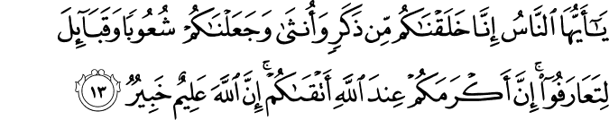

49.13. O humankind! Surely We have created you from a single (pair of) male and female, and made you into tribes and families so that you may know one another (and so build mutuality and co-operative relationships, not so that you may take pride in your differences of race or social rank, or breed enmities). Surely the noblest, most honorable of you in God's sight is the one best in piety, righteousness, and reverence for God. Surely God is All-Knowing, All-Aware.(1)

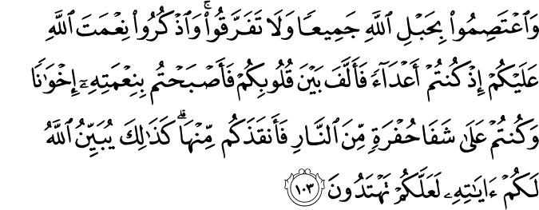

3.103. And hold fast all together to the rope of God, and never be divided. Remember God's favor upon you: you were once enemies, and He reconciled your hearts so that through His favor, you became like brothers. You stood on the brink of a pit of fire, and He delivered you from it. Thus, God makes His signs of truth clear to you that you may be guided (to the Straight Path in all matters, and be steadfast on it. )(2)

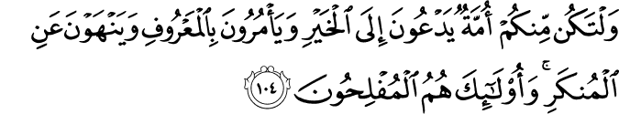
3.104. There must be among you a community calling to good, and enjoining and actively promoting what is right, and forbidding and trying to prevent evil (in appropriate ways). They are those who are the prosperous. (3)

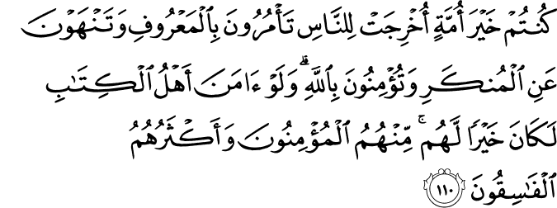

3.110. (O Community of Muhammad!) You are the best community ever brought forth for (the good of) humankind, enjoining and promoting what is right and good, and forbidding and trying to prevent evil, and (this you do because) you believe in God. If only the People of the Book believed (as you do), this would be sheer good for them. Among them there are believers, but most of them are transgressors.(4)

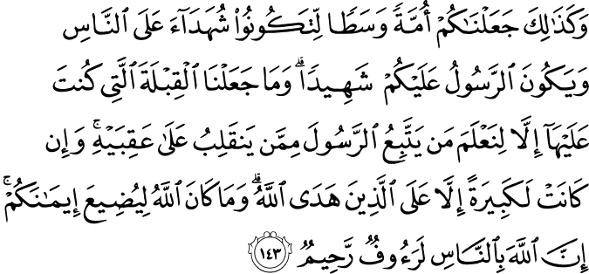
2.143. And in that way (O Community of Muhammad, whereas others turn in different directions and, straying from the Straight Path, falter between extremes in thought and belief), We have made you a middle-way community, that you may be witnesses for the people (as to the ways they follow), and that the (most noble) Messenger may be a witness for you. We formerly appointed (the Bayt al-Maqdis in Jerusalem) the direction to turn in the Prayer (and now are about to change it) so that We may determine who truly follows the Messenger from him who turns back on his heels (when the Messenger's way does not suit his desires). And indeed that testing was burdensome, save for those whom God has guided (and made steadfast in faith). God will never let your faith go to waste. Surely God is for the people All-Pitying, All-Compassionate. (5)

The Prophet (peace and blessings be upon him) said:

"The example of the person abiding by Allah's order and restrictions in comparison to those who violate them is like the example of those persons who drew lots for their seats in a boat. Some of them got seats in the upper part, and the others in the lower.
When the latter needed water, they had to go up to bring water (and that troubled the others), so they said, 'Let us make a hole in our share of the ship (and get water) saving those who are above us from troubling them.
So, if the people in the upper part left the others do what they had suggested, all the people of the ship would be destroyed, but if they prevented them, both parties would be safe."(6)

An Ideal Society

Groups formed by disorganized and sinful (disobedient) individuals are merely crowds with no esthetic values, people far from the thought of doing good. On the other hand, ideal or complete people carry the qualities of angels, and are monuments of human foresight and comprehension.
We see these qualities in the following Quran verse, as well as in many others: Lo, We have created humanity in the most perfect form and nature. Such people would understand this to mean that they are the most adorned and beautiful form of creation, be it material or spiritual. They enjoy the perfect state of creation, and are conscious of the unlimited gifts they have received.
Comprehending the verse: Humanity took on the burden that the earth, the sky, and the mountains rejected in fear of not being able to carry it out, they perceive that humanity is the sole candidate for reaching immortality.
These people may be considered as travelling the path to becoming a complete person, as long as they continue to develop further the gifts with which they were adorned and to live according to divine inspiration.
Such mysteries like the meaning of life and death, the reason of existence, and our responsibilities storm such people’s minds. They think deeply on concerns related to sin, doing good, and being pious. The meaning of catastrophes that harm humanity agitates their minds, the light of divine wisdom shines in their hearts, and the rays of this light reflects on their souls.
All of this allows them to see behind the curtain… Their astonishment and amazement turns into love and affection, and they turn to the Creator of their souls and feel contentment. Souls at this level are not spoiled by Divine benevolence or shaken by its loss, for they see benevolence and loss as one and understand that reward and punishment are the same. While others are spoiled by such favors and descend into pessimism at the first sign of tribulation, ideal people gain even when they seem doomed to lose. They manage to grow roses in the desert, to produce sugar from a dry cane.
Ideal people know that they are being continually tested and refined so that they may attain bliss. Even though they face fatal catastrophes and fall into the most terrible whirlpools, even in those most helpless and distressing moments they hear comforting and consoling whispers from the other world coming from right inside their souls, and bow in gratitude and admiration.
Such people have absolute confidence and trust in God, because they believe and trust in that omnipresent and omnipotent Immortal Power. The pure belief dwelling in the depths of their hearts, their conceptions that give them unbelievable perspectives, and their knowledge and thoughts raise them to such a point that they almost can hear a voice say: Do not fear, do not be sad! Enter the eternal home of Paradise as a reward for your good deeds! And then they would witness the most wonderful pleasures of all.
Ideal people try to remain far from sin, for they have designed their lives according to the Divine Law in which they believe so sincerely. And, because they always struggle against their egos, they have no time or energy to engage in ignorant pastimes or bohemian lifestyles their eyes always watch their Friend’s beauties, their minds are on the Hereafter, their hearts are bright and colorful gardens open to visits from spiritual beings and they themselves are travelers in and explorers of this mystic land and atmosphere
Worldly people, enslaved to their egos, live to fulfill their carnal desires. Never content with themselves, they feel no tranquility. But ideal people are always at peace with themselves. They are content and, furthermore, place their knowledge and understanding at humanity’s service. They courageously devote themselves to ridding the world of injustice and tyranny, and are not afraid to protect their land and honor. And, at times, they gracefully spread their wings of forgiveness over their brothers and sisters.
Knowing that everything but God is mortal and will fade away, ideal people do not bow to that which is not God. They resist the material world’s seductive attractions evaluate and use in the way of God that which has been bestowed upon them, just like heavenly beings examine all that occurs, like a scientist in a lab dedicate their lives to humanity and leave a much better world for the coming generations.
Ideal people constantly pursue God’s blessing and strive to be true. Neither their bodily passions nor spiritual goals cast doubt on their sincerity. They value all servants of God as the greatest of people, and appreciate each one as their peer. In their hearts, they melt any harshness or bad feelings coming from others, thus showing how kindness defeats wrong.
In their bright atmosphere, spears of lightning fade away and melt Nimrod, a merciless emperor who ordered Prophet Abraham to be thrown into a bonfire, would see his fire dim and turn into a green garden to soothe harsh and ill-tempered souls.
Most of us have not reached this level yet. We cannot confront wrong-doing with kindness. We confront harshness with harshness and hate with hate. We convince ourselves that our thoughts are objective and not really our own selfish desires. Thus we besmirch our struggle in the way of God and lose, although we had set out to gain. If it were not for the Quran’s own beauty, attractiveness, and life-giving rays, the misconceptions we have caused and the bad examples we have set would have prevented our religious mission from seeing this day.(7)

References
(1) 49:13/The Quran with Annotated Interpretation in Modern English by Ali Unal
(2) 3:103/The Quran with Annotated Interpretation in Modern English by Ali Unal
(3) 3:104/The Quran with Annotated Interpretation in Modern English by Ali Unal
(4) 3:110/The Quran with Annotated Interpretation in Modern English by Ali Unal
(5) 2:143/The Quran with Annotated Interpretation in Modern English by Ali Unal
(6) (Al-Bukhari)
(7) Gulen, M. Fethullah. Fountain Magazine. Issue 32 / October – December 2000

