THE RESURRECTION AND THE AFTERLIFE

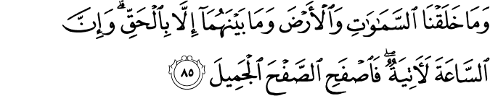

15.85. We did not create the heavens and the earth and all that is between them save with truth (meaningfully, and with definite purpose, and on solid foundations of truth); and the Last Hour is surely bound to come. So, overlook (the faults of the people, O Messenger) with a gracious forbearance.(1)

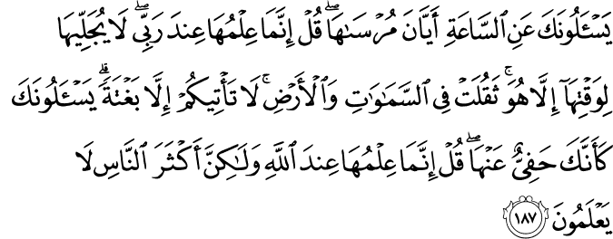

7.187. They ask you about the Hour, when it will come to anchor. Say: "It is my Lord alone Who knows it; none will disclose it in its time but He. It weighs heavily on the heavens and the earth. It does not come to you except unawares. " They ask you, as if you (being a Messenger required or meant that you) were well-informed of it. Say: "It is indeed God alone Who knows it, but most people have no knowledge (of this). "(2)

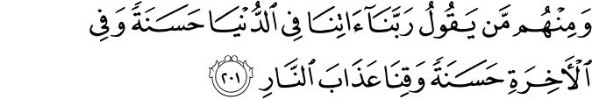

2.201. And among them are those who pray, "Our Lord, grant us in the world what is good, and in the Hereafter what is good, and protect us from the punishment of the Fire. "(3)

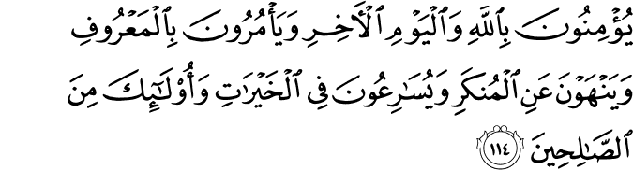

3.114. They believe in God and the Last Day, and enjoin and promote what is right and good, and forbid and try to prevent evil, and hasten to do good deeds, as if competing with one another. Those are of the righteous ones.(4)

HADITH

Zaid ibn Thabit reported: I heard the Messenger of Allah, peace and blessings be upon him, say, “Whoever makes the world his more important matter, Allah will confound his affairs and make poverty appear before his eyes and he will not get anything from the world except what has been decreed for him. Whoever makes the Hereafter his most important matter, Allah will settle his affairs and make him content in his heart and the world will come to him although he does not want it.”(5)

THE RESURRECTION AND THE AFTERLIFE THE VALUE OF HUMAN LIFE AND IT’S PURPOSES

A visible but oft-neglected difference between human and other types of life is instructive. Inanimate objects serve universal purposes in a complicated, amazing way, but do not know what they do or why they do it.
Plants and trees have some degree of life and serve animals and human beings as food. Also, addressing themselves to their senses by displaying spectacular scenes, spreading pleasant scents, and playing the most touching kind of music, they satisfy human senses (in particular, those of seeing, smelling and hearing) and decorate the earth. However, they do not know what kind of universal purposes they serve or what significant results they yield.
Animals perform tasks based on their abilities. Although they do not know why they are doing what they do, they derive some sort of pleasure from their work. A sheep, for example, gives milk, wool, and meat; a dog is a loyal friend; and birds are the loveliest singers in gardens or on mountains.
Of the earthly beings, only humans are conscious. They know what they are doing, why and for whom they are doing it, and why everybody else is working. People also can supervise and employ other people for their own advantage. However, human beings did not create themselves. Although of the same elements and living on the same substances, each individual is unique in countenance and character. Thus, each individual can be identified correctly by even his or her fingerprints.
People have no part in determining their physical features, family, race, color, birth date or place, and even their own nature. Their free will also is limited. For example, their role in producing bread is insignificant when compared with that of the One Who organizes the sun, rain, and soil; a wheat seed’s germination, growth, and life; the seasons; and the mutual helping between these elements.
Besides, people did not establish the basic conditions of life— they cannot prevent hunger, thirst, and sleep. They have no authority over the cycle of day and night or their bodies; they function automatically. For example, if they had to “wind” their hearts at exactly the same hour every morning like a clock to continue living, they would certainly have forgotten to do so every day.
Another interesting fact is that from the very moment an animal is born, it seems to know what to do. As if trained in another realm, it comes (or rather is sent) into the world and acquires full possession of those functions and abilities that it needs to survive within several hours, days, or months. For example, a sparrow or a bee acquires (or rather is inspired with), in less than a month, the ability to integrate into its environment in a way that would take a human individual many years.
This reveals an important fact: Animals have no obligation or responsibility to seek perfection through learning, progress through scientific knowledge, or pursue prayer and supplication by displaying their impotence. They are obliged only to act within the bounds of their innate faculties, which is the mode of worship specified for them.
In contrast, people are born completely ignorant of life and their environment; we need to learn everything. Acquiring such knowledge requires our whole lifetime. We appear to have been sent here in such a state of weakness and inability that it takes us as long as two years even to learn how to walk, and almost a whole life to learn how to distinguish between good and evil, and what is beneficial for us and what is harmful.
Despite these basic differences, human life is the most valuable, for whatever exists was created to produce humanity. We are the fruit of the tree of creation. Just as a tree is grown for the sake of its fruit and its whole life is directed to yield this fruit, the whole universe serves humanity. Thus, each human being has the same value as the entire universe.
One might even say that its value is greater than the universe, for each individual is equipped with consciousness and other intellectual faculties that make him or her superior to all other life forms. In one instant, the human imagination can travel throughout and far beyond the universe. We can speak; experience very complicated feelings, desires, and goals; as well as learn, think, judge, reason, and employ other living beings. Therefore, our value lies not in our physical composition and material aspect, but in the metaphysical dimension of life.
The Hand of Power that created humanity made a great “expenditure” on each human being by attaching the greatest value to them. That is, in addition to their mental and spiritual faculties that no worldly scales can weigh, It included in their physical or biological composition almost all elements of the tree of creation. Each individual’s physical or biological composition is so marvelous and expensive that if humanity joined together and built factories to produce a single cell, they would fail. When we consider only the neuron’s structure and tasks and the thousands of cords extending from the brain to each of the more than 100 million cells in a human body, we can get a glimpse of what an amazing and miraculous creation we really are.
Despite this miraculous mechanism and the expenditure made on it, our earthly life is very short. Many people die soon after birth. However, the cost for and value of each individual, regardless of how long he or she lives, is the same. So short a life, despite such a vast expenditure and having the same essential value as a long one, cannot have been made for the life itself. Nor can it be limited to this world. It must have far-reaching aims, and there must be ways to eternalize it.

BENEFITS OF BELIEF IN THE AFTERLIFE FOR SOCIETY AND PEOPLE

Belief in the afterlife is the bedrock of social and individual human life, the foundation of all felicity and achievement, because after belief in God, belief in the Resurrection has the primary place in securing a peaceful social order. For if we act according to the conviction that whatever we do is seen and recorded and we will have to give an account for it, we will live a disciplined and upright life. The Qur’an declares:
In whatever affair you may be, and whichever part of the Qur’an you recite, and whatever deed you do, We are witness over you when you are deeply engrossed therein. Not an atom’s weight in the earth and in the heaven escapes your Master, nor is there anything smaller or greater, but it is in a Manifest Book. (10:61)
Whatever we do is recorded by angels entrusted with that task. In addition, God has complete knowledge of all our deeds, intentions, thoughts, and imaginings. An individual who lives in full consciousness of this will find true peace and happiness in both worlds; a family and community made up of such individuals will be as if living in Paradise.
Children are sensitive and delicate, very susceptible to misfortune, and easily affected by what befalls them and their families. When a family member dies or they are orphaned, their world darkens and they experience great distress and despair. So, what else other than belief in the Resurrection, in reunion with the loved ones who emigrated to the other world, can compensate for the loss of parents, siblings, and friends? Only when a child is convinced that his or her loved one has flown to Paradise, to a much better life than this, and that one day they will be reunited, will he or she find true consolation and begin to heal.
How can you compensate the elderly for their past years, their long-ago childhood and youth? How can you console them for the loss of their loved ones, friends, spouses, children or grandchildren who went to the other world before them? How can you remove from their hearts the fear of death and the grave, which is coming closer every day? How can you make them forget death, which they feel so deeply? Can you console them with ever new pleasures of life? Only when they understand that the grave, an apparent open-mouthed dragon waiting for them, is really a door to another, much better world, or a lovely waiting room to that world, will they feel compensated and consoled for their losses.
Humanity is a unique part of creation, for people can use their free will to direct their lives. Free will is the manifestation of Divine Mercy. If our free will is used properly by doing good deeds, we will be rewarded with the fruits of Mercy. Belief in the Resurrection is a most important and compelling factor that urges us to use our free will in the right way and refrain from sin and from wronging and harming others.
Young people have a transforming energy. If you let them waste that energy in trivial things and self-indulgence, you undermine your nation’s future. Belief in the Resurrection prevents young people from committing atrocities and wasting their energies on passing pleasures, and directs them to lead a disciplined, useful, and virtuous life.
Belief in the Resurrection is also a source of consolation for the ill. Suffering from an incurable illness, a believing patient thinks: “I am going. No one can make me live longer. Fortunately, I am going to a place where I will enjoy eternal health and youth. Everyone is doomed to die anyway.” Such a belief has caused the beloved servants of God, primarily including the Prophets, to welcome death with a joyful smile.
The world is a mixture of good and evil, right and wrong, beauty and ugliness, oppressor and oppressed. Many wrongs go unnoticed, and numerous wronged people do not recover their rights. Only their belief in the Resurrection into a world of absolute justice consoles such people and prevents them from seeking vengeance. The afflicted and those suffering misfortune also find consolation, for they believe that whatever befalls them erases some of their sins, and that what they have lost will be restored to them in the Hereafter as a blessing, just as if they had given these items as alms.
Belief in the Resurrection changes a house into a garden of Paradise. In a house where the young pursue their pleasures, children ignore religious sentiment and practices, parents are engrossed in procuring ever more possessions, and grandparents are sent to a poorhouse or a nursing home, or left to shower their love only on pets but not on their grandchildren, life is a heavy burden. Belief in the Resurrection reminds everyone of their responsibilities toward each other, and engenders a fragrance of mutual love, affection, and respect.
Belief in the Resurrection leads to mutual love and a deeper respect on the part of spouses. Love based on physical beauty is temporary, and therefore of little value. It usually disappears shortly after the marriage. But if the spouses love each other and believe that their marriage is eternal, and that in the other world they will be eternally young and beautiful, their love for each other will not disappear as they age and lose their good looks. If family life is based on belief in the Resurrection, family members will feel as if they are living in Paradise. If a country’s social order is based on belief in the Resurrection and the Day of Judgment, life in that country will be far better than what Plato imagined in his Republic or al-Farabi (Alpharabios) in his Al-Madinat al-Fadila (The City of Virtues). It will be like Madina in the time of the Prophet, or the Muslim lands under the rule of Caliph ‘Umar.(6)

References
(1)15:85 /The Quran with Annotated Interpretation in Modern English by Ali Unal
(2)7:187 /The Quran with Annotated Interpretation in Modern English by Ali Unal
(3)2:201 /The Quran with Annotated Interpretation in Modern English by Ali Unal
(3)3:114/The Quran with Annotated Interpretation in Modern English by Ali Unal

(5) Sunan Ibn Majah 4105
(6) Unal, Ali. The Resurrection and the Afterlife. The Light, Inc. 2006.

