Taqwa (Piety)

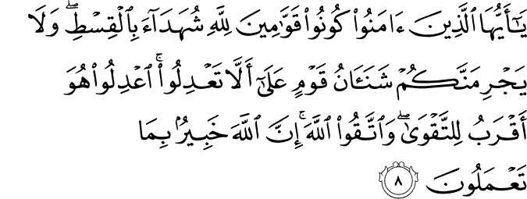

O you who believe! Be upholders and standard-bearers of right for God's sake, being witnesses for (the establishment of) absolute justice. And by no means let your detestation for a people (or their detestation for you) move you to (commit the sin of) deviating from justice. Be just: this is nearer and more suited to righteousness and piety. Seek righteousness and piety, and always act in reverence for God. Surely God is fully aware of all that you do.

This is the (most honored, matchless) Book: there is no doubt about it (its Divine authorship and that it is a collection of pure truths throughout) — a guidance for the God-revering, pious who keep their duty to God.²

2. The word translated as “the God-revering, pious who keep their duty to God” is muttaqī . It is derived from taqwā, from wiqāyah , meaning protection, self-defense and averting (danger). Taqwā is one of the most important concepts used to characterize a Muslim believer. It denotes refraining from sins in utmost reverence for God and receiving His protection against deviations and His punishment. God has two sets of laws: one includes the “religious” laws (including the pillars of faith, and principles of worship and morality) governing human individual and social life, and the other, the Divine laws of the creation and operation of the universe studied by the natural sciences (which we wrongly call “laws of nature”). God's protection depends on acting in accordance with both of these sets of laws. The recompense for complying or not with the former usually comes in the Hereafter, while for the latter, in this world. Taqwā , which we will render as “piety, righteousness, and reverence for God” in this commentary, is the only criterion of human distinction or nobility in God's sight:

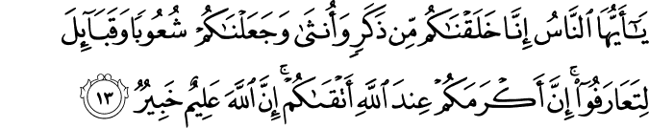

“Surely the noblest, most honorable of you in God's sight is the one best in taqwā (piety, righteousness, and reverence for God).” (49: 13) (3)

Revering Allah and Piety (Taqwa)

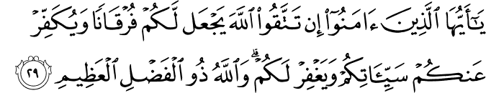

O you who believe! If you keep from disobedience to Allah in reverence for Him and piety, He will make a criterion for you (in your hearts to distinguish between truth and falsehood, and right and wrong), and blot out from you your evil deeds, and forgive you. Allah is of tremendous grace and bounty. (al-Anfal 8:29) (4)

43. Ibn Mas’ud, may Allah be pleased with him, reported that the Prophet, peace and blessings be upon him, used to say, “O Allah, I ask you for guidance, fearful awareness, chastity and independence.” (Sahih Muslim, Dhikr, 72). (5)
45. Abu Umama Sudayy ibn Ajlan al-Bahili, may Allah be pleased with him, said, “I heard the Messenger of Allah, peace and blessings be upon him, speaking in the Hajj of Farewell. He said, ‘Fear Allah, pray your five Prayers, fast your month, pay the Zakah on your property and obey your amirs and you will enter the Paradise of your Lord.” (Sunan at-Tirmidhi, Jumu’ah, 80).(6)

Taqwa (Piety)
Taqwa is derived from wiqaya, which means self-defense and avoidance. Sufis define it as protecting oneself from God's punishment by performing His commands and observing His prohibitions. Besides its literal and technical meanings, in religious books we find the meanings of piety and fear used interchangeably. In fact, taqwa is a comprehensive term denoting a believer's strict observance of the commandments of the Shari'a and the Divine laws of nature and life. Such a person seeks refuge in God against His punishment, refrains from acts leading to Hellfire, and performs acts leading to Paradise. Again, the believer purifies all outer and inner senses so that none of them can associate partners with God, and avoids imitating the worldviews and life-styles of unbelievers. In its comprehensive meaning, taqwa is the only and greatest standard of one's nobility and worth: The noblest, most honorable of you in the sight of God is the most advanced of you in taqwa (49:13).
The concept even the actual word of taqwa is unique to the Qur'an and the religious system of Islam. Its comprehensive meaning encompasses the spiritual and material; its roots are established in this world, while its branches, leaves, flowers, and fruits are located in the Hereafter. One cannot understand the Qur'an without considering the meaning or content of the fascinating and wonderful concept of taqwa, and one cannot be muttaqi (pious) if one does not adhere consciously and continually to the practices and concepts outlined in the Qur'an.
In its very beginning, the Qur'an opens its door to the pious: This is the Book about and in which there is no doubt, a guidance for the pious (2:2), and calls on people to live in accordance with it so that they may be pious: O men! Worship your Lord, Who created you and those before you, so that you may be pious (and protect yourselves from His punishment) (2:21).
The most lovable act in God's sight is piety (taqwa), His most purified servants are the pious, and His matchless message to them is the Qur'an. In this world, the pious have the Qur'an; in the Hereafter, they enjoy God's vision and pleasure. The pleasure felt in the conscience and spirit is another gift of piety, and in order to recall the importance of piety, the Almighty decrees: Fear God and be devoted to Him as He should be feared and devoted to (3:101).
Piety, which is the conscious performance of good and avoidance of evil, prevents individuals from joining the lowest of the low and causes them to advance on the path of the highest of the high. For this reason, one who attains piety has found the source of all good and blessing. The following is another testimony to this fact:
To whomever God has given religion and piety,
He has realized his aims in this world and the next.
Whoever is a soldier of God and pious,
He is prosperous and truly guided, not a wretched one.
Whoever has nothing to do with piety,
His existence is but a shame and disgrace.
One lifeless with respect to truth is not truly alive;
Only one who has found a way to God is alive.
Piety is an invaluable treasure, the matchless jewel in a priceless treasure of precious stones, a mysterious key to all doors of good, and a mount on the way to Paradise. Its value is so high that, among other life-giving expressions the Qur'an mentions it 150 times, each mention resembling a ray of light penetrating our minds and spirits.
In its limited sense, taqwa means sensitivity to the commandments of the Shari'a and refraining from acts that deprive one of Divine reward and result in God's punishment. The verse: Those who refrain from major sins and shameful deeds (42:37) expresses one aspect of this basic religious virtue; the verse: Those who believe and do good deeds (10:9) points to the other. Strict observance of obligatory religious duties and refraining from major sins are the two necessary and complementary foundations of taqwa. As for minor sins, which the Qur'an calls lamam (small offenses), there are many Prophetic declarations, such as: A servant cannot be truly pious unless he refrains from certain permissible things lest he should commit risky things, that warn people to be careful.
Perfect sincerity or purity of intention can be attained by avoiding all signs of associating partners with God, while perfect piety can be achieved by refraining from all doubtful and risky deeds. According to the Prophetic saying: The lawful is evident and the forbidden is also evident. Between these two are things which most of the people do not know whether they are lawful or forbidden, a truly righteous, spiritual life depends on being sensitive to matters about which there is some doubt. The Tradition just mentioned points out that the Legislator of the Shari'a has clearly explained in broad terms what is allowed and what is forbidden. However, as many things are not clearly allowed or forbidden, only those who avoid doubtful things can live a truly religious life. Using a simile in the continuation of the Tradition, the prince of two worlds, upon him be peace and blessings, said:
It is possible for one who does doubtful things to commit forbidden acts, just as it is possible for the flock of a shepherd pasturing near a field belonging to another or the public to enter that field. Know that each king has a private area under his protection; the private area of God is forbidden things. Also know that there is a part of flesh in the body. If it is healthy, the body will become healthy; if it is ailing, the body will be ailing. That part is the heart.
In light of this basic foundation for a healthy spiritual life, perfect piety can be obtained by avoiding doubtful things and minor sins. In order to do this, however, one must know what is lawful and what is forbidden, and have a certain knowledge of God. We can find the combination of piety and knowledge in these two verses: The noblest, most honorable of you in the sight of God is the most advanced of you in taqwa (49:13), and: Only the learned among His servants fear and revere God (35:28). Piety brings honor and nobility, and knowledge leads one to fear and revere God. Individuals who combine piety and knowledge in their hearts are mentioned in the Qur'an as those who succeed in the test of piety: They are those whose hearts God has tested for piety (49:3).
In the context of worship and obedience, piety means purity of heart, spiritual profundity, and sincerity. In the context of refraining from what is unlawful, piety means being determined not to commit sins and to avoid doubtful things. For this reason, each of the following may be considered an aspect of piety: A servant must
- Seek only God's approval and pleasure, and not set his or her heart upon whatever is other than Him.
- Observe all commandments of the Shari'a.
- Do whatever is necessary to achieve the objective, and be convinced that only God will create the result. Thus one cannot be a fatalist (i.e., one cannot neglect to perform whatever is necessary to obtain a certain result, and must take all necessary measures against possible misfortune or defeat) or a pure rationalist and positivist (Mu'tazili) who attributes all human acts and accomplishments to oneself by denying God any part in them.
- Be alert to whatever may divert him or her from God.
- Be alert to the carnal pleasures that may lead to the realm of the forbidden.
- Ascribe all material and spiritual accomplishments to God.
- Not consider himself or herself as higher and better than anyone else.
- Not pursue anything other than God and His pleasure.
- Follow the guide of all, upon him be peace and blessings, without condition and reservation.
- Renew himself or herself, and continuously control his or her spiritual life by studying and reflecting on God's acts and works as well as on His laws of nature and life.
- Remember death, and live with the conscious knowledge that it may happen at any time.
In conclusion, taqwa is the heavenly water of life, and a muttaqi (pious one) is the fortunate one who has found it. Only a few individuals have achieved the blessing of this attainment. A poet says:
God Almighty says: The great among you are those who are pious.
The last abode of the pious will be Paradise and their drink kawthar.
O God! Include us among Your pious servants who were sincere in all their religious acts. (7)

References

5:8/The Quran with Annotated Interpretation in Modern English by Ali Unal
2:2/The Quran with Annotated Interpretation in Modern English by Ali Unal (3)8:29.The Quran with Annotated Interpretation in Modern English by Ali Unal (4)49:13.The Quran with Annotated Interpretation in Modern English by Ali Unal (5)Nawawi, Imam. Riyad As-Salihin; The Gardens of the Righteous: A collection of authentic hadiths. Tughra Books Press, Inc. 2014 (6)Nawawi, Imam. Riyad As-Salihin; The Gardens of the Righteous: A collection of authentic hadiths. Tughra Books Press, Inc. 2014 (7) M. Fethullah Gulen, Q/A Jun 1993, Vol 15, Issue 173

