FORGIVENESS
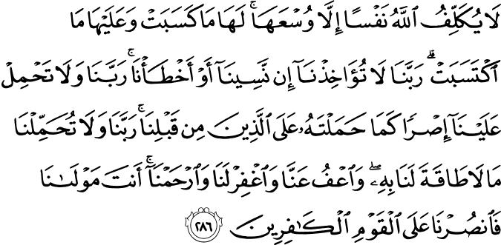

2:286. (O believers, if you are worried that God will take every soul to account even for what the soul keeps within it of intentions and plans, know that) God burdens no soul except within its capacity: in its favor is whatever (good) it earns, and against it whatever (evil) it merits. (So, pray thus to your Lord:) "Our Lord, take us not to task if we forget or make mistakes. Our Lord, lay not on us a burden such as You laid on those gone before us.¹⁶² Our Lord, impose not on us what we do not have the power to bear. And overlook our faults, and forgive us, and have mercy upon us. You are our Guardian and Owner (to Whom We entrust our affairs and on Whom we rely) so help us and grant us victory against the disbelieving people!"¹⁶³ (1)
162. The burden laid upon the previous communities was required by the education they had to receive according to the time and conditions, and to their disposition. (Also see sūrah 7, note 38.)
163. The last two verses were revealed to God's Messenger during the Ascension. It is a highly meritorious Sunnah act to recite them before going to bed every night. The Messenger advises parents to teach them to their children.
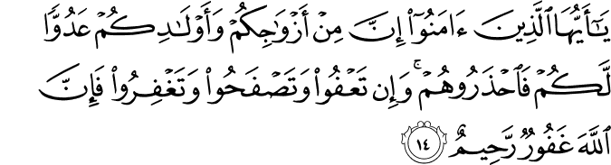

64:14. O you who believe! Among your spouses and children there may be enemies for you, so beware of them. Yet, if you pardon, forbear, and forgive (their faults towards you and in worldly matters), then (know that) God is All-Forgiving, All-Compassionate.(2)
^{Hadith}
867. Al-Agharr al-Muzani, may Allah be pleased with him, reported that the Messenger of Allah, peace and blessings be upon him, said, “A cloudiness comes over my heart and I ask for Allah’s forgiveness a hundred times a day.” (Sahih Muslim, Dhikr, 41).
Annotation: Although there is no evident report about what is meant by the heart’s being clouded, possible meanings can be as such:
The Prophet’s heart was constantly oriented toward Allah Almighty and when he had to carry out worldly responsibilities, he considered as a shadow over his relation with his Lord and thus asked forgiveness.
If he did not find an opportunity to make his habitual recitations, he would ask forgiveness owing to that delay.
When his heart was enveloped by sakinah (serenity), he asked forgiveness to offer worship and thanksgiving.
Scholars like Suyuti commented that this hadith is mutashabih (allegorical) and we cannot know what it exactly means; Allah knows best.(3)
868. Abu Hurayra, may Allah be pleased with him, reported that the Messenger of Allah, peace and blessings be upon him, said, “By the One in whose hand my soul is, if you did not do wrong, Allah the Almighty would remove you and bring a people who do wrong and then ask Allah the Almighty for forgiveness and He would forgive them.” (Sahih Muslim, Tawbah, 11). (4)
869. Ibn Umar, may Allah be pleased with him, said, “We used to count out for the Messenger of Allah, peace and blessings be upon him, in one assembly a hundred times, “Lord forgive me and turn to Me, You are the Tawwab (the One Who accepts repentance and returns it with liberal forgiveness and additional reward), the Merciful.” (Sunan Abu Dawud, Witr, 26; Sunan at-Tirmidhi, Da’awat, 39). (5)
Humans are creatures with both exceptional qualities and faults. Until the first human appeared, no living creature carried such opposites within its nature. At the same time as humans beat their wings in the firmaments of heaven, they can, with sudden deviation, become monsters that descend to the pits of Hell. It is futile to look for any relationship between these frightening descents and ascents; these are extremes because their cause and effect take place on very different planes.

At times humans are like a field of wheat bending in the wind; at other times, although they appear as dignified as a plane tree, they can topple over, not to rise again. Just as the times that the angels envy them are not few, neither are the times when even the devils are shocked by their behavior.

For humans, whose natures contain so many highs and lows, even if committing evil is not essential to their nature, it is inevitable. Even if becoming sullied is accidental, it is likely. For a creature which is going to spoil his good name, forgiveness is paramount.

However valuable it is to ask for and expect forgiveness and to bemoan the things that have escaped us, forgiving is that much greater an attribute and virtue. It is wrong to think of forgiveness as being separate from virtue or of virtue as being separate from forgiveness. As the well-known adage says, “To err is human, to forgive divine,” and how well this has been said! Being forgiven means being repaired; it consists of a return to our essence and finding ourselves again. For this reason, the most pleasing action in the eyes of Infinite Mercy is any activity pursued amidst the palpitations of this return and search.

All of creation, animate and inanimate, was introduced to forgiveness through humanity. Just as God showed His attribute of forgiveness through humanity, He also put the beauty of forgiveness into the human heart. While the first man dealt a blow to his essence through his fall, something which was almost a requirement of his human nature, forgiveness came from the heavens because of the remorse he felt in his conscience and because of his sincere pleas.

Humans have preserved gifts, such as hope and consolation, which they have obtained from their ancestors over the centuries. Whenever people err, by boarding the magical transport of seeking forgiveness and by surmounting the shame caused by their sins and the despair caused by their actions, they are able to attain infinite mercy and are shown the generosity that is involved in veiling their eyes to the sins of others.

Thanks to their hope for forgiveness, humans can rise above the dark clouds that threaten their horizon and seize the opportunity to see light in their world. Those fortunate ones who are aware of the uplifting wings of forgiveness live their lives amidst melodies that please their spirits.

It is impossible for people who have given their heart to seeking forgiveness not to think of forgiving others. Just as they desire to be forgiven, they also desire to forgive. Is it possible for someone not to forgive if they know that salvation from the fires of suffering caused by his/her mistakes in the inner world is possible by drinking deeply from the river of forgiveness? Is it possible for people not to forgive if they know that the road to being forgiven passes through the act of forgiving?

Those who forgive are honored with forgiveness. One who does not know how to pardon cannot hope to be pardoned. Those who close the road to tolerance for humanity are monsters that have lost their humanity. These brutes that have never once been inclined to take themselves to task for their sins will never experience the high solace of forgiveness.

Jesus Christ said to a crowd that was waiting rocks in hand to stone a sinner: “If anyone of you is without sin let him be the first to throw a stone.”[6] Can anyone with a sin on their conscience still be inclined to stone another if they truly understand this idea? If only those unfortunate ones of today who spend their lives putting the lives of others to the litmus test could understand this! In fact, if the reason for stoning a person is our malice and hatred, if this is the reason why we have passed judgment on them, then it is not possible to pass this sentence on them. The truth is, unless we destroy the idols in our ego as courageously as Abraham destroyed the idols, we will never be able to make a correct decision in the name of our selves or in the name of others.

Forgiveness emerged with and reached perfection through humanity. In this respect, we can witness the greatest forgiveness and the most impeccable tolerance in the greatest exemplars of humanity.

Malice and hatred are the seeds of Hell that have been scattered among humans by evil spirits. Unlike those who encourage malice and hatred and turn the Earth into a pit of Hell, we should take this forgiveness, and run to the rescue of our people who are confronted by countless troubles and who are being continually pushed toward the abyss. The past few centuries have been turned into the most unpleasant and foul years by the excesses of those who do not know forgiveness or recognize tolerance. It is impossible not to be chilled by the thought that these unfortunate ones could rule the future.

For this reason, the greatest gift that the generation of today can give their children and grandchildren is to teach them how to forgive—to forgive even when confronted by the worst behavior and the most disturbing events. However, thinking of forgiving monstrous, evil people who enjoy making others suffer would be disrespectful to the idea of forgiveness. We have no right to forgive them; forgiving them would be disrespectful to humanity. I do not believe that there is any probability that anyone could see an act that is disrespectful to forgiveness as being acceptable.

A generation which was raised in a particular past under constant hostile pressure saw continuous horror and brutality in the dark world into which they had been pushed. They saw blood and pus, not just in the dark of night, but also at the break of day. What could be learned from a society whose voice, breath, thought, and smile were tainted with blood? The things that were presented to this generation were the complete opposite and totally contrary to what they needed and what they desired. This generation took on a second nature, caused by years of neglect and misleading suggestions; the disorder and sedition caused by these became a flood. If only by now we could have understood them. Alas! Where is such insight?

We believe that forgiveness and tolerance will heal most of our wounds, if only this celestial instrument will be in the hands of those who understand its language. Otherwise, the incorrect methods of behavior, those used up until now, will cause many complications and will only confuse us from now on. (7)

Diagnose the illness, then set out to treat it:
Do you think any ointment will be a cure for every wound?
Ziya Pasha[8]

References

(1) 2:286.The Quran with Annotated Interpretation in Modern English by Ali Unal
(2) 64:14.The Quran with Annotated Interpretation in Modern English by Ali Unal
(3) Nawawi, Imam. Riyad As-Salihin; The Gardens of the Righteous: A collection of authentic hadiths. Tughra Books Press, Inc. 2014
(4) Nawawi, Imam. Riyad As-Salihin; The Gardens of the Righteous: A collection of authentic hadiths. Tughra Books Press, Inc. 2014
(5) Nawawi, Imam. Riyad As-Salihin; The Gardens of the Righteous: A collection of authentic hadiths. Tughra Books Press, Inc. 2014
[6] Gospel of John, Chapter 8, Verse 7.
(7)This article was written in 1980 and originally appeared in Çağ ve Nesil [The Age and New Generations], Kaynak, Izmir, 2003 (first edition 1982), pp. 57-60.
[8] Ziya Pasha (d. 1880): An influential literary figure in the nineteenth century who was a member and advocate of the Young Turks, a secret nationalist organization formed in Istanbul in June 1865.

