Grave Life

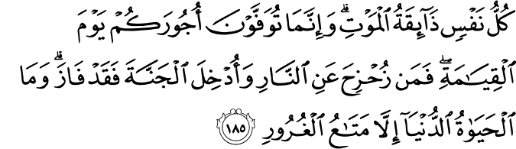
3.185. (No one will live forever doing what they do:) Every soul is bound to taste death. So (O people), you will but be repaid in full on the Day of Resurrection (for whatever you have done in the world). Whoever is spared the Fire and admitted into Paradise has indeed prospered and triumphed. (Know that) the present, worldly life is nothing but a transient enjoyment of delusion.(1)
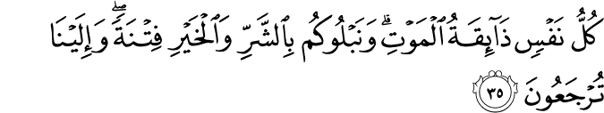
21:35. Every soul (person)⁵ is bound to taste death, and We try you through the bad and the good things (of life) by way of testing (so that your real character and rank may reveal itself). In fact, you are on the way to return to Us (to finally be brought to Our Presence).(2)
5. The term nafs (soul, self) is used in the Qur'ān in various, but similar, complementary meanings. First, it means the self of a person or a thing. In this meaning, it is also used for God (3: 28; 5: 116).
Its second meaning is the substance and essence which is the source of physical life in a human being, or the dimension or aspect of the spirit which is the basis of animal and human physical life (6: 93).
In its third meaning, as the basis of the human physical or worldly life, it is the essence or substance which is aware of the needs of life, which demands and tastes pleasures and encourages a person to meet those needs and experience those pleasures. In a sense, it is the substance which incites a person to commit evil (12: 53). It can and must be trained. When trained, it can be elevated from being a substance which commands evils, or being an evil-commanding soul, to the rank of being a soul at rest with faith in and worship of God (89: 27–28).
In its other and most comprehensive meaning, it is human nature or the individual person (4: 1).

The Messenger of Allah (p.b.u.h.) said, "Everyone who dies - then his actions are sealed except for the one guarding the border in the way of Allah - his actions continue to increase for him until the Day of Resurrection and he is saved from the trials of the Grave.(3)
The Messenger of Allah (p.b.u.h.) said, "Verily the grave is the first stopping place for the Hereafter; so if he is saved therein, then what comes after is easier than it. And if he is not saved there from, then that which comes after is harder.(4)

Following death, the spirit is taken to the Presence of God. If it led a good, virtuous life and refined itself, the angels charged with taking it to the Presence of God wrap it in a piece of satin and take it, through the heavens and all inner dimensions of existence, to His Presence. During this journey, angels welcome it in every mansion or station it passes and ask: “Whose spirit is this? How beautiful it is!” The angels conveying it introduce it with the most beautiful titles it had while in the world, and answer: “This is the spirit of the one who, for example, prayed, fasted, gave alms, and bore all kinds of hardship for God’s sake.” Finally, God Almighty welcomes it and tells the angels: “Take it back to the grave where its body is buried, so that it can answer the questions of Munkar and Nakir, the interrogating angels.”
Whatever misfortune we experience is the result of our own sins. If believers are sincere but cannot always refrain from sin, God, out of His Mercy, allows misfortune to strike so that they may be purified. God may subject them to great agony during death either to forgive their still unpardoned sins or to promote them to higher (spiritual) ranks, but then takes their spirit very gently. If, despite all misfortunes and death agonies there are still some sins that have not been forgiven, these people are somehow punished in the grave and are thus freed from punishment in Hell. In addition, since the grave is the first station on the journey toward eternal life, where everyone will be rewarded based on their words and deeds, it also features a preliminary interrogation by two angels into what kind of life the deceased lead. And almost everyone, except Prophets, is subjected to some suffering.
It is recorded in reliable books that ‘Abbas, the uncle of the Prophet, upon him be peace and blessings, desired very much to see ‘Umar in his dream after the latter had died. When he saw him 6 months later, he asked him: “Where were you until now?” ‘Umar replied: “Do not ask me that! I have just finished accounting (for my life).”
Sa‘d ibn Mu‘adh was among the greatest of the Prophet’s Companions, may God be pleased with them all. When he died, the Archangel Gabriel, upon him be peace, told God’s Messenger, upon him be peace and blessings: “The Divine Throne trembled when Sa‘d died.” Innumerable angels took part in his funeral. After Sa‘d, may God be pleased with him, was buried, the Messenger said in amazement: “Glory to God! What (will happen to others) if the grave squeezes (even such people like) Sa‘d?’”
In the grave, everyone is questioned by the angels Munkar and Nakir. They ask: “Who is your Lord? Who is your Prophet? What is your religion?” and many other questions. If the deceased believed in God and His Prophets, upon them be peace, and in the other essentials of belief, they can answer these questions. Otherwise, they cannot. The questions continue with their deeds in the world.
The spirit’s relationship with the body differs according to which world it inhabits. In this world the spirit is confined within the prison of the body. If the evil-commanding self and bodily desires dominate it, the spirit inevitably deteriorates and spell the person’s final doom. If the person uses his or her will-power in the way taught by God and disciplines the evil-commanding self and “nourishes” the spirit through belief, worship, and good conduct, and is not enslaved by bodily desires, the spirit is refined, purified, and furnished with laudable qualities. This will bring happiness to the person in both worlds.
After burial, the spirit waits in the intermediate world between this one and the Hereafter. Although the body decomposes, its essential particles—called in a hadith ajb al-dhanab, which literally means coccyx—do not rot. We do not know whether ajb al-thanab is a person’s genes or something else. Whatever it is, however, the spirit continues its relations with the body through it. This part also serves as a foundation upon which God will rebuild or re-create us on the Day of Judgment. God will make this part, which is formed of the body’s essential particles or atoms or all of its other particles that have already mixed into the soil, conducive to eternal life during the final destruction and rebuilding of the universe, and will use it to re-create us on the Day of Resurrection.
The intermediate world is the realm where the spirit feels the “breath” of the bliss of Paradise or the punishment of Hell. If we led a virtuous life in the world, our good deeds (e.g., prayers, recitations, acts of charity) will appear as amiable fellows. Also, windows onto heavenly scenes will be opened for us and, as stated in a hadith, our grave will become like one of the gardens of Paradise. However, if some of our sins still remain unpardoned, regardless of how virtuous we were, we may suffer some punishment in the intermediate world so that these final sins will be forgiven and we can deserve Paradise. If we did not believe and indulged in sin, these facts will assume the forms of bad fellows and vermin. We will see scenes of Hell, and our grave will become like one of the pits of Hell.

References
(1) 3.185. The Quran with Annotated Interpretation in Modern English by Ali Unal
(2) 21:35. The Quran with Annotated Interpretation in Modern English by Ali Unal
(3)" (Sahih: Abu Dawud, at Tirmidhi, al Haakim from Fadaalah Ibn Ubaid & Ahmad from Uqbah ibn Aamir.)
(4) ." (Hasan: At Tirmidhi, Ibn Majah, al Hakim: from Uthmaan)
(5) This article has been adapted from Risale- i Nur Collection.

