THE DOOMSDAY, THE RESURRECTION AND THE AFTERLIFE

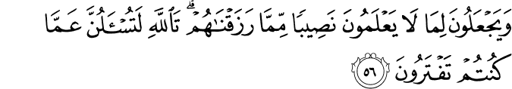
16:56. They assign, out of what We provide for them, a portion to the things (non-existent gods, misunderstood "causes," the real nature of) which they have no sure knowledge.¹¹ By God, you will certainly be questioned about what you used to fabricate.
11. This verse has several meanings:
- So as to order their lives, some people ascribe creativity and the authority to things or beings which they assume to have (Divine) power, such as idols, persons, institutions, celestial bodies, spirits, and so on.
- They ascribe authority to make lawful what is unlawful, or unlawful what is lawful, concerning their livelihood to powers other than God; yet their livelihood has been granted to them by God.
- They assign to God, of the produce and cattle that He has created, a portion, and they say: "This is God's" – so they assert – "and this (the rest) is for the partners which we associate with God." (6: 136) (1)

25:72. And (those true servants of the All-Merciful are they) who do not take part in, or bear witness to, any vanity or falsehood (and who will not deem anything true unless they know it to be so for certain), and when they happen to pass by anything vain and useless, pass by it with dignity; (2)

Hadith
Narrated Aisha: Allah’s Messenger (peace be upon him) said, “Do you know who will go first on the Day of Resurrection to the shade of Allah, Who is Great and Glorious?” Then on receiving the reply that Allah and His Messenger (peace be upon him) knew best, he said, “Those who when given what is right accept it, when asked for something give freely, and who judge in favour of others as they do for themselves.” (3)
Narrated Aisha: A man asked permission to enter upon the Prophet (peace be upon him). When the Prophet (peace be upon him) saw him, he said, “What an evil brother of his tribe! And what an evil son of his tribe!” When that man sat down, the Prophet (peace be upon him) behaved with him in a nice and polite manner and was completely at ease with him. When that person had left, ‘Aisha said (to the Prophet). “O Allah’s Apostle! When you saw that man, you said so-and-so about him, then you showed him a kind and polite behaviour, and you enjoyed his company?” Allah’s Apostle said, “O ‘Aisha! Have you ever seen me speaking a bad and dirty language? (Remember that) the worst people in Allah’s sight on the Day of Resurrection will be those whom the people leave (undisturbed) to be away from their evil (deeds).” (4)

THE DOMMSDAY

O heedless soul! You have illusions and see the exceedingly temporary world as undying and permanent. When you look around yourself at the world, you see it as stable to a degree, and constant. Since looking with the same view you also consider your own transient self to be constant, you only take fright at Doomsday (Kiyamat). You are only frightened at that as though you were going to live till then.

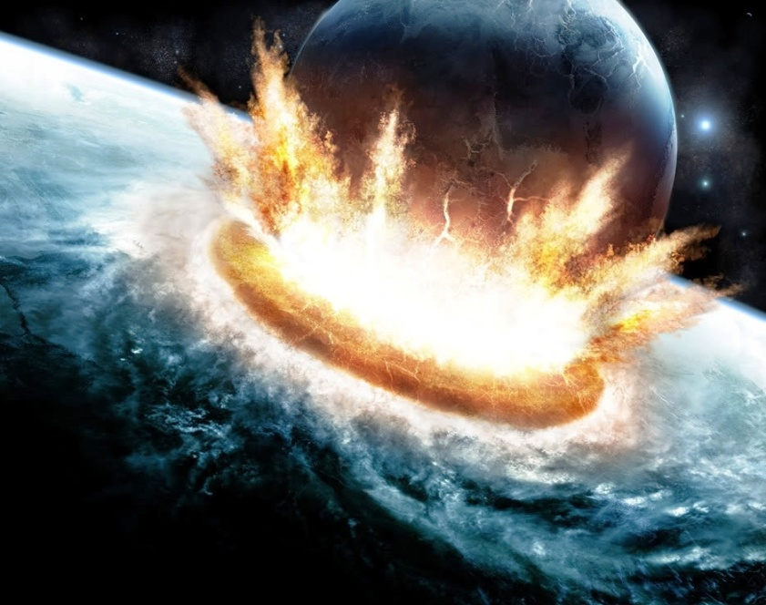
Use your reason! You and your personal world are perpetually subject to the blows of death and decline. Your illusion and sophistry resemble this comparison: if you have a mirror and hold it up to a house or a town or a garden, their images will appear in it. If the mirror is moved the tiniest amount or the smallest change occurs to it, the images become confused and distorted. The fact that the actual house, town or garden outside the mirror continue and are constant is of no avail to you, for the house in the mirror in your hand and your town and garden are only in the scale and proportions which the mirror gives you.
Your life is the mirror. The support and mirror of your world and its centre is your life. Every minute it is possible that the house, town, and garden will die and be destroyed, their condition is such that any minute they may collapse on your head and your doomsday will come. Since it is thus, do not burden this life and world of yours with loads they cannot raise and support! (5)

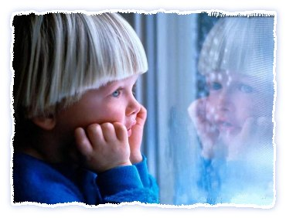
They will be grieved according to their degrees. They will be grieved in the same way that they are grieved at the overwhelming, wrathful manifestations of the angels towards themselves. In respect of his mind and conscience a person is affected by those trembling in the snow and cold outside while he himself is inside in the warm. Similarly, since they are connected to the universe, according to their degree, immortal spirits are affected by the awesome events of the universe. The Holy Book indicates and alludes to this and to the tormented being afflicted in a grievous manner, and those destined for happiness being struck by wonder and amazement, and even rejoicing. For the All Wise the Holy Book always mentions the extraordinary events of the resurrection in the form of threats; it says: "You will see it!" Whereas those who will witness it physically are those living at the Last Day. That is to say, the spirits whose bodies have rotted in their graves also have a share of those Qur'anic threats.

THE RESURRECTION AND THE AFTERLIFE
A visible but oft-neglected difference between human and other types of life is instructive. Inanimate objects serve universal purposes in a complicated, amazing way, but do not know what they do or why they do it.
Plants and trees have some degree of life and serve animals and human beings as food. Also, addressing themselves to their senses by displaying spectacular scenes, spreading pleasant scents, and playing the most touching kind of music, they satisfy human senses (in particular, those of seeing, smelling and hearing) and decorate the earth. However, they do not know what kind of universal purposes they serve or what significant results they yield.
Animals perform tasks based on their abilities. Although they do not know why they are doing what they do, they derive some sort of pleasure from their work. A sheep, for example, gives milk, wool, and meat; a dog is a loyal friend; and birds are the loveliest singers in gardens or on mountains.
Of the earthly beings, only humans are conscious. They know what they are doing, why and for whom they are doing it, and why everybody else is working. People also can supervise and employ other people for their own advantage. However, human beings did not create themselves. Although of the same elements and living on the same substances, each individual is unique in countenance and character. Thus, each individual can be identified correctly by even his or her fingerprints.
People have no part in determining their physical features, family, race, color, birth date or place, and even their own nature. Their free will also is limited. For example, their role in producing bread is insignificant when compared with that of the One Who organizes the sun, rain, and soil; a wheat seed’s germination, growth, and life; the seasons; and the mutual helping between these elements.
Besides, people did not establish the basic conditions of life— they cannot prevent hunger, thirst, and sleep. They have no authority over the cycle of day and night or their bodies; they function automatically. For example, if they had to “wind” their hearts at exactly the same hour every morning like a clock to continue living, they would certainly have forgotten to do so every day.
Another interesting fact is that from the very moment an animal is born, it seems to know what to do. As if trained in another realm, it comes (or rather is sent) into the world and acquires full possession of those functions and abilities that it needs to survive within several hours, days, or months. For example, a sparrow or a bee acquires (or rather is inspired with), in less than a month, the ability to integrate into its environment in a way that would take a human individual many years.
This reveals an important fact: Animals have no obligation or responsibility to seek perfection through learning, progress through scientific knowledge, or pursue prayer and supplication by displaying their impotence. They are obliged only to act within the bounds of their innate faculties, which is the mode of worship specified for them.
In contrast, people are born completely ignorant of life and their environment; we need to learn everything. Acquiring such knowledge requires our whole lifetime. We appear to have been sent here in such a state of weakness and inability that it takes us as long as two years even to learn how to walk, and almost a whole life to learn how to distinguish between good and evil, and what is beneficial for us and what is harmful.
Despite these basic differences, human life is the most valuable, for whatever exists was created to produce humanity. We are the fruit of the tree of creation. Just as a tree is grown for the sake of its fruit and its whole life is directed to yield this fruit, the whole universe serves humanity. Thus, each human being has the same value as the entire universe.
One might even say that its value is greater than the universe, for each individual is equipped with consciousness and other intellectual faculties that make him or her superior to all other life forms. In one instant, the human imagination can travel throughout and far beyond the universe. We can speak; experience very complicated feelings, desires, and goals; as well as learn, think, judge, reason, and employ other living beings. Therefore, our value lies not in our physical composition and material aspect, but in the metaphysical dimension of life.
The Hand of Power that created humanity made a great “expenditure” on each human being by attaching the greatest value to them. That is, in addition to their mental and spiritual faculties that no worldly scales can weigh, It included in their physical or biological composition almost all elements of the tree of creation. Each individual’s physical or biological composition is so marvelous and expensive that if humanity joined together and built factories to produce a single cell, they would fail. When we consider only the neuron’s structure and tasks and the thousands of cords extending from the brain to each of the more than 100 million cells in a human body, we can get a glimpse of what an amazing and miraculous creation we really are.
Despite this miraculous mechanism and the expenditure made on it, our earthly life is very short. Many people die soon after birth. However, the cost for and value of each individual, regardless of how long he or she lives, is the same. So short a life, despite such a vast expenditure and having the same essential value as a long one, cannot have been made for the life itself. Nor can it be limited to this world. It must have far-reaching aims, and there must be ways to eternalize it. (6)

References
(1)16:56.The Quran with Annotated Interpretation in Modern English by Ali Unal
(2)25:72.The Quran with Annotated Interpretation in Modern English by Ali Unal
(3)Transmitted by Ahmad.Al-Tirmidhi – Hadith 3711
(4) Sahih Al-Bukhari – Book 73 Hadith 59
(5) 17th Flash, Risale-i Nur
(6)Unal, Ali. The Resurrection and the Afterlife. The Light, Inc. 2006.

